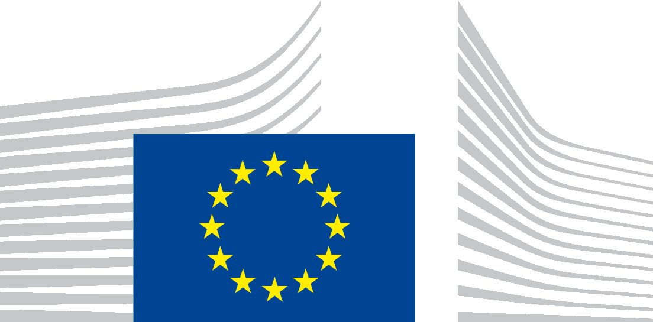 | EUROPEAN COMMISSION  DIRECTORATE-GENERAL  JOINT RESEARCH CENTRE  JRC
Brussels,

Mr Gary Rimmer
1 Princes Close
LONDON SW4 0LG
United Kingdom
Subject: Your application for access to documents - Ref. Gestdem 2015/5110 & 5236
We refer to your e-mails dated 28 September and 1 October 2015 in which you make a request for access to documents, registered on 29 September and 2 October respectively under the above mentioned reference numbers.
For your request on results of laboratory and on-road testing of vehicles since 2010, we enclose a list of publications on such results. For most of these, the internet link to these documents is included in the list. For those where the link is not available, we enclose PDF versions.
For your request about the identities of the cars tested in the 2011 and 2013 reports of the JRC, we are preparing a public release covering also this information, which is due to be published this Friday 13 November. We will send you a link to the internet page on Friday.
Yours faithfully,

JRC ACCESS DOCUMENTS
Contact:
JRC-ACCESS-DOCUMENTS@ec.europa.eu

Enclosures:

List of documents
CERT-2012.pdf
CERT-2014.pdf
CRC-2012.pdf
SUN-2012.pdf
SUN-2013.pdf

