**UfM PLATFORM ON GAS**

**BACKGROUND REPORT**

**on**

**“COMMON CHALLENGES FOR THE DEVELOPMENT OF A MUTUALLY BENEFICIAL MEDITERRANEAN GAS MARKET PLACE”**

**First Draft**

**9 June 2015**

**TABLE OF CONTENTS**

1. Security of demand 3

1.1. Evolution of gas demand and expectations for the future 3

1.2. Risks and visibility of demand 6

1.3. Place of gas in the energy mix 8

1.4. Impact of energy transition policies and role of gas in energy efficiency policies 10

1.5. Gas quality 11

2. Security of supply 14

2.1. Evolution of supply and expectations for the future 14

2.2. Exploration and production: trends, challenges and opportunities 16

2.3. Unconventional gas in the Euro-Mediterranean region 20

2.4. New and alternative supply sources 22

3. Infrastructure challenges 26

3.1. LNG in the Euro-Mediterranean Region 26

3.2. Storage in the Euro Mediterranean Region 30

3.3. Pipelines in the Euro-Mediterranean Region 32

3.4. Identification of potential bottlenecks 37

3.5. Investment barriers 39

4. A Euro-Mediterranean gas hub 42

4.1. Characteristics and requirements of different gas hub models 42

4.2. The importance of gas contract price formation 46

4.3. Organisation of the gas market in the region 50

4.4. The prospects for a gas hub in the Mediterranean region 62

# 1. Security of demand

## 1.1. Evolution of gas demand and expectations for the future

In past decades, the promotion of natural gas use has been a clear target of energy policies in most countries in the Euro-Mediterranean region.[1] The rationale behind that choice was that natural gas is the cleanest fossil fuel, which benefits from the most efficient power generation technologies. Natural gas demand in the EU is mainly concentrated in North-West Europe and Italy, where gas markets developed 50 years ago, together with Spain in which gas was a relatively recent addition to their energy mix. In the South and East Mediterranean gas demand is concentrated in Turkey and Egypt.

Natural gas demand[2] in the EU increased by 45% from almost 375 billion cubic metres (bcm) in 1990 to 545 bcm in 2008, but since then it fell by more than 70 bcm, to 472 bcm in 2013. The EU gas demand in 2014 was 10% lower than in 2013, according to the preliminary data from Eurostat. The drop of some 125 bcm in the EU gas demand between 2008 and 2014 is due to several factors: deteriorating economic conditions, increased gas production in North America due to shale gas revolution there leading to abundant and inexpensive coal supplies, price dynamics between the various energy commodities, low carbon prices which benefit coal-fired generation, growing importance of incentivised renewable energy production which have weakened demand for natural gas in the power and industry sectors, and warmer weather (2014 was the warmest year on record for some of Europe).

Several unforeseen (spontaneous) events in the past few years have created large uncertainties with regard to the future of natural gas demand in Europe. For instance, in March 2011 Tsunami and subsequent nuclear crisis in Japan have shifted the short to medium-term dynamics of global LNG markets.

After having been relatively limited to its domestic market, the changes caused by the US shale gas revolution are impacting the energy markets around the World. First, this revolution benefited Europe with excess LNG supplies originally intended for the US. However, since the Fukushima nuclear accident, those available volumes of gas have been redirected to Japan. The policy impacts, however, will be more enduring due to a step back from nuclear renaissance. So far, many governments have either reviewed the safety of their existing nuclear plants, or suspended/delayed plans for new nuclear installations, or announced their intention to abandon nuclear energy as part of their energy mix. Secondly, the abundance of cheap gas in the US entailed a decrease in coal demand in its domestic market, increasing supplies of coal on the world markets, at a time of slowing economic growth. As a result and due to the low level of carbon prices, the use of coal for power generation has increased in several European countries.

Global changes affect not only European gas demand, but also positively impact on gas hub trading. Since 2011, there has been a decoupling between spot prices of coal and gas in the EU. Coal prices have dropped significantly while gas prices have increased. The main driver of the coal/gas price dynamics has been the shale gas revolution in the US. However, this is not the only reason. Gas prices have continued to increase in the EU despite falls in demand. This illustrated the decoupling between the pricing of natural gas and the fundamentals of supply and demand in EU natural gas markets. At the same time, positive developments have been taking place in terms of movements towards more gas hub trading in Europe.[3]

Although natural gas has a major role to play as an alternative to more carbon-intensive fossil fuels and as a complement to variable renewables (particularly solar and wind) it is still not clear whether the EU considers or will consider gas as a bridge-fuel or a low carbon energy source. Meanwhile regulatory uncertainties in the EU have started to have increased negative impact on company decisions regarding their long-term investments. As a result of these EU Energy and Climate Policy developments, there are large uncertainties on how much gas Europe will actually consume in the medium to long term.

After setting the 20-20-20 goals in 2009, the EU defined in 2011 a roadmap to 2050 for further increasing the objectives with regard to energy efficiency and renewable energy (RES) production. The EU goals towards increased penetration of RES, energy efficiency and Greenhouse gas (GHG) emissions reduction have been further specified in the 2030 European framework for climate and energy objectives. However, uncertainties on the nature, the speed and extent of the implementation of these policies create a wide range of scenarios for future EU gas consumption. As a whole, in an optimistic scenario towards achieving environmental and economic sustainability, gas demand could be expected to increase slightly over the next decade, and remain strong in the energy mix. However, if a weak carbon price persists, and coal maintains its competitive advantage, gas demand would drop by 2030.

Many factors affect future demand. Several of those are not even quantifiable. Future demand levels for gas will strongly depend on the future role of gas in the EU Energy and Climate Policy. Four main elements create uncertainty about EU gas demand growth to 2030: large challenges the power market is facing in Europe due to decommissioning of nuclear power plants, emergence of coal and an increasing market share of renewable energy; economic growth; energy efficiency and climate policies. These are the main reasons why available forecasts for EU gas demand are widely apart, the demand uncertainty in 2030 sums up to +/- 150 bcm/y. Naturally, this uncertainty affects the long-term outlook for the EU gas imports.

***Figure 1: EU Gas Demand: Past trends and forecasts for 2030***



Source: OME

The South and East Mediterranean region is characterised by a rapid energy demand growth. Demand for gas has been booming in the region – the result of a growing population, rising living standards, decade-long policies fuelling in particular domestic industries, and the booming power sector.

***Figure 2: South and East Mediterranean Gas Demand (in bcm)***



Source: OME, based on data from the IEA and national sources.

Since 1990, demand for gas multiplied by a factor of 11 in the East Mediterranean region, mostly due to booming gas consumption in Turkey. It tripled in the South Mediterranean over the same period, largely due to expansion of gas consumption in Egypt. Although the magnitudes of future gas demand growth level in both regions vary, all studies suggest this upward trend to continue in the future.

## 1.2. Risks and visibility of demand

After decades of growth, EU gas demand stabilised at the end of the last decade and has regressed as a consequence of the economic downturn and the EU-climate policies. The lingering economic crisis in Europe, fiscal austerity across the region, dampened demand for electricity and reiterated European goals for renewable energy development will inevitably impact the investments needed into the natural gas sector.

In the coming years, approaching 2030, gas is destined to be in high demand on the global marketplace. In the EU, trends are less certain, although there is large potential for an important role for gas in achieving the 40% GHG reduction for 2030, a central aim of the EU 2030 Energy and Climate Change Framework.

Further uncertainty is generated by *negative* public statements on natural gas. For example, in a Statement by the European Commission in July 2014 it was estimated that for every additional 1 percent in energy savings, EU gas imports would fall by 2.6%. A calculation considered that energy efficiency policies achieving 40% savings would result in lowering gas imports by as much as 40% by 2030 in comparison with 2010. However, in the Reference Scenario of the analysis, imports would grow by 5% in that year[4].

All this uncertainty affects the long-term outlook of regionally produced gas imports since the demand for imports results in the overall demand netted from indigenous production.

The EU is currently the main market for the gas produced in the Southern Mediterranean countries. Therefore, the outlook for gas consumption in the EU, and South and East Mediterranean is a key component to securing favourable environment for investment in production and transport capacity across the region.

Medium- and long-term gas export potential of South Mediterranean gas exporters is subject to an important degree of uncertainty. One of the most important challenges of these countries is to address their increasing domestic energy demand, which in turn has an impact on their level of achievable exports and source of revenue. Not only does a history of project delays over the past years suggest potential for similar delays in the future, but the region is also far from having recovered from the disruptive effects of the Arab Spring. Moreover, difficulties in defining a long-term energy strategy and slow decision-making process have had an unsettling effect on the exploration and the exploitation of energy resources available in the region, and have put under pressure the meeting of the increasing demand for energy.

The Southern Mediterranean countries have however, the potential for higher production capacities thanks to huge untapped resources. But important investments are required to fully exploit these resources. Consequently, conditions for an attractive business environment need to be created in order to attract potential investors.

In this context, regional cooperation and the development of new resources in the Euro-Mediterranean area can deliver important benefits to all parties concerned. This could be done by strengthening exchanges with historical producers such as Algeria, Libya, and Egypt that represent about 80% of the present proved gas reserves in the Euro-Mediterranean region.

An important precondition for further enhancement of the EU’s gas supply security is to diversify its supply sources and routes. This would require new infrastructures such as pipelines and LNG liquefaction facilities to be built in particular in the Southern and Eastern Mediterranean countries. These new infrastructure projects will bring several challenges in terms of technical standards, financing, interoperability and the integration of gas markets.

Furthermore, political risks in the wider neighbourhood may affect the gas market in the region and hence need to be taken into consideration as well. The Euro-Mediterranean developments must therefore go hand in hand with the EU stream of policies supporting infrastructure projects of European Interest (i.e. Connecting Europe Facility, Projects of Common Interest, Juncker Plan).

There are a number of framework conditions that underpin the development of gas markets and that need to be considered for the Euro-Mediterranean region.

Regulatory risk is an important factor affecting business decisions. Frequent and unexpected changes in the legal and regulatory environment affect investor interest, complicate planning and long-term investment decisions,[5] and eventually endanger the outlook for the demand for cost- and energy-efficient fuels such as natural gas.

Uncertainty about future market design and development of inappropriate climate policy design could affect demand for gas. Policy-makers need to reduce uncertainty about what the future market design will look like. It is equally important to use market forces to guarantee and strengthen security of demand. Balancing and flexibility markets would smoothen electricity market fluctuations and can hedge against strong and abrupt price fluctuations, adding further value to the process and securing against possible risks.

On the Northern shore of the Mediterranean, clarification of European countries’ approach to cross-border allocation of costs of gas interconnection projects of strategic relevance is a core prerequisite for the establishment of a successful investment climate, and would ultimately be in the interest of all Mediterranean customers. In this sense the implementation of the EU TEN-E regulation 347/2013 is expected to be a step further.

In this context, it is important to value the regional resource capital, along with creating a favourable policy framework to develop the needed long-term investments. Appropriate transparent, and stable regulatory tools that would ensure an optimised use of the existing gas infrastructure, an efficient use of new infrastructure, safeguard security of supply and limit the possibility of developing stranded assets are equally important. Equally so, it is also vital to diversify the market for both consumers and producers, and optimise the contractual relationship between them taking into account the need of long-term investments.

Finally, to foster an investment-friendly regulatory framework and thus help achieve the development of energy infrastructure of interest to the region as a whole, it would be essential to strengthen the cooperation between operators, national regulators and governments, as well as among governments/regulators themselves.

## 1.3. Place of gas in the energy mix

The energy mix in the northern part of the Mediterranean area is evolving with growing integration of renewable sources and energy efficiency in a stagnant period of demand, the phasing out of nuclear energy in some countries and the price developments in different fossil fuel sources. Moreover, the entirety of the Mediterranean area is facing a transformation of market conditions and relations between suppliers and consumers. Altogether, this raises energy security concerns.

Whilst gas fired power stations across Europe have seen reductions in utilisation, gas remains an important energy source in many other areas. Customers include residential and commercial (heating, cooking and hot water), industrial (chemical feedstock) and transportation (shipping and road vehicles).

As mentioned earlier, natural gas is a major source of energy in the Euro-Mediterranean region, for power generation, heating and industrial purposes, and it is also anticipated to develop for the transport sector.[6] It is expected that, given the right political context, demand for gas in transport may be seven times greater in 2035 than it is today[7].

Together the 28 members of the EU consumed approximately 1.7 billion tonnes of oil equivalent of primary energy in 2013. For several years until 2007, there had general upward trend in total EU energy consumption. The decrease in the years after 2007 (including) was partly due to a reduction in economic activity in this period. Although EU economic activity has been recovering, energy consumption in 2013 was at the same level as in 1990. However, the consumption of gas in 2013 was almost 30% higher than 1990 levels.

The share of natural gas in EU’s energy mix has changed in the past decades. Gas gained market share against coal while renewables increased significantly in the framework of a movement towards cleaner energy sources. From 18% in 1990, its share reached its peak of over 25% in 2010. Since then the share of gas has not increased anymore. On the contrary, it has been declining slightly, to almost 23% in 2013.

Over the same period, between 1990 and 2013, while the share of natural in energy mix declined slightly in non-EU countries in north Mediterranean, it increased considerably in the East Mediterranean (from 5% to 30%) and South Mediterranean (from 31% to 48%), largely due booming gas consumption in Egypt and Turkey.

***Figure 3: The share of gas in energy mix and electricity generation in Euro-Mediterranean region***



Source: OME, based on data from the IEA, Eurostat and national sources.

Although the prolonged economic crisis, the impact of the US shale gas revolution, the Fukushima accident and attitude to climate change have created uncertainties, the share of natural gas in the EU energy mix is expected to stay above its current level in the next two decades under all scenarios (New Policies, Current Policies and 450 Scenario) presented at the IEA’s World Energy Outlook 2014.

Over the past 25 years not only has the composition of the energy mix changed but also how electricity is generated in the EU. Fuels used in electricity generation have become more diverse. The share of natural gas in electricity generation increased rapidly from 7% in 1990 to almost 24% in 2008. Natural gas has thus become one of the main sources used for power generation. But since then, the situation has started to change. As a result of the stagnant electricity demand in the past few years, several gas power plants have been shut down, and many others are planned to be stopped, due to loss of profitability, a rebound of (cheap) coal use and booming renewables in electricity generation. The share of natural gas in electricity generation declined below 20% in 2011, and keeps declining.

The share of gas in electricity generation in East Mediterranean increased from 14% in 1990 to over 45% in the late 2000s, and remained around 40% afterwards. In South Mediterranean, however, it jumped from 45% in 1990 to 75% in 2013 due mainly to a shift in the region from oil fired to gas fired power generation.

## 1.4. Impact of energy transition policies and role of gas in energy efficiency policies

There is no firm definition of energy transition which applies primarily to mature energy systems such as those in Europe, the US and Japan. The concept in itself does not apply to developing energy systems on the Southern and Eastern shores of the Mediterranean, but provides elements for the development of sustainable energy systems eventually without the need of a “transition”. However, some elements are always part of this concept:

* Energy efficiency and demand side management;
* Reduction of the environmental impact of the energy system, which includes climate change, acidification, air quality issues, water use, land use, waste etc;
* Development and wider availability of energy services.

With its relatively low ratio of carbon to calorific value, gas is regarded as being relatively ‘green’ compared to other fossil fuels. This means that it is seen as an important component for a transition to a low carbon economy. At the same time, gas as a flexible fuel can deliver increased fuel and cost efficiency in activities, such as heating and transport, and is already doing so.

Gas provides considerable potential for reducing CO2 emissions in the power generation. However, there is great uncertainty around whether this potential will be realised in Europe over the medium and longer term. The eventual make-up of the energy mix will result from a complex interplay of global and European market forces, and of European and national energy policies and market designs.

An EU energy mix based on a larger share of natural gas combined with a large share of renewables in the power generation sector would allow the EU to reach the 2030 emissions reduction targets cost-effectively.[8]

For example, the roll-out of condensing gas boilers in the EU in the short run, and gas heat pumps and further (micro-) CHP deployment in the mid-term would achieve deep cuts in cut carbon emissions among end-users. According to Eurogas,[9] changing from the older traditional gas boiler system to a new gas condensing boiler system will save emissions because the condensing boilers are at least 20% more efficient. Up-front capital costs of switching to more efficient gas boilers are recaptured in a short number of years by lower energy consumption. Replacing all Europe’s traditional gas boilers with gas-condensing boilers would reduce Europe’s total GHGs by 7% in one year alone. Add to this the range of hybrid options in heating appliances, and there could be much room for partnering renewable electricity provision with robust gas-fired options.

## 1.5. Gas quality

Gas quality plays a crucial role for the interoperability of gas systems and thus the free flow and trade of gas. Currently, there exist different natural gas quality specifications across Europe depending largely on the different sources of gas. With the declining European natural gas production and the expected increase in demand in the coming decades, Europe’s import dependency of Europe will most likely grow. Therefore, the interconnectivity of existing transportation systems, the ability of gas storage facilities and LNG terminals to modulate demand and the ability to import LNG from a wide range of sources will all play very important roles in providing security of supply throughout Europe.

Although covered by a generic term, natural gas varies in its composition, and therefore in its quality, depending on its source worldwide. In this context, the issue is how to ensure security of gas supply at reasonable cost, knowing that gas quality parameters of imported gas may be different from one source to another.

Gas quality has two major technical aspects, the “pipeline specification”, in which stringent specifications for water and hydrocarbon dew point are stated along with limits for chemical components such as sulphur. The objective here is to ensure pipeline material integrity for reliable gas transportation purpose. The second aspect is related to the “interchangeability specification” which may include parameters such as calorific value and relative density, which are specified to ensure satisfactory performance of end-use equipment (safety, performance and emissions).

The most common measure of interchangeability worldwide is the Wobbe Index. For example, and depending on the source, some re-gasified LNG has higher Wobbe Index than pipeline gases, and in some countries needs to be treated prior to entry into transmission systems.

Up to date the EU does not have any Standard on gas quality, although this is expected to change soon. The only initial European reference on gas quality was the 2005 EASEE-gas Common Business Practices on gas quality that have never been questioned and broadly accepted in Europe.

In 2007 the European Commission approved a Mandate (M/400) to elaborate a gas quality specification in Europe for H natural gas. Initial reference was the EASEE-gas Common Business Practices and two premises had been taken into account: a specification as wide as possible in order to guarantee the security of supply, and maintaining adequate security levels at reasonable cost.

The Work was structured in two phases; the first phase gathers an analysis of appliances working conditions and performance due to gas quality variations. The Final report was issued by CEN/BT WG 197 “Gas quality” in 2011. The main conclusion was that a single Wobbe Index range for all of European countries was not rational and a roadmap for implementation in each country was proposed. The second phase gathers the Development of the Standard by CEN/TC 234 WG 11, which was constituted in September 2011. The First draft was submitted to Public Enquiry (May - October 2014).

Furthermore, the 1st July 2014 an informative workshop was organized by the European Commission to provide information about the gas quality standardization process. The conclusion paper submitted by the European Commission produced a change of direction in the process. As a result of this, the last CEN/TC 234 WG11 took the final decision of not including a Wobbe Index parameter in the first version of the EU gas quality standard (expected to be published by end 2015). Furthermore, a deeply analysis should be done in the near coming years and the reactivation of a Pilot Study is also considered.

At this point, it should be recall that the Standard is not to be binding and that National Authorities will decide how to implement it.

Furthermore, from experience, in some Euro Mediterranean region gas systems, a high calorific gas has been distributed, mainly due to LNG imports. In some other areas gas has been also distributed even with high variations of Wobbe Index over a certain period of time, without registering any significant problem while maintaining high levels of security.

Nevertheless, in Europe new gas supplies via pipeline will go on stream during the next decade and LNG terminals will receive LNG cargos from many different sources, which may lead to higher Wobbe Index values. Simultaneously, possible development of non-conventional gas and renewable energies (biomethane and hydrogen) may lead to lower Wobbe Index values.

In this context, what is clear is that gas flows in Europe will change and that the range of Wobbe index will certainly be enlarged comparing to present.

Due to this, a Wobbe Index band as wide as possible is required.

Since, one of the key issues is the importance of diversification of sources, suppliers and routes to meet the demand and the role of LNG is crucial as it provides security and diversification of supply, the broader the gas quality specification, the easier it will be to attract/import LNG/pipeline gas from different parts of the world. A broad gas quality specification guarantying adequate security levels to gas end-users at reasonable cost is in favour of the competitiveness, security of supply, flexibility and the liquidity on the European gas markets.

# 2. Security of supply

## 2.1. Evolution of supply and expectations for the future

The EU is becoming increasingly reliant on imports of energy. This is particularly the case with natural gas. Until 2002 the EU imported less than half of gas it consumed. Since then the proportion of natural gas imported from outside sources in total supply continued to increase to reach two-thirds by 2013.

***Figure 4: EU Gas Supplies***



Source: OME, based on Eurostat data

Of the total amount imported into the EU, more than 85% was supplied through pipelines and 15% via LNG, mainly coming from more distant locations.

Russia, Norway and Algeria have been the main suppliers of gas to the EU. Imports of gas from Russia to the EU increased in 2013 compared to previous years. This was due to lower activity on the LNG market, restricted availability of gas coming from South Mediterranean region and reduced Norwegian supply, compared to 2012. Imports of gas from Southern Mediterranean gas producing countries (Algeria, Libya and Egypt) have been declining since 2008 whilst the entire region is experiencing increasing internal demand.

In 2013, the main sources of gas supply to the EU market were: production within the EU, which represented 34% of the EU's total supplies; Norway supplied 23% by pipelines (plus a little by LNG); Russia supplied 31%. The other sources of gas supply to the EU market are the South Mediterranean (currently only Algeria and Libya, mainly by pipelines under the Mediterranean Sea) and worldwide LNG markets.

***Figure 5: EU gas imports by transport mode and country of origin***



Source: OME, based on Eurostat data

There are numerous forecasts for European domestic gas production and demand into the future. This report will not comment on these forecasts.[10] However, profound implications arise from those differing estimates with respect to import needs and eventual consequences for energy policies in Europe. A steeper decline in domestic gas production translates into a growing gas deficit and hence growing import dependency, even if demand remains flat. Plenty of uncertainties surrounding the future EU gas demand and production boil down to uncertainty about import requirements.

Whether the degree of these uncertainties will widen or narrow will largely depend on the decisions taken and the path that will be followed by the European policy makers. This issue is important since suppliers would like to have a sense of magnitude of how much their gas is needed so that they could formulate their upstream and infrastructure policies and particularly related investment needs. Similar is true for the companies in importing countries. Increasing uncertainties surrounding the demand as well as import requirements of their customers will surely make suppliers uncomfortable and hence will force them to be more careful with investment plans.

It is highly likely that the trend for EU dependency on external gas suppliers will continue into the future. Due to the reasons highlighted in the first section, available studies suggest that the EU may need more than 100 bcm of additional net imports to satisfy its gas demand by 2030.

It is expected that in the future most of the EU's future gas imports will either originate from or transit across the Neighbourhood countries, which lie between the EU and some three-quarters of the world’s proven gas reserves.

There are a number of risks associated with the procurement of gas and its transportation to the EU. The present level of supplies from Norway is considered secure for another decade, but their further expansion may be constrained. Supplies from Russia are competitive but cannot be considered secure in a political sense today: there is a risk of Russia's gas supplies to the EU being interrupted for political reasons.

In this context, the Mediterranean basin is key for future diversification. Since the construction (and subsequent expansion) of the gas pipelines connecting the Northern and the Southern shores of the Mediterranean, Algeria and Libya (and until recently Egypt) have contributed to meeting the gas needs of some of the largest consumers in Europe, such as Italy, Spain and Portugal. Over the years, LNG facilities have also played an increasingly relevant role in developing trade, security and diversification of supply in this area.

Southern Mediterranean gas producing countries (Algeria, Libya and Egypt) currently find themselves subject to other policy imperatives. Europe has been their main customer, which absorbs around 80% of their gas exports. EU gas imports from the region have been declining since 2008 whilst the entire region is experiencing increasing internal demand. They could play a major role in the EU’s search for additional gas supplies as they have significant untapped gas resources. However, huge investments are required to fully exploit these resources, both conventional and offshore.

In order to encourage and maintain the flow of gas from the region into Europe it will be necessary to encourage and facilitate investment in and development of gas resources and associated transport infrastructure in the region. The Algerian government has taken steps to encourage increases in production and has recently made changes to the Hydrocarbons Laws intended to offer more attractive conditions. Both Libya and Egypt have seen significant reductions in gas production since 2010 as a result of the lack of investment and conflict in those countries, but their long-term future looks bright.

Due to its significant conventional and unconventional gas resources, the Southern and Eastern Mediterranean basin will remain at the top of the European energy agenda in the coming years. The new gas discoveries in the Eastern Mediterranean offshore area, for instance, are expected to strengthen the centrality of the region for the European market as well as introduce additional gas into regional trade.

The EU's recent Energy Union strategy has identified the Mediterranean as a strategic priority and has set the objective of boosting the energy partnership with the Southern and Eastern Mediterranean countries - inter alia by exploring the potential for more gas imports from the Mediterranean and the development of a Mediterranean gas hub.

## 2.2. Exploration and production: trends, challenges and opportunities

Conventional natural gas reserves in the Euro-Mediterranean region are estimated at more than 10 tcm as of January 2015.[11] Some 80% of these reserves are located in the Southern Mediterranean and 4% in the Eastern Mediterranean. The remaining reserves are found in European countries[12] (15% of which in the EU member states and the rest in non-EU member European countries).

Since their peak in 1995 gas reserves in Europe have been declining. Majority of the reserves in Europe are held in mature reservoirs located in the countries surrounding the North Sea. Discovery of new reserves, which on average have turned out to be getting smaller and more costly, has not been keeping pace with the maturation of existing fields. In addition, prospects that can be explored have become smaller, and the aging infrastructure has become a barrier for field development.

Developing domestic resources, which is recognized in the EC’s Energy Union Strategy as well, is undoubtedly important for improving Europe’s security of supply.[13] The problem is that during the past two decades the upstream gas sector in Europe was marked by limited discoveries of new major gas fields. This is mainly because in most European countries exploration has proceeded in irregular course, with irregular results. The implication of low level drilling activity has naturally been felt on the number of discoveries. Unfortunately despite the surge in technology, relatively high investments in recent years, increasing development drilling as well as higher oil and gas prices until recently, gas production continues to decline.

European natural gas production increased from 215 bcm in 1990 to its peak of 273 bcm in 1996. Production entered a period of bumpy plateau until 2004 and since then it has started to decline. In 2013 almost 175 bcm of gas was produced in Europe. Around 99% of this production occurred in the EU member states. The Netherlands account for half of the gas production in the EU. It is followed by the UK (22%), Germany and Romania (almost 7% and 6% respectively).

Most countries try to sustain their tail end production, and extend the life of their fields in order to prolong their current production at a plateau level with extensive use of technology and investment in the upstream sector. Even though somewhat significant discoveries could be expected in the future, additional production in Europe will unlikely be sufficient to compensate the loss from depletion in the medium to long term.[14]

***Figure 6: Natural gas Production in Euro-Mediterranean Region***



Source: OME, based on data from IEA and Eurostat.

Contrary to Europe, gas production in Southern and Eastern Mediterranean region rose until 2010 but dropped in 2011 due to the social unrest in the region and remained at a plateau level afterwards. Steady decline in Algerian gas production since 2005 and in Libya and Syria since 2011 is partly compensated by production increases in Egypt and Israel. Algeria and Egypt currently account for over 85% of total gas production in the region.

Future gas production,[15] especially a decade ahead, is rather less complex to estimate if one applies a bottom up approach by looking into production profiles of existing fields, and ongoing and planned field development projects. The EU's production of natural gas, which is significant today, is declining strongly. Without new discoveries the declining trends in European gas production is set to continue in the future, but its magnitude will depend on how much new investment the region will attract. Unconventional gas prospects could potentially help slow down the decline in production but progress has been very slow and the contribution to total gas production is unlikely to be significant, at least for another decade. Stranded gas[16] could also potentially contribute to domestic supply but a lack of pipeline infrastructure needed to transport the gas ashore constitutes an important bottleneck.

Europe has seen a reduced number of investments in exploration activity for new reserves of gas. According to Wood Mackenzie there were just 85 licenses awarded in Continental and Mediterranean Europe (excluding Norway and the UK) during 2014. Although the licensing activity will remain steady this year, the region is expected to experience a decline in its upstream development investment.[17] It is true that as major productive areas have become more mature, the size of new discoveries has become smaller. At the same time exploration costs have increased. However, this partly explains the low level of exploration activity.

A number of obstacles and difficulties have been hindering the efforts of companies to explore, to bring the discovered fields into production and to continue their operations. Decreasing availability of drilling rigs (partly due to a lack of harmonisation of regulatory requirements in the EU countries bordering the North Sea) has led to significant increases in costs; the difficulty and the time length required for issuing the licenses and the necessary authorization for drilling due to a high levels of bureaucracy and cumbersome environmental permitting; in some cases the difficulty to access resource and reserves information including well and seismic data which might be classified as confidential by the regulator[18]; there may be no clear access to critical infrastructure;[19] expected returns from small fields may be considered too low.

Upstream activities are very sensitive to changes in the tax and regulatory regime. Fiscal and regulatory instability (in some cases unpredictable and non-transparent) damaged investors' confidence and impaired investment in several countries in the last decade. In addition, the dramatic fall in oil prices since the mid 2014, the volatile and potentially prolonged weak market fundamentals have had a negative impact in exploration budgets and investment plans due to intensified cost optimization programs. Several companies have announced capital expenditure cuts, particularly on high-risk investment, with some operators already delaying drilling until next year. This has caused freezing or cancelling numerous investments in upstream projects. In order to protect shareholder value, many companies preferred to prioritise projects in their portfolios based on returns. As a result, many investment plans in exploration and development projects are currently at risk.

Currently the major challenges are to attract investors in high-risk, high-cost and long-term projects such as deepwater and high-pressure onshore fields; increase the resource base by finding new reserves at competitive costs; extend the life of ever decreasing fields economical by maximizing the recovery as well as explore in a rather low price and sometimes uncertain fiscal and regulatory environments with unclear political support. The latter is quite important in the current risk aversion sentiment surrounding the upstream industry. In this environment it is quite natural that companies will prefer to focus their efforts in more robust and investor friendly markets.

Europe still has abundant conventional[20] and unconventional natural gas resource potential. Until recently, the largely underexplored Adriatic Sea has not been available to the international exploration business for a variety of political reasons. Bulgaria, Ireland, Croatia, Montenegro, Albania, Greece and UK have either launched or are in the process of exploration tenders that they hope will bring substantial amount of investment and boost regional energy security.

In order to maximise domestic gas production, more attention needs to be paid in Europe to fostering a climate that attracts investment and recognises the importance of exploration in ultimately delivering new sources of energy supply, according to International Association of Oil & Gas Producers.[21] A political support and public awareness (better communicating the benefits of domestic production in order to prevent initiatives taken by the industry from attracting hostility) for exploration, especially in the European Mediterranean, could also pave the way to increase market confidence. In order to facilitate the return of investor confidence fiscal regime was significantly improved in some countries (such as the UK in early 2015) but there is still plenty of room for improvement in general.

Some of the above mentioned challenges are also valid for the countries in the Southern and Eastern Mediterranean. The length of time taken to run bid rounds and licensing procedures, the lengthy ratification process for exploration and production agreements, rather unattractive fiscal and regulatory environment and in some cases concerns about physical security have caused deterioration in investor confidence.

## 2.3. Unconventional gas in the Euro-Mediterranean region

The exploitation of unconventional gas resources has resulted in a sea change in the field of energy but has also become one of today’s most controversial issues on the global energy agenda. The quick growth of unconventional gas production in the US, which now accounts for more than half of total gas production in the country, has attracted worldwide attention. Many countries in the Euro-Mediterranean region have also been investigating their potential and evaluating impacts of possible exploitation of unconventional resources on their gas market and energy security.

The amount of unconventional gas resources in Euro-Mediterranean region is strongly influenced by the access to them. Any evaluation circulated so far proved unrealistic and not very reliable. Such becomes even more severe if analyzed on a country by country basis. The two major conditioning factors are the very heterogeneous availability and quality of field data and the ever growing difficulty for government and operators to gain the social license to carry out activities that imply the usage of the Hydraulic Fracturing Technique. In Europe the development of unconventional resources and the use of hydraulic fracturing (or fracking) technology are banned in almost all the countries where a reasonable mining potential exists. In North Africa the situation is even more challenging given the continuous social unrest in some countries and the rapidly evolving organized anti-frack movements in other countries where the aftershocks of the springtime revolutions where not perceived. Moreover, almost all available estimates rather focus on shale gas.[22] An assessment by the US Energy Information Administration in June 2013 shows a potential 33 tcm of technically recoverable shale gas resources in the Euro-Mediterranean region.[23] However, the few drilled and fracked wells in Europe so far have not delivered good news.[24]

France, the 3rd largest shale gas potential in the region,[25] was the first country in Europe to explicitly outlaw fracking and shale gas extraction in July 2011. In the following years, many others followed France, and banned/suspended shale gas or fracking activities.

Algeria, which has the largest shale gas potential in the region (also ranks 3rd in the world), signed several unconventional resources Joint Studies/Prospection Agreements as well as three mixed targets (conventional/unconventional) exploration permits with international companies.[26] However, after the announcement of successful drilling in December 2014 with promising results, widespread reactions and protests in the country have been calling for a moratorium on shale gas operations and a public debate on the subject.

Even in the countries most in favour of shale gas, no commercial production has been achieved yet. Poland, with the 2nd largest shale gas potential in the region, the rising star of the region was just a few years ago, but so far the drilled wells proved minimal technical success and commerciality is probably extremely difficult to be proven.[27] As a result, almost all major companies left the country.

At present, the UK is the only country in the region where the biggest hopes lie. However, following the tightening environmental rules with regard to shale gas regulations in January 2015, and the moratorium imposed by the Scottish parliament and the banning of hydraulic fracturing by the Welsh Assembly recently, the future of shale gas in the country is very uncertain.

In the end, the Euro-Mediterranean shale gas boom has not materialised in the way that many people were predicting. As a matter of fact, many investors have been withdrawing from their concessions in the past few years. This slow development and in some cases lack of progress can be explained by a number of uncertainties, factors, constraints or challenges. These include: limited geological data; challenging geological conditions; limited number of test wells; not yet developed dedicated competitive services market; strict environmental laws and regulations; largely unstable nature of the fiscal, legislative and regulatory climate as well as lengthy procedure to operate; complicated access to gas transportation and transmission pipelines; publicly owned mineral rights; potential problem with water; decline in oil prices since the mid-2014, and perhaps most importantly, little social acceptance, increasing public pressure and an ongoing debate in the European institutions on the possible adoption of more restrictive regulation.

Public opposition and lack of public acceptance issues can be group under five main concerns: (1) Water management in the hydraulic fracturing process which includes the amount of water needed for drilling and fracturing as well as ground water contamination concerns; (2) possible climate impacts of methane leakage during fracturing operations; (3) disruption induced by shale gas activities; (4) possible seismic activity associated with fracking; (5) concerns about human health risks and other negative impacts.[28]

In sum, there is a growing consensus among the industry experts that shale gas in the Euro-Mediterranean region is unlikely to be produced commercially in the short to mid-term. Although the region may become a rather modest producer in the longer term, the volumes produced might offset part of the decline in conventional gas production, hence making a modest contribution to the European energy security by allowing some degree of import substitution.

## 2.4. New and alternative supply sources

Since the beginning of the new century, as indigenous production declined and issues related to the transit of Russian gas arose, security of gas supply has become a key issue for importing countries. This is quite natural because although Europe is surrounded by diverse gas resources within its reach by pipeline or as LNG, global demand rapidly increases and diversification of supply sources and routes in Europe has only progressed to a certain extent.

As the gas market develops further in Europe, and as security of supply remains a top priority on the European political agenda, the Mediterranean basin stands to offer a portfolio of both sources and routes of supply. Nevertheless, some other new and alternative supply sources will be needed to meet the expected increase in the EU’s gas imports in the next decades.

**Middle East / Gulf** (excluding the offshore Mediterranean fields and Iran)

Although countries in the Middle East/Gulf have substantial proven gas reserves, estimated at 46.3 tcm,[29] only few are gas exporters.

Current supply routes: LNG (mainly to Asia-Pacific, but significant volumes also to Euro-Med) – with some spare capacity available to expand supplies to the Euro-Mediterranean region.

Potential alternative supply routes to Euro-Mediterranean region are pipelines such as Iraq-Syria- Jordan/Lebanon, Iraq-Turkey, Kuwait link to Iraq, and Qatar link to Iran or Saudi Arabia).

The development of new supplies from the Middle East seems to be constrained primarily by various political concerns. These concerns relate in some cases to lack of (physical) security. However, there also seems to be political opposition from some potential transit countries to the development of gas pipelines across their territory.

**Iran**

Despite its estimated proven reserves of 33.8 tcm, Iran has been a modest gas exporter.

The current supply routes are via pipeline: Iran-Turkey, Iran-Armenia and Iran-Azerbaijan).

The potential alternative supply routes to Euro-Mediterranean region could be: LNG and pipelines such as Iran-Iraq link to Middle East and/or the expansion/extension of links to Southern Gas Corridor.

The development of potential gas supplies either by LNG or pipeline from Iran (which according to some data sources now has even more proven gas reserves than Russia) has been effectively blocked by the EU, which in 2012 banned gas imports from the country as part of the sanctions imposed on it. However, the prospect in 2015 of a long-term political solution to these concerns could open the way for Iran to supply the Euro-Mediterranean region with gas. Iran's existing pipeline infrastructure already connects it to Turkey, and also seems to run close enough to Iraq's gas pipeline network to be connected to the other countries of the Eastern Mediterranean. Even so, the road to achieve the exploration and production of the major fields (South Pars, Kirsh, North Pars) seems far.

**Caspian**

More than 80% of the estimated proven reserves in the Caspian region (17.5 tcm) are in Turkmenistan. Other significant reserves in the region are found in Kazakhstan (1.6 tcm), Uzbekistan (1.1 tcm), and Azerbaijan (0.9 tcm).

The current supply routes are the Baku-Tbilisi-Erzurum (South Caucasus) gas pipeline from Azerbaijan to Turkey via Georgia and the links to Russia and Iran.

The potential alternative supply routes to Euro-Mediterranean region could be via pipeline (Iran-Iraq link to Middle East; expansion/extension of links to Southern Corridor possibly with Trans-Caspian pipeline.

The development of new supplies from the Caspian region via the "Southern Gas Corridor" (sometimes known as the "Fourth Corridor") is progressing steadily.

More than twenty years after the signing of the 'Contract of the Century' project to develop Azerbaijan's Chirag-Gunashli block of oil-fields, supplies natural gas westward from Shah Deniz to Turkey now amounted to around 6 bcm in 2014 and flows destined for the EU (via Georgia and Turkey into the EU ) are scheduled to begin in 2020.

The EU's Energy Security Strategy refers to an eventual 25 bcm/y under currently envisaged plans, which would still be small compared with the volumes which the EU as a while consumes (more than 400 bcm/y). Nevertheless, the pipeline has already enabled the Caspian region to become a supplier of the Euro Mediterranean region. Some 16 bcm/y has been committed from the Shah Deniz II field which is currently under development with huge potential for growth, and the transportation network has been designed to carry up to twice that flow.

**Sub-Saharan Africa**

More than 80% of estimated proven gas reserves (6.3 tcm) in Sub-Saharan Africa are in Nigeria. The remaining 20% is found in other countries in the region.

The current supply routes for Sub-Saharan gas are through LNG (mostly to Asia-Pacific).

The potential alternative supply routes to Euro-Mediterranean region could involve a pipeline, the so –called, Trans-Saharan pipeline, running through Nigeria, Niger and Algeria.

The potential development of new supplies from Sub-Saharan Africa has been studied, notably the construction of a Trans-Saharan pipeline from Nigeria across Niger to Algeria. The two main obstacles to this would seem to be the lack of (physical) security related to the geopolitical problems and the economic cost of such a pipeline: at least one study has indicated that the expansion of LNG might be a better option.

**Eastern Mediterranean (offshore Levantine basin)**

Since 2009, the discovery of sizeable natural gas resources (of over 1160 bcm) offshore Israel and Cyprus has significantly transformed the region’s energy outlook, from a long-term importer of energy to a potential exporter of natural gas. The region’s proximity could turn the East Mediterranean region into a potential future gas supplier to European markets.

The Tamar and Leviathan fields were amongst the world’s largest deep-water gas discoveries of the last decade. Israel has the potential to become a gas exporter. This is similar for Cyprus once the Aphrodite field is developed. Further to Aphrodite, there is ongoing exploration activity offshore, which could lead to additional hydrocarbons discoveries. Lebanon may also join the exporters club if the first offshore exploration bid round turns out to be fruitful.

Production from offshore fields in the Eastern Mediterranean has now made Israel self-sufficient in gas, and there are signs that it could also soon supply other countries in the same region.

In what concerns the development of new resources in the region, recent large-scale offshore gas discoveries have opened up a new deep-water province, although it is unlikely that any Eastern Mediterranean gas will flow to Europe before 2020 - with the possible exception of some volumes of Israeli and Cyprus’ natural gas via Egyptian LNG terminals. Nevertheless, in the longer term, while figures for 2030 are inevitably speculative, if there are additional discoveries, it is possible that 13–18 bcm/y of LNG could be exported outside the region by 2030, some of which would be expected to be sold in Europe.

**New sources of LNG**

Although pipeline gas imports of the EU are expected to increase in the future in terms of volume, their share in total net imports of the EU is expected to decrease, leaving more room for LNG.

Much of the LNG currently being supplied to the Euro-Mediterranean region either originates from countries within the region (Algeria and Norway) or crosses them (from the Gulf via the Suez Canal). As it is a globally-traded commodity, LNG is "fungible" - depending on market conditions it could instead be obtained from other sources. In recent years, other suppliers of LNG to the Euro-Mediterranean market have included Egypt, Peru, Trinidad and Tobago, and Nigeria.

Currently the world LNG market is comfortably supplied. The USA's development of unconventional gas production in recent years, together with an LNG demand growth in Asia lower than expected, resulted in a surplus of LNG supply capacity elsewhere in the world, notably in the Gulf where LNG capacity had been built in the expectation that the USA would become a significant net importer of LNG. Indeed, after the huge development of shale gas, USA will become a net exporter of LNG. Their first shipments will be delivered from 2016. In principle, the EU should be in a good position to take advantage of relatively low gas prices which have been the result of the shale gas boom in North America. However, it is not likely that there will be large volumes of gas flowing from North America to the EU in the immediate future. This may change in the longer term as more export capacity becomes available.

# 3. Infrastructure challenges

## 3.1. LNG in the Euro-Mediterranean Region

The Euro-Mediterranean Region (EMR) is a very active region in the LNG business, importing around 14% of the total LNG flows in the world from more than 8 different countries, being responsible for more than 95% of the total re-exports in the world and producing around 6.5% of total worldwide LNG volumes.[30]

In terms of LNG infrastructure, the Euro-Mediterranean region is very well equipped, with 25 LNG regasification facilities, providing a regasification capacity of 210 bcm/y and representing more than 20% of the worldwide regasification in the world.

Despite the large capacity in the region, the regasification terminals have remained largely under-utilised during the past years due to different reasons, namely the high spot prices in Asia and South America, the shale gas revolution in USA (as explained earlier, diverting cheap coal into Europe which was more price competitive than gas), and the economic crisis in Europe. In 2014, Euro-Mediterranean region regasification terminals imported around 41 bcm of LNG. Considering the 210 bcm/y total send-out regasification capacity in the region, the regional average utilization ratio of LNG regasification terminals during 2014 was around 20%.

LNG is a global market and changes of prices in some regions in the world have impact on others. In view of the narrowing of price differentials between Asia and Europe, LNG flows into Europe are increasing again, after several years of decline. Therefore, EU LNG regasification terminals are seeing their regasification activity being increased during 2015. Indeed, EU LNG terminals have already registered[31] an increase of 50% in send-out volumes during Q1/2015 compared to Q1/2014.

Regarding new LNG projects, currently, one LNG regasification terminal (Zeebrugge) is under expansion and 4 terminals are under construction (Polskie LNG, Dunkerque and 2 Gascan terminals in the Canary Islands). There is however a large number of LNG regasification projects under study/planned, more than 45 in total, either for construction of new terminals or expansion of the existing ones. However, it is still not clear how many of these announced/planned projects will be finally executed.

As regards LNG liquefaction capacity, Algeria, Libya (stopped), Egypt and Norway had a joint production capacity of some 55 bcm/y. According to GIIGNL figures, these countries produced 16.58 bcm in 2014, which means an average load factor of >30% for the liquefaction installations in the Euro-Mediterranean region. New planned liquefaction capacity in the region involves only one potential project in Cyprus (Vassilikos) with a planned production capacity of 5 million tons per year.

During the last 3-4 years, LNG regasification terminal in the EMR have found in the reloading services a great business opportunity to compensate the decrease in the regasified volumes. In 2014, more than 8 bcm were downloaded, reloaded and sent to another destination in the world (mainly Asian and South American markets). The Euro-Mediterranean’s regasification terminals carried out the vast majority of all these reloading services, being Spain the number one accounting with more than 60% of all the reloaded volumes in the world.[32] In 2014, Spain re-exported more than 4.8 bcm, which means that Spain become the first LNG exporter in Europe, overpassing Norway, but without producing any LNG in the country.

Apart from the Large LNG services, the Euro-Mediterranean region is also growing in Small Scale LNG services, such as bunkering, truck loading, etc. While in some countries truck loading is only just starting and growing at fast pace, in other countries (e.g. Spain and Portugal) truck loading services have been offered at the LNG terminals for more than four decades. In 2014, more than 35,000 LNG trucks were loaded at Spanish terminals, safely covered more than 8 million kilometres and supplied more than 1 bcm to small LNG receiving satellite plants not connected to the main transmission grid, both in Spain and abroad.

***Figure 7: LNG regasification terminals and liquefaction plants in the Euro- Mediterranean Region***

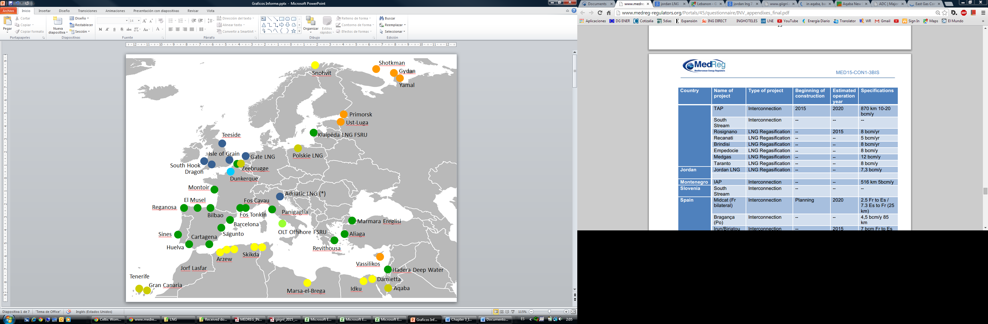***Existing and under construction Planned /FID not adopted yet***

Planned/FID not adopted yet

Under Construction – Exempted

Regulated

Exempted

Initially Exempted – renunciation to exemption

Under Construction / Regulated

Existing Liquefaction

Liquefaction Planned or Under Construction

(*) 80% of the capacity is exempted, the remaining 20% is subject to rTPA

Source: GIE

***Figure 8: Cross-border capacities in the Mediterranean Region***

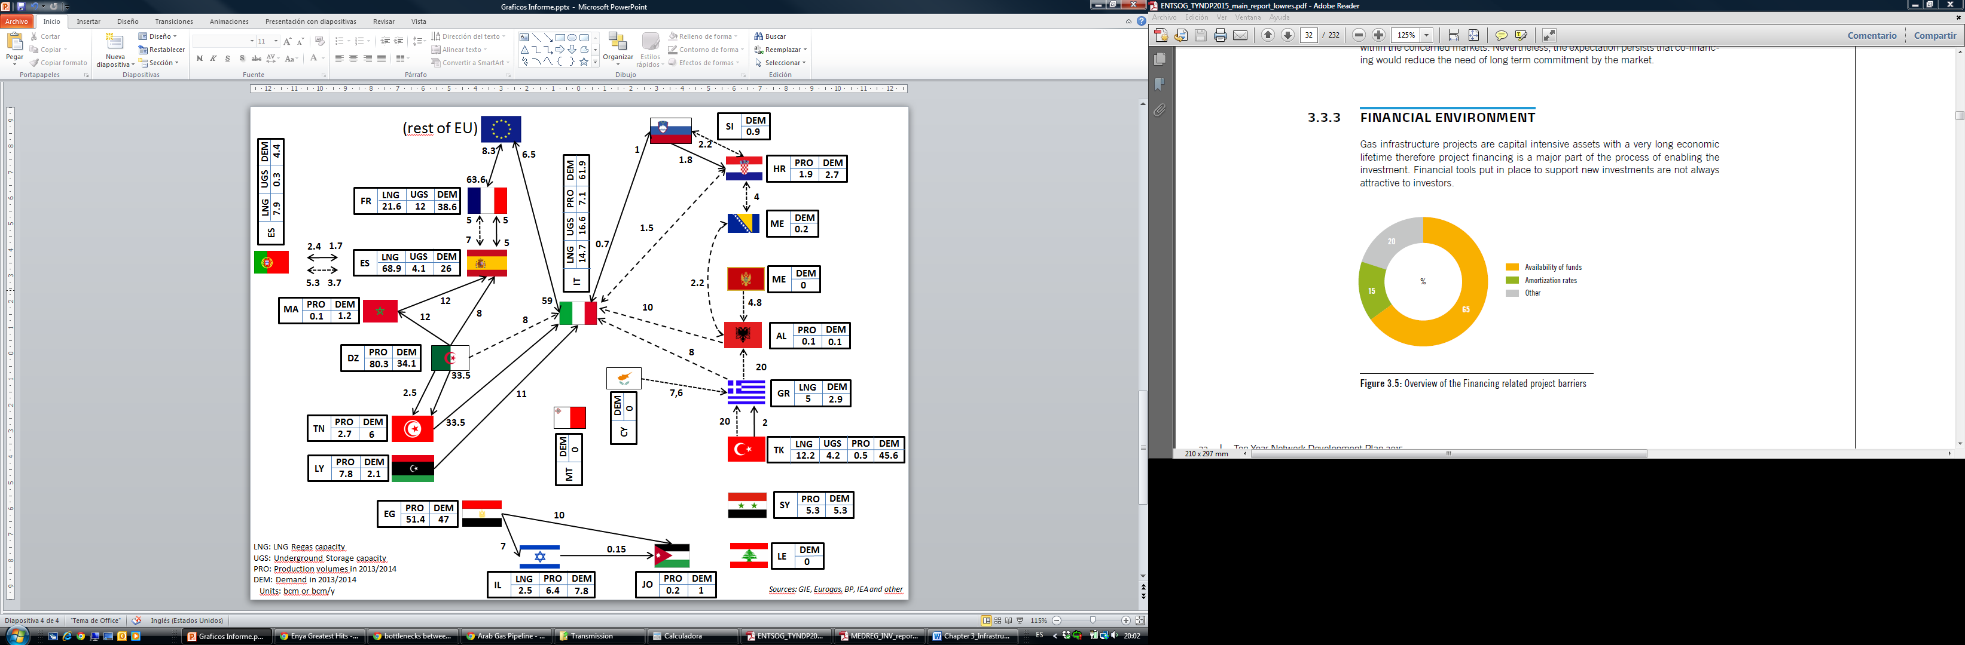

## 3.2. Storage in the Euro Mediterranean Region

Underground Gas Storages were firstly developed in those countries which are dependent on gas imports as a way to buffer gas during summer in order to have it available during winter time. Nowadays, underground storages not only ensure security of supply and continuity of gas deliveries, but they also provide flexibility, offer possibility for arbitrage and help for gas system optimization.

The Euro-Mediterranean region has currently 153 underground storage facilities, which offer more than 112 bcm of operational working gas volume, 2124 Mm3/day of withdrawal capacity and 1179 Mm3/day of injection capacity.

In terms of types of storages, the region presents a large majority of depleted fields (73.1 bcm working gas volume), and similar amount of Salt Caverns (18.2 bcm) and Aquifer (19.4 bcm). These facilities are mainly in the European countries, while South and East Mediterranean countries have not developed these facilities yet.

There are two main types of storage facilities that operate in the storage market in Europe:

* *Seasonal storage*: these facilities are traditionally larger and can be constructed from depleted gas fields or saline aquifers. They are characterised by having large capacity compared to their injection and withdrawal rates. As such, they are traditionally used to meet “seasonal swing”, i.e. participants inject gas to the facility during low demand periods in the summer and withdraw in the winter, thus their primary storage cycles tend to be annual. The primary driver behind the value of this type of storage is the summer-winter (price) spread.
* *Fast-cycling storage*: storage facilities which tend to be smaller and have higher injection or withdrawal rates fall into the category of fast-cycling storage. Unlike seasonal storage, these facilities offer much shorter storage cycles and thus primarily take advantage of shorter term price differentials, e.g. weekday/weekend spread, in addition to providing some more traditional seasonal products. This allows these types of facilities to play an active role in balancing.

The booking of storage capacity and the utilisation of that capacity depends on several factors:

* European Demand: as highlighted earlier, there is uncertainty regarding European consumers’ future gas needs. However, trends in recent years indicate a decline in European demand. Fast-cycling storage is ideally positioned to facilitate more flexible outputs from gas-fired power stations. However, if the seasonal fluctuations in industrial and domestic demand continue to decrease, the picture for seasonal storage is not as clear.
* Storage capacity evolution: storage capacity in the EU has increased by more than 20% since 2009.
* Flexibility market: Gas storage competes with other sources of flexibility (e.g. production, line-pack, LNG, etc.)
* Summer-Winter spreads: due to the situation in the previous mentioned points, the trend in recent years has been for a decline in the summer-winter spread.

The outlook for the storage market is not clear in particular as long-term forecast for gas demand remains uncertain. The demand flexibility will likely recover in the future, largely based on a new role for gas-fired power generation as a source to enable the integration of variable renewable power generation. In addition, implementation of the Network Code on Gas Balancing in Transmission Systems will ensure that shippers are responsible for balancing their inputs and off-takes from the system. This will introduce a shift towards more short-term flexibility, and potentially an opportunity for fast-cycling storage because network users need to balance their portfolio on a daily basis.

As regards future investments and new projects in the region, the GSE Map shows that new projects are currently under construction totalling 7.6 bcm. Additionally, 32 bcm of new storage capacity has been announced, but given the uncertainty surrounding the evolution of the winter-summer spread, it is difficult to forecast how many of those projects will be finally built.

As regards storage utilisation, the data provided by GSE through its AGSI+ platform shows a comparative of filling/emptying curves during the whole year.

***Figure 9: Actual Filling Levels in Gas Storages (%) – EU 28***

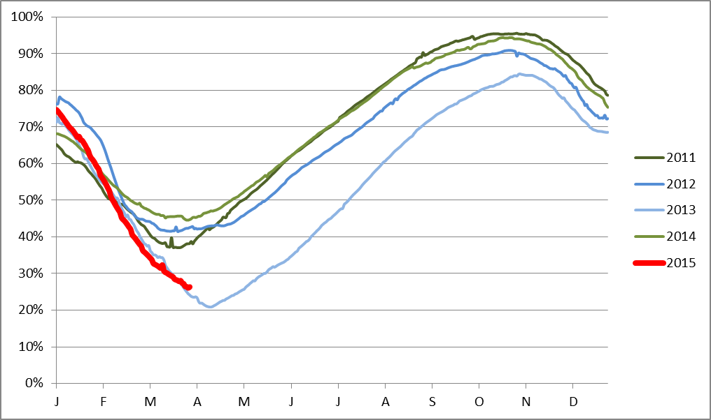

Source: GSE (AGSI+)

In 2014, gas storages in Europe had high filling levels (>90%) due to high levels already present in March 2014 (mild winter 2013-2014). Although last winter has been relatively average (even warm), still significant high withdrawal rates have been observed during the whole period, not justified by temperature, and it has resulted in storages ending the winter with lower storage filling levels than usual. The filling levels vary from year to year significantly depending on various factors in the wholesale market. The low summer-winter spreads continue to be the main commercial driver to store gas. If this summer-winter spread remains low as in previous year, the commercial development of storage market in Europe might remain uncertain.

Moreover, in some EU Member States, some storage capacity is dedicated only to cope with emergency situation. This is the so called “strategic storage” permanently stored underground, used to compensate for either the lack/reduction in internal gas supply or gas crisis and hence contributing to the security of supply of the country. It can be used only under authorization by the Government and only when the commercial storages have been fully used.

## 3.3. Pipelines in the Euro-Mediterranean Region

Natural gas is of critical relevance for the overall Mediterranean energy trade. While Middle East and North African countries (including neighbours of the Mediterranean countries, as discussed in section 2.4) are among the world’s leading gas producers, European countries are counted among the greatest consumers. As a consequence, the Mediterranean basin has the potential to become the marketplace where these two significant amounts of supply and demand meet.

While the geographical form of the Mediterranean Basin is that of a ring, gas trade did not develop circularly, as it happened for electricity trade. The lack of east-west gas interconnections geographically divides the Mediterranean into three separate corridors or zones: Western Mediterranean, Eastern Mediterranean and Central Mediterranean.

Thus, there are vertical, not horizontal, gas trade links in the region, which mark four separated trade zones. A regional market stretching from Algeria through Spain to Portugal and France creates the Western gas trade zone. In the Central Mediterranean, Italy, interconnected to the Balkan countries, is both a transit and consumer country. The two main producers of this zone are Algeria and Libya.

The Eastern Mediterranean, on the other hand, is fractured into two other zones. In recent years, Egypt has been the main exporter in the south-east, with lines linking it to Jordan and Israel, but is currently a net importer of gas.

To the North, Turkey and Greece show potential as transit countries in the region. They also have potential to serve as hub in their region. However, it seems that currently this potential cannot be fully exploited, as far as the right gas infrastructure (including transit and interconnection pipelines) is not in place.

Physical integration between the different zones could improve security of gas supply in the region as a whole. However, even if found to be economically feasible, the construction of pipelines to link the zones would not seem possible without a substantial improvement in political and security conditions in Libya and Syria.

**Western Mediterranean Region**

In the Western Mediterranean, a regional gas market exists among Algeria, Morocco, Spain, Portugal and France. Algeria is the single exporter to the Moroccan gas market, and it is one of the dominant suppliers to the Iberian Peninsula, while some Algerian gas could potentially reach France through Spain although in limited quantities. Algerian gas is transported to the Iberian Peninsula via two separate undersea transmission lines. The oldest one is the 1,620 km Maghreb – Europe Gas Pipeline (MEGP), operational since 1996 connecting Algeria to Morocco, Spain and Portugal. It has a capacity of around 12 bcm per year. A recent project, MEDGAZ, has come into existence in 2011. The 210 km MEDGAZ sub-sea pipeline directly links Algeria to Spain and transports 8 bcm gas per year. The Spanish gas network operates as the transmitter of Algerian gas to Portugal and France via four bidirectional interconnections. The Tuy and Badajoz interconnections link Spain to Portugal and both of them together are considered a virtual interconnection point. Both markets can be considered fully integrated from a physical point of view. The Irun and Larrau interconnections are directed towards France and its capacity has been recently increased thanks to the success of two open season processes.

However, President Juncker and the leaders of France, Spain and Portugal have agreed on 4 March 2015 the way forward to better connect the Iberian Peninsula with the rest of the EU energy market. The parts recognised that gas interconnections are essential to achieve a fully integrated gas market, eliminating bottlenecks, connecting the regional markets, maximizing the diversification of the gas portfolio through new sources and routes, reinforcing the negotiating capacity and increasing the European security of supply. In this sense, the President of France, the Prime Ministers of Spain and Portugal, agreed on the need to actively asses the completion of the Eastern gas axis between Portugal, Spain and France, allowing bigger bidirectional flows between the Iberian Peninsula and France through a new interconnection project currently known as the MIDCAT which would allow the entrance of Mashreq gas and LNG to continental Europe. The 3rd Portugal-Spain interconnection should be developed in accordance. In order to ensure this commitment, the new High Level Group for South-West Europe is expected to assess by October 2015 the compatibility of the MIDCAT project, the national plans and the EU security of supply needs and whether it allows delivering bidirectional gas flows between the Iberian Peninsula and the French gas systems through the Eastern axis.

Once market integration between France and the Iberian Peninsula is enhanced, additional gas would be able to enter the Northern and Central Europe from the Western Mediterranean through the capacity to be developed by France at its Northern borders. From 2015 to 2020, three new interconnections will be built at the French borders with Belgium (8.5 bcm/year), Switzerland (3.2, bcm/year) and Germany (3.1 bcm/year). Additionally, a new interconnection project between France and Belgium is expected to start operations in 2015 with an annual capacity of 8.5 bcm.

**Central Mediterranean Region**

In the Central Mediterranean region, the two gas suppliers are Algeria and Libya. Italy, on the other hand, is the main consumer of this corridor. Slovenia, Croatia, Bosnia and Herzegovina have relatively smaller gas markets. Montenegro, Albania and Malta currently have no gas consumption. The main gas artery of the central Mediterranean is the Transmed pipeline which starts from Algeria, passes through Tunisia and reaches Italy. This line, active since 1983 (doubled in 1997) and with a capacity of 33.5 bcm/year, is largely underutilized due to commercial reasons, linked to price formula renegotiations.

Another submarine pipeline is the Greenstream pipeline connecting the onshore Wafa field and the offshore Bouri field to Italy. The 550-kms-long pipeline transports 11 bcm/y. Due to the political turmoil in 2011, the pipeline was shut down, reopening shortly after. Italy also imports gas, via pipeline, from Northern Europe and Russia through interconnections with Switzerland and Austria.

In the Balkans, Slovenia and Croatia are part of the regional gas trade as Slovenia has a bidirectional flow with Italy and Croatia is connected to Slovenian network. However Bosnia and Herzegovina is not connected to regional countries. The majority of its gas is imported from Russia via Serbian border. The other two Balkan countries, Montenegro and Albania, have not yet developed gas infrastructure and they do not currently consume gas.

Various ongoing projects have the potential of diversifying trade routes and sources, eliminating bottlenecks and introduce natural gas to non-gas consuming countries through the region. Italy strengthens its central position with new submarine pipelines. The Galsi project (Gasdotto Algeria Sardegna Italia) would allow Italy to introduce gas to the Sardinia island (as well as to the French island of Corsica) and import an additional 8bcm/year gas from Algeria through a direct flow. This project is expected have a length of 861 km.

Two more submarine pipeline projects are under consideration in the Balkans.

The Trans-Adriatic (TAP) project, whose construction is scheduled to start in 2016, will transport gas from the Caspian Basin to Italy, as an extension of Trans-Anatolian Pipeline (TANAP)[33] passing through Turkey. The TAP will be 870 km long (Greece 545 km; Albania 211 km; Adriatic Sea 105 km; Italy 8 km) and have a 10 bcm/year of capacity (with the possibility of being expanded by 10 bcm/y in a second phase). The project will start operations in 2020 on the condition that the Azeri Shah Deniz 2 project and the TANAP Project are simultaneously realized.

The IGI-Poseidon pipeline should in turn bypass Albania and directly link Greece to Italy. The Poseidon project will be designed to transport over 8 billion cubic meters of natural gas per year. However, while the TAP project gets pace, the future of the Poseidon project is linked to other supply route realisation in the Eastern Mediterranean area.

The Balkans are interested by two additional projects: Ionian Adriatic Pipeline (IAP) and the Bosnian interconnection with Croatia. The IAP will be 516 km long and will connect Croatia and Montenegro with Albania. It shall have a capacity of 5 bcm/year. The Bosnian interconnection with Croatia, still in its projection phase, has been part of the Balkan gas ring project and will enable Bosnia to diminish its dependency from the Russian gas. The role of the Energy Community in identifying PECIs (Projects of European Community Interests[34]) and in promoting them remains essential.

The assessment of one hundred projects submitted as candidates resulted in 35 PECIs being identified in the region. From those 35 energy projects, 10 are corresponding to gas projects (8 pipeline projects and 2 LNG terminal projects).

**Eastern Mediterranean Region**

The Eastern Mediterranean regional market is not complete. The two main gas markets in the region, those of Egypt and Turkey, are not interconnected.

Turkey is the most interconnected country. It imports gas from Russia, Azerbaijan and Iran and gets LNG from different entry points. However, Turkey’s current exit capacity is limited, as it has only one export point with Greece. The interconnection between these two countries does not allow large amounts of gas to flow (less than 1 bcm annually). This limited capacity makes Greece currently captive as far as pipeline is concerned to gas coming from Russia via a single entry point from Bulgaria. Therefore improvement of the exit points and interconnection of TANAP not only with TAP pipeline but with other pipeline projects is of vital importance. Studies for Turkey-Bulgaria Interconnector (ITB) project are also ongoing. This project could also contribute to the energy security of Europe. In this regard, The EU Member States’ decision to support the ITB project under the funding programme called “Connecting Europe Facility” (CEF) and the recent decision which included the Project among priority energy infrastructure projects in Europe are important steps.

Until recently, Egypt has been the main natural gas supplier for the rest of the region, through two branches of pipelines. One of them goes to Israel, while the other passes through Jordan, Syria and ends in Lebanon. The lack of alternative sources and routes sets a barrier to the increase of gas trade in the region as well as to security of supply.

An essential step to eliminate trade barriers could be completion of the Arab Gas Pipeline and the construction of a connection between Syria and Turkey. This would not only allow Egyptian gas to flow to Turkey, but also enable other regional countries to import gas from the Caspian basin.

Other Turkish investment projects include the Iraqi interconnection and TANAP. The latter, due to connect at the Greece-Turkey border to TAP, is projected to transport gas from the Shah Deniz field in Azerbaijan to Italy via Greece and Albania.

Newly found gas resources in the Eastern Mediterranean offshore and potential for further discoveries, are expected to introduce a significant amount of gas into regional trade. There are several options to export gas from the offshore fields in the region to foreign markets. These options include building one or more of the following infrastructures: LNG liquefaction plants, a pipeline to Egypt, pipeline to Turkey or to Greece. The 1700 km-long East Mediterranean Pipeline (Israel-Cyprus-Greece-Italy) known as EastMed pipeline project with a capacity of 8 bcm/year could link Israel and Cyprus to European gas markets.

Based on the existing gas quantities and the current economic environment, the regional pipeline option from Cyprus to Egypt seems currently to be commercially the most viable option. This will consist of a FPSO standalone unit at the Aphrodite field connected with a pipeline directed to Egypt and a gas pipeline supplying natural gas to the Cyprus domestic market. Similarly, gas from Tamar and Leviathan could be directed to Egypt. Another project regarding marketing of the Israeli gas is the pipeline from Israel to Jordan.

The other ways through which East Mediterranean gas could supply the wider Euro-Mediterranean Region could be, westward via Egypt and Libya to Italy (which would require construction of a new section to link the pipeline network in western Egypt to that in eastern Libya) or east and then northward via the Arab Gas pipeline (if this is extended across Syria to Turkey, as has been foreseen in the past). All of the pipeline options mentioned here currently face geopolitical challenges as well as uncertainty about their economic feasibility.

**Potential integration of the different Mediterranean zones**

Pipeline links between the different zones could improve security of gas supply in the region as a whole, because it could enable major gas supply sources to have more than one possible route to the major sources of demand. As discussed above, the Algerian gas network already supplies both Spain (Western Mediterranean zone) and Italy (Central Mediterranean zone). This actually represents a degree of physical integration between the Western and Central Mediterranean zones, since a change in the volume of supply via the Algerian network could in principle affect either (or both) of these zones. This already strengthens security of supply in the two zones, as a supply shock in one zone could be absorbed by both.

In contrast, there are no pipeline links between Egypt and Libya nor between Syria and Turkey: consequently, the effects of supply changes in the eastern zones have to be fully absorbed by the countries concerned. Thus the current shortage of gas supply in the South-Eastern zone is not being ameliorated by supplies from/via the Central or North-Eastern zones. The lack of pipeline links between the zones also prevents them from becoming transit states for gas supplies from some of the world’s leading gas producers to the European market. However, the development of such links would not seem possible without a substantial improvement in political and security conditions in Libya and Syria.

## 3.4. Identification of potential bottlenecks

The UfM Gas Platform (Platform) was created with the aim of promoting gas trade in the region, by making optimal use of the existing infrastructure, and by identifying projects which could be labelled as Projects of Euro-Mediterranean Interest (PEMIs), similarly to the PCISs (Projects of Common Interest in the EU) or PECIs (Projects of Energy Community Interest).

In line with this target, the Platform working group has considered appropriate identifying potential bottlenecks in the region where investments would be most needed in order to increase gas trade, flows, security of supply and liquidity in the Euro-Mediterranean region, while simultaneously enhancing connectivity not only North – South, but also South-South.

In general, it is considered that there is a bottleneck between two networks if a price convergence between their spot gas prices is not observed. In the absence of contractual congestions, existence of bottlenecks is mainly attributed to insufficient[35] physical pipeline capacity between those two networks. However, when producing countries enter into the study, bottlenecks between producing areas and consuming areas can be identified assuming the highest production scenario and checking whether the existing capacity is able to transport the expected flow rates towards the consuming areas.

In this sense, the following table shows a very basic analysis of where bottlenecks could be located. This analysis is based on the principle of “If entry much higher than exit = potential bottleneck”. This principle means that if a given country has a large entry capacity (from LNG and/or producing countries via pipeline), but its exit capacity towards neighbouring countries is not big enough, then, there could be the situation when the given transit country would not be able to evacuate all the inflows received, and it would become “de facto” a bottleneck country.

Under these assumptions, and being in need to define some quantitative criteria, it was proposed to conclude that a country could be a potential bottleneck country if: Entry Capacity (pipeline, LNG and production) – Exit Capacity – National Demand > 100% [36] National Demand.

***Table 1: Potential Bottlenecks in the Mediterranean Region***

|  |  |  |  |  |  |  |  |
| --- | --- | --- | --- | --- | --- | --- | --- |
| **Country** | **Entry Capacity (Pipeline)**  **[bcma]** | **Entry Capacity (LNG) [bcma]** | **Exit Capacity [bcma]** | **Actual Demand [bcma]** | **Production [bcma]** | **Excess Capacity = EnCap – ExCap – Demand + Production** | **Is Excess Capacity > 100% of Actual Demand (Yes/No)**  **Potential Bottleneck (Yes/No)** |
| **Where? (entry or exit)** |
| France | 68.6 | 22 | 13.3 | 38.6 | 0 | 38.7 | Yes; Yes; at the border with the northern and central Europe as well as with Spain |
| Greece | 5 | 5 | 0.5 | 2.9 | 0 | 6.6 | Yes; Yes (in theory); the fact that Greece has no exit points is by itself a potential bottleneck. No physical connection with the Italian market (and other more liquid markets of the CEE EU) and therefore no possibility for a commercial flow from Italy to Greece and even to Turkey renders spot gas price convergence between Italy and Greece (and Turkey) impossible. |
| Israel | 7 | 2.5 | 0.15 | 7.8 | 6.4 | 7.95 | Yes; Yes, at the exit. Israel would need more exit capacity. |
| Italy | 104.2 | 14.7 | 7.5 | 61.9 | 7.1 | 56.6 | No |
| Spain | 20 | 68.9 | 5 | 26 | 0 | 57.9 | Yes; at the exit with France and rest of Europe |
| Turkey | 46.6 | 12.2 | 2 | 45.6 | 0.5 | 10.7 | No |

Source: Internal analysis, based on data provided by GIE (capacity), Eurogas (demand), IEA and others.

Based on this principle, and taking as input data the existing infrastructure, assessment has been performed for a number of countries located in the Mediterranean region, which could be labelled as “Potential Bottleneck Country” (PBC). These PBCs would be strong candidates to carry out investments, which could remove the bottlenecks, eventually resulting in a higher integration, enhanced trading and delivering a more beneficial situation for the whole Euro Mediterranean region. Six transit countries receiving gas from producing areas (i.e. Algeria, Tunisia, Egypt and Azerbaijan) towards the consuming markets (e.g. European market) have been analysed following the above mentioned formula. The results are shown in the table below.

## 3.5. Investment barriers

Natural gas infrastructure is a long-term capital intensive business which is highly exposed to uncertainty due to the long period of times required to recover the investment. As a result, investors and project promoters try to avoid uncertainty as much as possible.

In order to better understand the current regulatory barriers, two surveys have been conducted: one survey among the MEDREG regulators and another survey among project promoters having submitted projects to ENTSOG for inclusion in the TYNDP 2015. The results of both surveys are publicly available. The first survey is part of the MEDREG report on interconnections, and the results of the ENTSOG survey constitutes as chapter of the ENTSOG TYNDP 2015-2035.

**MEDREG survey**: For MEDREG regulators, the three main barriers to investment are the “insufficient market demand”, “financial feasibility of the project” and the “lack of internal reforms”.

***Figure 10: Relevant investment barriers identified by the MEDREG Regulators***

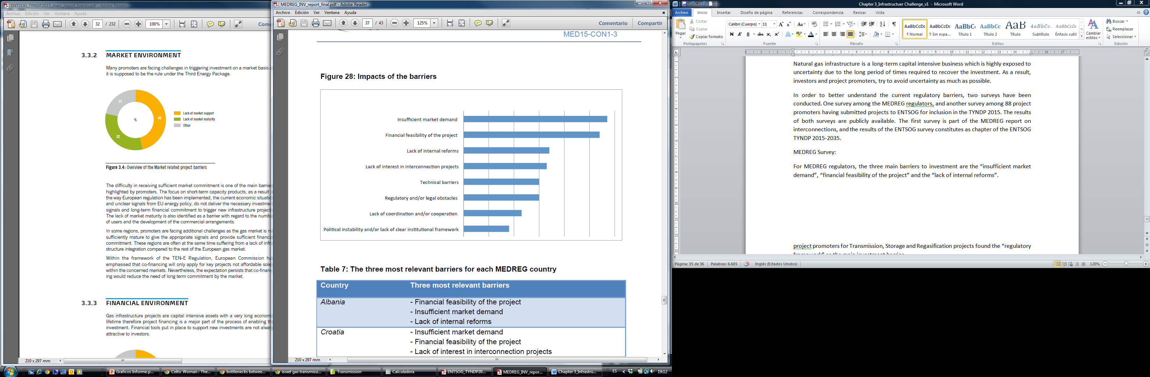

Source: MEDREG

The MEDREG Regulators also provided insights on barriers associated to investments under the different Mediterranean regulatory frameworks.

These barriers are the following.

* + **Lack of transparency**: Mediterranean energy markets are mainly managed by state owned monopolies that influence prices and trading conditions. For this reason, foreign investments tend to be discouraged by scarce information on market prices, conditions and available transmission capacity.
  + **Low levels of investments and involvement of private sector:** the recent economic crisis has hindered new investments. They are however needed, especially for existing infrastructures, in order to fully exploit the available transmission capacity.
  + **Fragmented legal and regulatory framework:** energy legislation substantially vary from country to country, although the optimal condition for national market would be to have cross-border interconnections.
  + **Significant subsidization:** in some non-EU Mediterranean countries consumers tend to rely on subsidized domestic prices, without any market mechanism in place.
  + **Unclear institutional architecture at national level:** regulators, TSOs, operators and other actors should cooperate with clear distinction of roles at national level. Sometime considerable conflicts of interest occur, heavily affecting the credibility of the country face to foreign investors.
  + **Lacking regulatory incentive mechanisms:** some Mediterranean countries have no effective methodologies for costs evaluation, thus affecting investment plans for new infrastructures.

**ENTSO-G survey on investment barriers:** Eighty eight project promoters, covering projects in transmission, storage and regasification, were consulted about the investment barriers in Europe. They found the “regulatory framework” as the main investment barrier.

For many project promoters, the regulatory framework is perceived as not being appropriate to ensure the delivery of new infrastructures even when they have been identified as necessary to complete the integration of the European gas market.

The level of rate of return is perceived as a major obstacle. Setting the level is exclusively subject to the national regulatory regimes but should encourage long-term investments with a reasonable rate of return. If the rate is too low or not sufficiently stable over long periods of time, then investments will be put at risk and consequently the completion of the internal gas market. The setting of the rate should fairly reflect the risk involved. It should strike the right balance between the benefits of further market integration and the impact on transmission tariffs which represent a moderate share of the wholesale market price of gas.

The practice of applying incentives, such as premium rates of return for higher risk projects, has already been adopted by some Member States.

As part of the Framework Guidelines and Network Code processes on Capacity Allocation Mechanism and Harmonised Transmission Tariff Structures for Gas, NRAs have allowed low priced short term capacity products and quotas, measures which have not been fully supported by TSOs.

Other aspects which have been pointed out by the investors as major investment barriers refer to “Market Environment”, “Financial Environment” and long and difficult “Permitting” processes.

***Figure 11: Combined overview of projects, as submitted by investment barriers***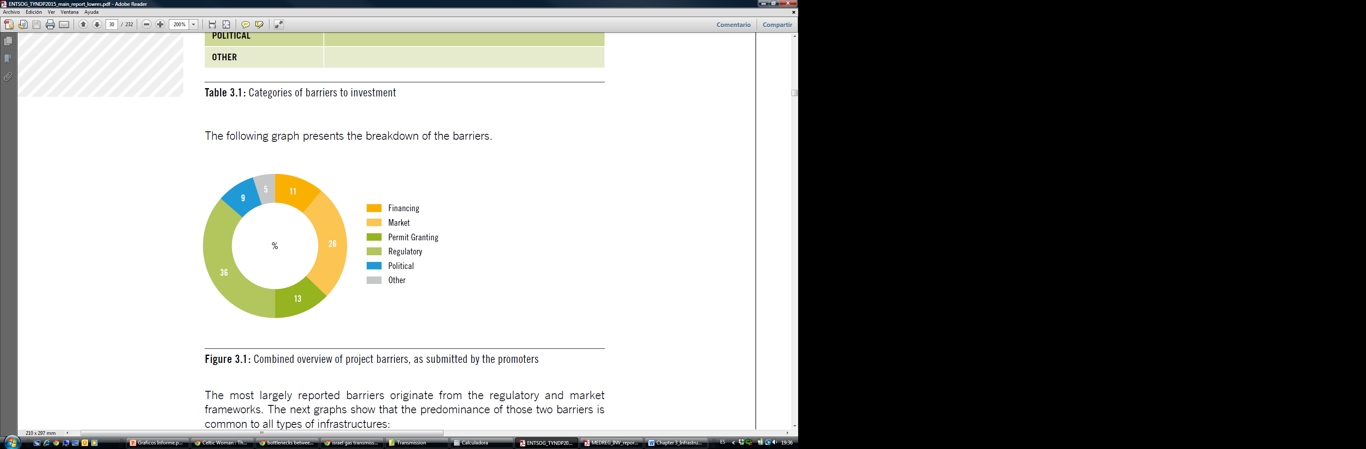

Source: ENTSOG TYNDP 2015-2035.

As regards “Market Environment” project promoters are referring to the difficulty of receiving sufficient market commitment. Gas infrastructure is a long-term capital intensive business, where assets are depreciated over a long period (>40 years. The focus on short-term capacity products, as a result of the way European regulation has been implemented, together with the current economic situation and unclear signals from EU energy policy, might not deliver the necessary long-term financial commitments to trigger new infrastructure projects. The lack of market maturity (gas penetration and liberalisation) is also identified as a barrier with regard to the number of users and the development of the commercial arrangements.

# 4. A Euro-Mediterranean gas hub

## 4.1. Characteristics and requirements of different gas hub models

Despite nearly 20 years passing since the British gas market liberalised and some 15 years since the EU published its first Gas Directives, there is still confusion in some parts of Europe as to what a ‘gas hub’ actually is. Confusion over whether a hub is an actual geographical location (terminal, flange, processing plant, compressor station etc.) or a virtual place often, but not always, a country’s gas grid network; this is what is also often referred to as an Entry/Exit zone or Market Area. This report will focus on the commercial or financial, virtual, trading hub.

The first prerequisite for the development of a liberalised wholesale market and a successful traded hub is to ensure that the industrial, commercial and residential markets are fully liberalised; this creates competition at the retail end and encourages the end-user to demand more competitive pricing. This in turn will lead to the wholesale sector requiring and using traded hubs in order to satisfy the risk management of their portfolios and that will lead to the market suppliers also using the wholesale markets in a competitive fashion.

The contracts used in the gas market tend to be standardised, meaning that all contracts are the same except for delivery period, quantity and price. They can be traded bilaterally or on exchanges but they are all essentially the same. This is important because standardisation concentrates liquidity, liquidity attracts volume, volume attracts traders and together they help create a successful hub.

In Britain, the NBP is a notional point, effectively the whole National Transmission System (NTS) and was ‘invented’ to permit the balancing mechanism of the Network Code, where Shippers nominate their buys and sells and where the Transmission System Operator (TSO) can balance the system on a daily basis. This was the first system of its kind and was also the first virtual trading point for gas in Europe. Several years later, the Italian PSV and the Dutch TTF virtual hubs were closely modelled on the NBP.

The NBP rapidly evolved as a trading point too as traders had confidence in buying and selling gas on a standardised basis at the most liquid point, in the UK's high pressure transmission system, the NTS; this is in stark contrast to the ‘old world’, where gas was mostly traded at the Entry Points. The NBP was used as the basis for the standardised “NBP’97” trading document, the cornerstone of the UK OTC traded market and subsequently became the delivery point for the ICE futures natural gas contract. In Continental Europe, the EFET contract has become the standard trading contract in traded gas markets.

The principal features of trading gas at the NBP are that deliveries are for ‘flat’ gas[37], that participants are ‘kept whole’[38], that in practice there is no Force Majeure (FM)[39] and that there are standardised billing and payment terms. Some but not always all of these features are also included in some of the European hubs. The only FM permissible would be an event beyond the control of the affected party resulting in the inability to get a trade nomination into or accepted by Gemini, the TSO’s nominations system. These features are what instilled confidence in traders and led to the success of the NBP as a traded gas hub.

All of the gas hubs in Europe are ‘balancing’ hubs: these are used by Shippers to balance their portfolios near to and at maturity and by the TSO to balance the gas grid, usually on a daily basis; the ‘trading’ hubs are additionally used by Shippers to risk manage their portfolios, often up to 3 or more years in advance. The more mature and successful hubs are both balancing and trading hubs.

The process leading to such mature and successful hubs can be described as being a ‘path to maturity’ as shown in Figure 1. The development of a liquid hub takes time, commitment and, as history has shown us in North America, Britain and now North-West Europe, can cost a lot of money too.

***Figure 12: Hubs development ‘path to maturity’***

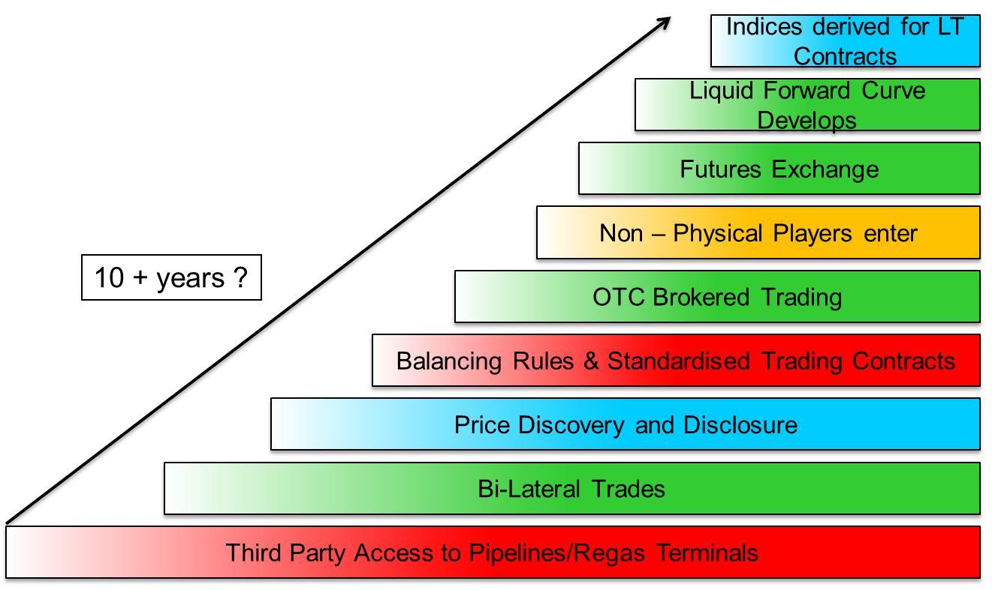

Source: H.Rogers (OIES)

Based on the time it took for the North American and British markets to transition from the ‘old world’ to the new, it can take 10-15 years or more and this is now proving to be the case in Europe. It also requires the commitment of governments, suppliers and system operators to achieve a smooth transition; furthermore, a market that has indigenous production and/or is well supplied by competing sources of gas, is likely to achieve the goal more quickly and become more successful.

The process usually starts with a move to Third Party Access (TPA) to the network infrastructure, often accompanied by legislative changes forcing incumbents to release volumes and incentivising independents to enter the market. There will also be the adoption of rules and regulations governing the physical side of the business, whilst the emergence of standardised contracts will favour the commercial aspects. This will then be followed by bilateral trading, often aided by the first brokers helping to create trading opportunities between counterparties and whose trades start to be reported in the trade press, thus creating the beginnings of a transparent market. With price disclosure comes price discovery which in turn attracts more players to the market, often at this stage smaller physical traders and the first tentative moves by financial players too. The creation of exchange products (futures), based on the underlying physical contracts gives a greater access to the market, especially by non-physical players who will always close out their trading positions before maturity.

Gradually, as more and more different and varied participants come to trade a particular market, a forward curve will develop and this will be used for risk management purposes; the final stage of maturity is when a given market develops sufficient liquidity that traders start to use certain defined products (such as the Day Ahead or the Month Ahead) as indices to price their physical transactions.

There are five main requirements that lead to successful trading: they are liquidity, volatility, anonymity, transparency and traded volumes.

1. Liquidity is a measure of how easy it is to trade volume at a given price without ‘moving’ the market. Standardisation tends to concentrate liquidity in one product.
2. Volatility is a measure of price movement in relation to market activity. Historically, financial markets have high liquidity and fairly low and consistent volatility, whereas energy markets are typically very volatile yet may also be very liquid. They are sensitive to external information.
3. Anonymity is the ‘corner stone’ of futures trading. The Clearing House is the counterparty to all trades and this allows both ‘big’ and ‘small’ participants to trade alongside each other.
4. Market transparency is very important in the development of a successful traded market. It means that traded volumes and prices are quickly disseminated in the public arena and this openness gives traders added confidence in the market in which they are trading. Indeed, the importance of accurate, reliable and timely market data cannot be understated, whether this is official government statistics on energy consumption, TSO data on physical flows or capacity auctions, broker or exchange information on volumes and prices. There is very good data availability in Britain and the Netherlands but many of the other European countries are still far behind, although there are signs of improvement.
5. Traded volumes simply relates to the total actual volume traded in any given market; this could be the OTC volume or the exchange volume or the split between spot and curve but in all cases refers to the total traded in each category.

The usual reason for trading in the spot and prompt contracts is to physically optimise or balance a portfolio at, or just ahead of, delivery. The curve is usually used to financially optimise a trading portfolio for hedging or speculative purposes. Most trading activity takes place in the prompt and near curve, with the most popular contracts being WD, DA, MA[40] and the front two seasons. There is activity too in the mid-curve, especially because of spreads between seasons, although beyond three years activity is far less, primarily for credit reasons.

The length of time forward that it is possible to trade is known as the ‘curve’. This traded curve covers the spot, the prompt, the near, mid and far curves:

* Spot refers to today or tomorrow;
* Prompt refers to all other periods within the month and the next month;
* The near curve covers the first two seasons;
* The mid curve covers out to about two years forward;
* The far curve is everything beyond that, currently up to about five years forward, although it is possible to get quotes as far out as 10 years in some European gas markets (mainly NBP and TTF).
* The spot and prompt contracts cover days or groups of days such as Within Day (WD), Day Ahead (DA), Balance of Week (BOW), Weekend (WE), Balance of Month (BOM) and the Month Ahead (MA) contract, also known as the first or front month. The ‘curve’ trades in months, quarters, seasons and years (both calendar and gas year).

There are some other differences between OTC and Exchange trading:

The OTC market has evolved in a standardised way in which trades are conducted in ‘clips’ or multiples (of 25,000 therms per day on NBP and ZEE; of 20MWh per day on the Continent) in one of several clearly defined time periods (as detailed above). This allows for ease of trading, greater transparency and inevitably greater liquidity, and form the backbone of the brokered market today. These deals can be traded over the phone, or more commonly nowadays, by electronic media. Despite the standardisation of these contracts and their popularity, it must be remembered that these are still bilateral contracts and therefore still hold counterparty credit and performance risk.

The Exchanges are regulated markets where traders are secure in the knowledge that these markets are governed by the relevant financial regulator in each country and that the clearing also financially guarantees all of the trades executed. Exchange trading has gained in popularity since the financial crash, although the market penetration is very different from country to country. The European Exchanges that offer gas contracts are: ICE, ICE-Endex, EEX, Powernext, CEGH and GME.

***Figure 13: Diagram of the “routes to market”***

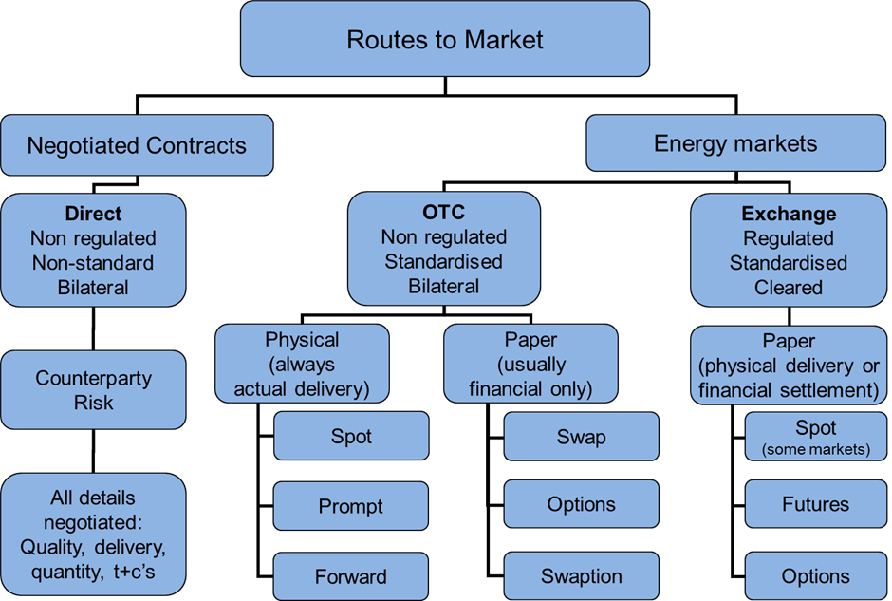

Source: P. Heather, The Evolution and Functioning of the Traded Gas Market in Britain, Oxford Institute for Energy Studies, August 2010.

Having established the path to maturity, it is also necessary to examine and understand why one would need or want to trade before actually setting about transacting. There are several reasons why a company would want to trade: to buy or sell gas to balance a physical portfolio; as a financial hedge; or as speculation. This in turn will determine which route to follow, as shown in the diagram in Figure 13.

The reason for trading will determine which route to follow: through the regulated or non-regulated markets; through the “paper” market or the physical market; using a bilateral contract or a cleared contract. The instruments of trading vary from the bilaterally negotiated traded contracts to the OTC standardised physical deals; from the futures market and other cleared transactions to financial trades such as swaps; finally there is the possibility on some markets of trading options, either cleared or bilateral, physical or financial.

## 4.2. The importance of gas contract price formation

The history of the development of gas and its introduction directly led to the commercial structure of the gas markets around the world, a structure which was replicated when natural gas substituted town gas in the 1960’s: the town gas markets were originally very local, some later becoming national; the introduction of natural gas initially simply replaced town gas using the same business model, namely one of ‘cost plus’. In the commercial and industrial sector, the arrival of natural gas opened up a new customer base that invariably was using Gas Oil or Fuel Oil as a fuel; this necessitated a new approach to pricing the commodity, one of ‘competing fuel price minus’. This approach was very successful and natural gas quickly gained market share, although when looking from a wider commercial perspective, the individual markets were quite small, usually remaining within national borders and only sometimes with cross border arrangements (of course from an infrastructure viewpoint, transit pipelines were built but ‘physical balancing’ was strictly a national issue).

The pricing structure for gas saw the first signs of change in North America when their gas market started to liberalise in the 1970’s; 40 years later and despite having a very successful benchmark hub, Henry Hub, the overall gas market has a complicated structure: there are a total of 33 Market Centers/Hubs and traders have to ‘wheel’ gas shipments from hub to hub, sometimes as many as 5 or 6 or 8 in order to get gas from a supply point to its final consumer market. The process of liberalisation took nearly 20 years to become a regulated competitive market, and then, only truly liberalised at the wholesale level. Most American wholesale gas supplies are priced against the Henry Hub marker, although downstream there are still several States that operate regulated pricing structures.

In Europe, the process of change followed two very different courses: that of Britain’s privatisation and Continental Europe’s liberalisation. In Britain, the change from the old world to the new was primarily due to the need of Mrs Thatcher’s government in the early 1980’s to balance the Exchequer: in a series of privatisations of nationalised industries, British Gas was the second company to go through the process. This was a lengthy process of transformation which took 15 years and was ‘painful and costly’ to most participants[41]. However, today, Britain has a fully liberalised, established and successful traded gas market which has reached maturity and has a very successful benchmark hub, the NBP. All of Britain’s gas supplies are now priced against the NBP marker, whether they are contracted or traded supplies. The whole market is liberalised, both at the wholesale and retail level.

Continental Europe’s liberalisation of the energy markets was driven by the EU’s political ambitions to create a fair market for all consumers and this it instigated through Directives part of ‘Energy Packages’[42] that also included reforms to the electricity markets. The process of transformation started in the late 1990’s although the first real signs of change were only in the mid 2000’s and only in Western Europe; there is still much to do, especially in Eastern Europe and it now looks likely that the whole process will also take some 15 or so years to complete, just as it did in both North America and in Great Britain. However, in Western Europe, the Dutch TTF hub has now established itself as a marker hub and there are even plans for regional hubs in Central Europe and South Eastern Europe.

The pricing of Continental Europe’s gas supplies is still undergoing the process of transformation. The historical Long Term gas Contacts (LTCs) are in turmoil and, in the words of the CEO of a major wholesaler[43], need to be “re-engineered”: oil indexed pricing has not reflected market fundamentals for quite some time now and the recession and a period of gas over supply have made this situation untenable.

Indeed, the real catalyst for change came in 2009/10: the recession of 2008-09 led very quickly to a major downturn in demand for gas across Europe, followed in the autumn of 2009 by the commissioning of the two Qatari LNG import projects in Europe[44] which then saw large volumes of LNG being imported, especially into the British South Hook terminal. Across the Atlantic, the shale ‘revolution’ in the US reduced North America’s LNG import requirements, such that cargoes of LNG previously destined for the US were diverted mainly to Europe; also, in the same period, there were several other large LNG export projects coming to market such as the Tangguh, Yemen and Sakhalin liquefaction plants, that added to the wave of surplus gas.

Combined, these four factors created a mini gas ‘bubble’ in Europe. At the same time, world oil prices were recovering from early 2009, leading to a marked increase in the price of oil-indexed LTC gas coming in to Europe from summer 2009 onwards. Finally, there were two significant German legal decisions that galvanised the change in attitude towards traded gas markets and to gas hubs in Continental Europe: already in June 2006, the higher regional court of Dusseldorf had upheld a Federal Cartel Office decision declaring that long term contracts between E.On and its distributors were illegal and imposed limitations on the duration of any future supply contracts; then, crucially, in March 2010, the German Federal Court of Justice declared that prices for natural gas for private clients were no longer allowed to be immediately linked to the price for heating oil[45]. These two pieces of legislation, along with vociferous complaints by industrial users and their ability to purchase spot gas at the hubs are key factors which caused the German end-user market to open up.

The change in attitude towards trading across Europe has been primarily a ‘bottom up’ demand for change, but there are signs that some sellers are also prepared to change. GasTerra has publicly said[46] that it was responding to its customers’ demands for more market pricing and that it has therefore agreed with many of them to change the point of delivery from the ‘factory gate’ to the TTF hub. It went on to show how it is supporting both the hub and its customers by the role it is playing in helping make the TTF more transparent and liquid; it is doing this by offering products on the TTF market where it is also acting as a Market Maker[47], as well as offering its customers products using TTF indexation.

This is a significant change in attitude towards gas trading as it comes from a Dutch company selling Dutch gas. The Dutch were the first to market natural gas in the 1960s and the ones who ‘invented’ oil indexation as a means of marketing their new product. That is why it is so important that it is GasTerra that is now committed to selling its production on the TTF or on contracts priced at the TTF hub.

Of the other gas suppliers in to Europe, Norway is already selling a large proportion of its gas at hub prices[48] and is well placed to embrace a pan-European market-priced environment as and when the change occurs. LNG is sold both at hub prices and on contracts with pricing formulae, depending on where it is landed and who the seller is, but will most probably migrate towards the ‘norm’ of hub pricing if and when that happens. Russia has been arguing the merits of oil indexation but, in reality, has been willing to adjust its contracts to reflect hub prices and the latest analysis shows that the average Russian selling price to European buyers is within 5% of hub prices[49]. The last stumbling block to moving fully towards a market priced situation in Europe is Algeria, which is for the time being holding out for the ‘traditional’ oil-indexed contracts.

The markets are changing then and this is a consumer led change. To be successful, this will require robust and reliable marker prices. To be credible, a marker or benchmark hub must have good liquidity from spot to several years forward, as well as being fully transparent and fully open and accessible to a wide range of participants. There is evidence that the pricing structure of European gas markets is finally changing: two independent analyses[50] have shown that, already in 2013, the estimated split of European gas supply between oil indexed pricing and market pricing tipped over in favour of market pricing by 51% to 49% during the year and by the end of that year had reached 57% to 43% in favour of market pricing; this is a trend that has continued to 2015 as more LTCs are re-negotiated to include a greater portion of market pricing, or are the subject of arbitral decisions in favour of including a greater element of market pricing in the formula or simply in the out-turn price.

Very different price formation mechanisms operate across different European regions: north west Europe is clearly dominated by hub-pricing, but only 15% of gas is sold at hub prices in the Mediterranean region (virtually all of which is in Italy) and none in south east Europe. Half of central European gas is priced at hubs but still 35% in relation to oil.

There is further evidence that the move to market pricing is not spread across all of Europe in the same way: in late 2013 the Financial Times newspaper ran an article[51] on European gas pricing in which they quoted Statoil’s Eldar Sætre[52] on the company’s response to market liberalisation. He explained that “all of its German contracts and nearly all its UK, Dutch and Belgian contracts now reference prices at regional gas hubs” and further explained that “progress has been slower in modifying contracts for supplies in to eastern and southern Europe, where hubs are less well developed”. Statoil’s changing approach to selling its gas to European consumers clearly follows the development of the hubs in each of their consumers’ countries.

How long the transition to fully liberalised, commercial, hub-priced gas markets will take to complete is uncertain: it will take time and it will be costly, as it was in North America and in Britain, but competition will mean that gas-to-gas pricing will ultimately prevail. Successful, liquid traded gas hubs will provide the ability to price and risk manage physical supply contracts: this is already the case with the British NBP and the Dutch TTF; in the future, it is possible that a third European hub will develop to help price and risk manage supply contracts to those regions.

## 4.3. Organisation of the gas market in the region

There has been much progress in the development of the European gas hubs but there are still some very important hurdles to overcome before to have efficient, successful and mature gas markets that can provide a reliable price reference for contracted gas supplies. The three main areas of concern are liquidity and transparency; physical connectivity; political willingness and cultural attitudes.

In order to reassure traders and encourage them to participate in a market, which in turn will help develop market liquidity, there must be full transparency. Where this is a problem in the European gas markets is in the quality of the available data and its timeliness: there is often a lack of common methodology, such as in the reporting of gas flows which can be in volume or in energy; some data is very easily accessible, such as British and Dutch physical flow volumes, some far more difficult, such as German physical flow volumes. Data can be had on a near real-time basis for both the British and Dutch markets, on the TSO websites, but again, far less easily and with far greater time delay for say, France or Belgium or Germany and indeed, for most of the southern and eastern countries. Finally there should not be any financial or administrative penalties in obtaining physical or trading data for the gas markets.

The physical infrastructure across Europe does need to be strengthened to allow for better physical transportation of gas but also to prevent constraints that in turn will distort prices. Each single entry/exit Market Area must have daily balancing and in order to provide this the infrastructure must be sufficiently resilient yet flexible enough to allow the balancing agent to fulfil their role. This requires de-bottlenecking and in some cases also increasing capacities. It is a costly process[53] that takes time and in some cases, the cost/benefit analysis can be very poor resulting in project delays or indeed projects not receiving financial approval. This is the major reason given for not merging the two German Market Areas into one[54] but, inevitably, the result is a less than perfect system for both the consumer and also the gas market itself. There are nonetheless ways round this last hurdle, namely ‘market coupling’ where two adjacent Market Areas have financial agreements to combine the two areas financially but not necessarily physically; this has already been done between the Dutch grid and the German Gaspool grid, with the coupling being offered and managed by the Gas Transport Services (GTS) TSO in Holland and its sister company, the Gasunie Deutschland TSO in Germany.

Finally, graphs do not show the ‘culture’ behind the data. There are very differing attitudes across Europe to both the liberalisation of the energy markets and to trading in particular. This applies to both political and commercial attitudes; what is certain is that in the only two mature traded gas markets in Europe, Britain and the Netherlands, there exists a political willingness to have liberalised markets, there is a long history of trading and all the market participants have embraced the traded market. There is a distinct pattern going from the north-west to the south-east, from the Anglo-Saxon and Scandinavian to the Slave and Latin regions of Europe.

The political willingness is a crucial factor in seeing change in the structure of the gas markets; this was clearly demonstrated in Britain when the Thatcher government had decided to implement a series of privatisations of nationalised industries and had to make these work in order for their policy to be successful. A completely different example is that of the Dutch government which decided in the mid-2000’s to implement their “Gas Roundabout” [55] strategy which, despite the TTF having been established a few years previously but had not really attracted any trader interest, very soon kick-started that hub to become today Europe’s second largest traded gas hub.

As with the British example, it was the politicians who had a vision that they strongly wanted to implement; this involved passing laws to make sure that change was effected. A further example is that of Austria: as in the Netherlands, the Austrian government and regulator pushed for reform of the network and for changes in commercial practices. After thorough consultation with the industry and discussion, the parliament voted through a new Austrian Gas Act[56] in October 2011. Since its implementation and the start of the new VTP hub in January 2013, there have been noticeable improvements to the liquidity of that hub.

The important difference with other countries that did also pass various laws to instigate a liberalised gas market, is that only a few countries actually persevered and made sure that the new laws were being enacted and followed. In others, such as France and Belgium, very little change actually happened to the gas market despite some superficial changes in regulations etc. In Italy, there was no real development for an effective commercial and liquid PSV gas hub until very recently, almost ten years after the hub was first established in 2003.

As well as the political will to put in to place the right laws and to see that they are observed, it is also very necessary for the market participants, from incumbent energy companies, to wholesalers, to distributors and even to the commercial and residential end users, to ‘want’ to follow the new commercial environment – indeed, they should ideally want to embrace it and to try and push it further to a ‘higher’ level still. This is where Britain and Holland have found it quite easy to succeed because, once the incumbent supplier/energy company was forced to relinquish its dominant position, then they and the rest of the value chain very quickly changed the way in which they approached the market and realised that it would be to their benefit to embrace trading.

It should also be noted that those countries with indigenous production have been at a distinct advantage in making the change to liberalised, commercial markets. North America has always had a high level of gas production and is now self-sufficient since the expansion of shale gas recovery; Britain experienced a boom in gas production in the 1990’s just as the internal market was going through its transformation from nationalised industry to a liberalised, competitive market; the Netherlands was Europe’s first major natural gas producer and exporter and still today produces nearly double its demand; and, Romania has the possibility of becoming the first country in eastern Europe to make the transition from a highly regulated national gas sector to a more liberalised one as its production is expected to increase from 8 bcm/y to 12 bcm/y later this decade, against a demand of around 10bcma – the surplus is what should help encourage a more commercial environment.

This doesn’t mean to say that other countries across Europe cannot effectively make the same move but it does mean that the process may take longer and might be more difficult. Sometimes there needs to be a catalyst for the change in attitude and in the case of Romania, it is probably that of the gas find in the Black Sea that could make the country not only self-sufficient by the end of the decade but even have a surplus for export. Another factor that could be a positive influence on developing a South-East European hub is the abandonment by Russia of the South Stream project in favour of a new Turkish Stream which would, potentially, deliver upwards of 40 bcm of gas at the Turkish/Greek Border after 2019.

***Map 1: European gas regions, markets and hubs***

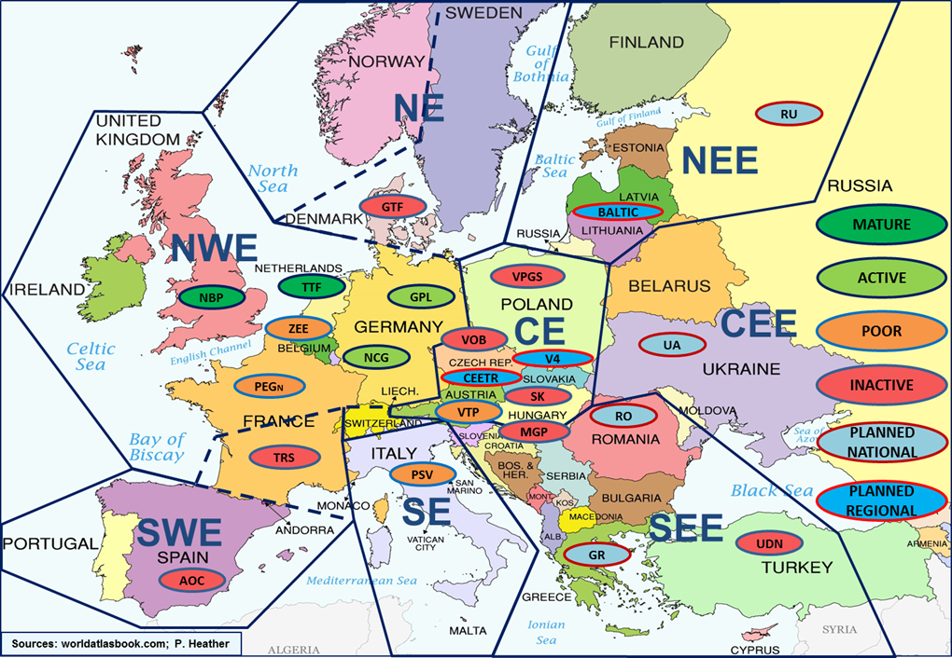

Source: P. Heather, The Evolution of European Traded Gas Hubs, forthcoming Summer 2015.

Europe is not one homogenous gas market, neither in infrastructure nor in political desire to change. The most developed part of Europe in terms of liberalised gas hubs is in the North-West but this is also the one with the most disparity between the ‘mature’, ‘poor’ and ‘illiquid’ hubs; the Central European region is the one showing most promise for further development over the coming years, both in infrastructure and in market development; most of Eastern Europe is still heavily dependent on Russian gas supplies, arriving through the historic network of ‘transit’ pipelines: their local gas networks are generally poor and there is a major need for better north/south connectivity.

The British NBP was the first European gas hub, which started trading in 1996 although it did not ‘catch on’ until the spring of 1997. It soon attracted all types of participants from producers to wholesalers to consumers, as well as financial players too. Within the first year, there was an exchange futures contract which also grew rapidly. This market exceeded a 10x churn within just a few years and, by 2001, the churn had reached about 20x. Despite a trading lull in the mid-2000’s, volumes have steadily grown on both the OTC and exchange markets and there are today a record number of active participants, estimated at about 140. NBP is the predominant European gas hub; it has the attributes of a successful hub: full transparency, easily accessible, with good liquidity and volume. It does occasionally ‘suffer’ in relation to its Continental neighbours, due to physical constraints and also to the fact that it trades in pence per therm. NBP was the first and still is the premier European gas benchmark hub.

The Dutch TTF started in 2003 but for several years did not trade very much. It was only when there was a real political emphasis to develop the Netherlands as the ‘Gas Roundabout’ of Europe that this hub started to take off, slowly at first in around 2007 then with the first of several ‘step changes’ in 2009. Progress was firm from 2009 to 2011, with traded volumes rising by over 62% year/year, from an average of 28.5bcm/mth in Gas Year 2009, to 46.3bcm/mth in Gas Year 2010, to about 50bcm/mth by the end of 2011[57]. After a second ‘step change’ increase in traded volumes in 2012, and a third in 2014, the TTF today is slightly more than half the size of NBP in total traded volumes. As with the NBP, the TTF has very good transparency and accessibility, good liquidity and is attracting an ever greater number of participants, estimated in 2013 at around 90 active. In the past year or so, it has become the second European benchmark hub and is priced in €/MWh.

Germany has today two Market Areas and two hubs: the NCG and the Gaspool (GPL) both of which started trading in 2009 but this has not always been the case: due to its historical gas structure, comprising 19 zones and having two major pipeline systems, progress has been slow, even after a period of rationalisation from 2009 to 2011. In 2010 the gas market areas in Germany were reduced to 3 high calorific gas and 3 low calorific gas zones; in 2011 there were two further changes, the first implemented on the 1st April, reducing the number of zones to three: 2 H-cal and 1 L-cal, then on 1st October, the last merger was effected, creating the current situation of a 2 Market Area system: Gaspool and NetConnect Germany, each with both high and low calorific gas networks which are still being balanced individually. The costs of energy conversion are expected to be ‘socialised’ by 2016.

The German set-up is quite different to the rest of NWE, whereby both the NCG and the GPL are each run by 6 TSOs. The proposed final merger, of NCG and GPL, has become a very political issue and the regulator, BNetzA[58], has stated[59] that it would see the increased benefits of a unified system but that for now was leaving it up to the TSOs to decide if/when to proceed – all 12 of them. If the German market cannot unite into one Market Area, this could be a major stumbling block preventing a German hub from becoming the Continental European gas price benchmark.

However, there are signs that things might be improving for these two hubs in 2014 but it is still too early to confirm. The traded volumes are dominated by the spot/prompt trades, although there has been an increase recently in near and mid-curve trading. As mentioned before, it is unlikely that the two grids will merge and this, in part, is what is holding this market back. The recent increase in volumes and in curve trading, in Q1-2014, is in part due to large quantities of Russian gas now being ‘traded’ at the Gaspool hub and in spreads between GPL and either NCG or TTF.

The Belgian Zeebrugge (ZEE) hub is a misnomer: it is actually a trading point, which started trading in 2000, the second gas hub in Europe. There has also been a virtual hub in parallel since 2012, the ZTP. Neither hub is particularly large although the Zeebrugge physical point is the one with the most trading, all OTC. Although volumes have grown a little they are mainly based on balancing needs of the shippers and/or spread trading between ZEE and either NBP or TTF.

France now has two Market Areas and two hubs: PEG Nord and TRS[60]; Nord has the majority of the traded volumes. The growth seen in late 2011 and 2012 has since slowed right down and, despite a brief success in financially linking the Nord and Sud hubs through an exchange spread contract, the price differentials between the hubs has widened again. These price differences are primarily due to infrastructure constraints and a general imbalance in market participation between the hubs, i.e. less liquidity in the TRS hub. There are plans approved by the French government to increase the N/S capacities thereby removing the physical constraint but this project has yet again been postponed[61] due to the financial crisis. Of all the European hubs, the PEGs have clearly become ‘balancing’ hubs with any risk management being done at the TTF through spread trading.

Austria was like Belgium in that they had a very important Trading Point, Baumgarten, named after the village near to the import processing plant on the Austrian/Slovakian border. The import terminal itself is vast[62] and is owned and operated by Gas Connect Austria[63]. Approximately one third of all Russian gas supplies to Western Europe come through Baumgarten for onward transportation to Germany, Italy, Slovenia and Hungary, as well as for supplying the national market. The CEGH hub started trading in 2005 and in fact offered trading at 6 locations across Austria of which Baumgarten was by far the most important and the one that registered the most trades.

However, since 1st January 2013, following the implementation of the Austrian Gas Act, they created a virtual trading point, the VTP for the Eastern Market Area (Austria’s two other Market Areas are independent of each other and of the main Eastern Area and are each linked to and supplied by the German NCG grid). The VTP is showing signs of improvement, albeit quite slow and again, most forward trading is the result of spreads with either the TTF or the NCG markets. Austria is also in discussions with two of its neighbours, Czech Republic and Slovakia, regarding the development of a Regional hub, the Central East European Trading Region (CEETR), although this project is developing very slowly indeed;

There is also a parallel competing project, called Visegrad Four (or V4)[64], to create a regional hub comprising the Czech Republic, Slovakia, Poland and Hungary but, so far, progress has been slow.

When Italy announced the formation of the PSV, in 2003, there was great hope amongst the gas trading fraternity that this could be the beginning of truly pan-European trading. The Italian Network Code for gas is almost identical to the British one, although entry capacity is not as flexible. However storage is on an open access basis and in fact all gas entering the system goes through the PSV. However, only a very small percentage of all that gas is actually traded at the hub and, until very recently, the National incumbent, ENI, did not trade at the PSV at all.

However, things have started to change: on the positive side, there have been a number of changes recently that have already made a difference and which might allow the PSV to develop in the future, including the new balancing regime, conducted through the PB-Gas contract on the GME trading platform[65], which started 1st December 2011 and has been producing rather benign cashout prices, the result of which has been that traded volumes of PB-Gas increased nearly 5-fold in the first three months[66]. Further proposed changes should help secure trader confidence; in Gas Year 2009 the TAG pipeline was upgraded by 6bcma and that extra capacity was bought by about 100 shippers[67]. The pipe operator has now started to offer on its website[68], since 1st March 2012, day ahead capacity auctions, usually making available some 50-60mcm/d of which about 15mcm/d are being bought. This has naturally led to price convergence of PSV towards the Austrian VTP and the other European hubs and indeed, the spread between the two hubs is now running at or close to the short term marginal cost of transportation which is in the order of €2/MWh. There appears to be a new political will emerging to see the PSV develop as a southern Europe market hub but it is still too early to say whether this will indeed occur.

The Czech VOB[69] hub is in the very early stages of trading but the Spanish AOC and the Danish GTF[70] barely trade nowadays. However, the AOC is expected to develop thanks to the start of operation of a gas platform. In addition, it has the aim to become a regional gas hub (Iberian gas hub) with the integration of both the Portuguese and Spanish gas markets in the near future. All other hubs in Europe are still at the planning stage.

An important consideration when comparing traded markets and in evaluating their relative success is to look at the products available to trade (Table 2) and to note where along the traded curve[71] the volumes are being effected. This is important as only risk management hubs are likely to become benchmark hubs providing market prices and only benchmark hubs are likely to be able to provide risk management products – a virtuous circle but one that can be seen in other commodities across the world: liquidity attracts liquidity which in turn makes a market successful, increases its churn rate and allows it to develop into a ‘mature’ market able to provide reference prices.

***Table 2: European gas hubs: traded products in 2014***

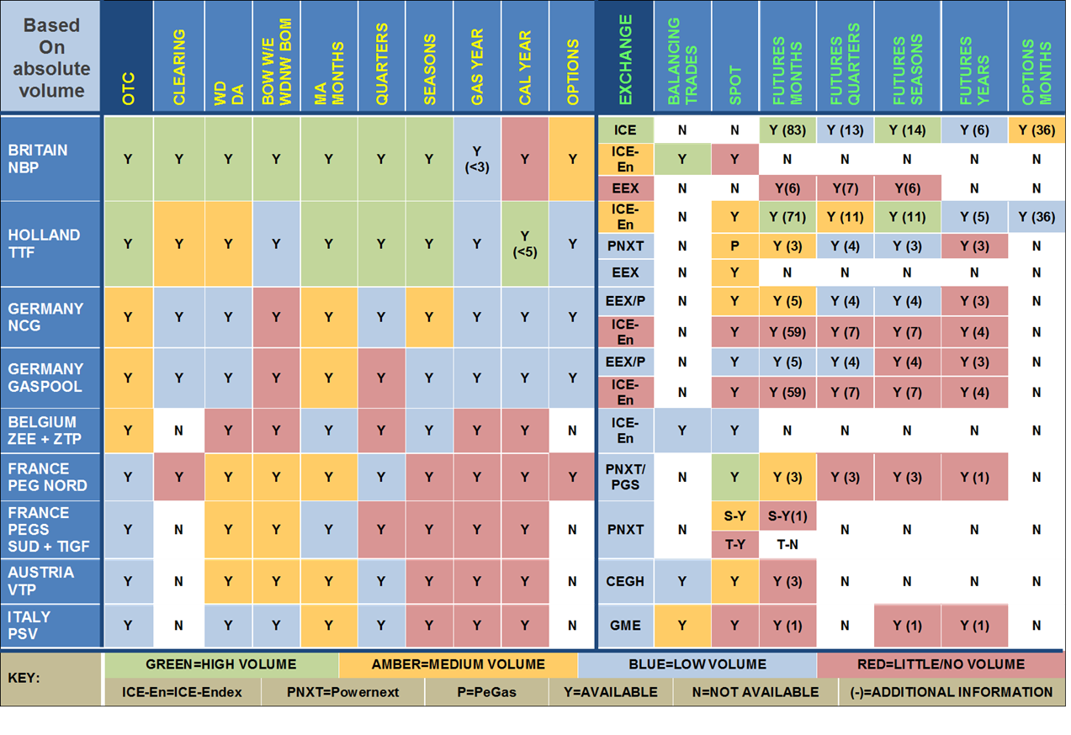

Sources: OTC: LEBA members; various participants; Exchange: ICE ; ICE-Endex ; EEX ; Powernext ; CEGH; GME; P. Heather

*NOTE A*: Additional Information relates to the number of contracts available in each exchange category / contracts traded in OTC.

NOTE B: GME offer both a trading platform and an exchange: PB-Gas trading platform for balancing trades (good volumes but not strictly speaking “PSV” trades); P-Gas trading platform for bilateral spot and forward trades (trades a little); MT-Gas exchange market for futures trades (does not trade at all).

The traded products table is interesting as it shows the different types of product that are available to trade and a guide as to their ‘popularity’ in each of the hubs (shown by the four colour codes); it is divided between the OTC market to the left and the exchange market to the right. Although it is possible to trade all along the curve in the OTC market in each of the European gas hubs, in reality only the NBP and TTF trade in any quantity beyond the Month Ahead contract and they do so up to about 3 years forward, with the German hubs now starting to trade medium volumes up to 18 months ahead. The Austrian and Italian markets struggle to trade any sizeable volume beyond the spot/prompt, despite the occasional trades in the near Quarters and First Season contracts.

On exchange trading, the differences across the hubs is even more stark: again the NBP and TTF hubs trade regularly across the curve, although in exchange trading the NBP contracts have been a roaring success, attaining 52% of the total traded volumes in 2014, with the TTF reaching 15% and the other hubs’ exchange volumes forming just a very small part of the overall total. The exception to this is the French PEG Nord exchange volumes which account for just over 25% of the total; however those volumes are almost exclusively in the prompt with very little trading along the curve. Finally, options contracts are available and do trade on both NBP and TTF but are not traded on any other hub. These products are favoured by the financial participants, especially the banks and hedge funds and again are usually only traded in mature markets that have good liquidity and transparency.

Another factor to consider when comparing different markets is the price correlation between them (see Figure below) and the occurrence of anomalies, indicating potential physical or other constraints. It must be noted that price correlation means prices move in the same direction at the same time by about the same amount; it does not mean ‘same price’. In the north-west European gas hubs, there has generally been very good price correlation over the past few years, with a few notable exceptions:

* The Italian PSV which prior to April 2012 had been as much as €10/MWh dearer than the average and was not correlated either. As mentioned above the PSV price narrowed in to the European average after TAG pipeline capacity was made available in daily auctions but since spring 2013 it has deviated once more, being on average €2/MWh dearer than the other hubs, reflecting the marginal cost of transport.
* The Austrian CEGH/VTP which is influenced by both its German and Italian neighbours and has periods of non-correlation, usually at a dearer absolute price.
* The biggest differences though are the Spanish AOC and the French southern hubs of PEG Sud and PEG TIGF. This is due to the fact that these two markets are largely supplied by LNG as well as having poor connectivity with the northern European hubs. This situation results in dearer absolute prices and quite a poor correlation.

In absolute traded volumes terms, the NBP is approximately 50% bigger than the TTF and the TTF is approximately 3½ times as big as all the other hubs put together. The OTC markets dominate across the traded hubs overall but exchange trading is rising fast, especially at the NBP where it now accounts for 52% and at the TTF where its share is 15%. In the last two years NBP has lost market share to Continental hubs, in particular TTF, where Continental players prefer to trade in €/MWh and where they can now risk manage their physical portfolios when they used to do so previously at the NBP; TTF has gained risk management trading from the NBP and also from other Continental hubs; German and French hubs have lost curve trading to TTF; German and French hubs are focused more on balancing, not risk management (although this is now changing in Germany);

***Figure 14: NWE/CEE/SE hubs price correlation, Month Ahead contracts: 2012-2014***

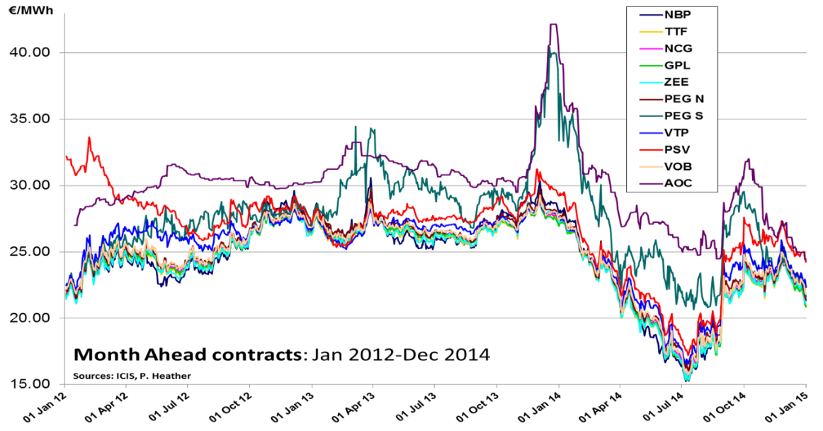

Sources: Heather (2015)

Throughout 2014, traded volumes increased across all hubs except for Zeebrugge; there has been a slight increase in volatility which has attracted more speculators; NCG and especially GPL are showing a marked increase in curve volumes, indicating more risk management trading; exchange volumes have continued to rise, to record levels on NBP and on TTF; options volumes increased further on both NBP and TTF to 11% and 4% respectively of total exchange trading. After a brief dip in traded volumes in 2013, these have risen once more.

Two important measures of a gas hub’s commercial success are the Tradability Index and the Churn ratio.

The second is the multiple of traded volume to actual physical throughput: a measure of the number of times a ‘parcel’ of gas is traded and re-traded between its initial sale by the producer and the final purchase by the consumer. Commodity markets are deemed to have reached maturity when the churn is in excess of 10 times.

The ICIS Tradability Index is a measure of how narrow the bid/offer spreads are across the trading curve, indicating good liquidity; it is calculated by ICIS and reflects the ease with which a market can be traded and therefore is an indication of market confidence and its maturity. It is not in itself an indication of a deep, liquid and transparent market but it can assist the analysis of the development of a traded hub, in conjunction with other metrics. For the result to have any indication, you need to look firstly at the progression of the Index over time, then at the actual number: a result below 16 is not very meaningful, whereas a result of 18 or above does indicate that the hub in question does have reasonable liquidity. The Tradability Index shows[72] that the NBP has been at the top (19/20) for over 5 years and that the TTF joined it in the last 3 years; NCG is third with a score of 15 and GPL is just behind at 13, whilst all the other hubs are struggling with a mediocre score of 7-11.

The churn rates are a much better measure of a hub’s real liquidity and success and are a parameter used in most commodity and also financial markets. Gas has a peculiarity in that there is something called ‘transit gas’ which historically has or has not been included in official statistics, including demand figures and even in some cases physical throughput volumes (Eurostat did not include Transit gas in some countries’ physical demand volumes until very recently and there are still statistical anomalies!). A further complication is that for some Market Areas, the TSO or Regulator publishes churn figures which do not seem to be comparable to other countries’ figures; this is usually because they quote ‘trading’ volumes obtained from the TSO database as opposed to using market data from brokers or the trade press; this completely distorts the result.

For these reasons two different methodologies for each of the hubs are calculated: the Net Market Churn is the EU definition[73] of total trades/physical consumption[74] at the hub; the Gross Market Churn is total trades/total demand[75] (i.e., throughput including exports) as, theoretically, all gas in the system could be traded and so, ultimately, this is a better indication of the trading activity in each Market Area. For some countries like the Netherlands in particular this methodology more than halves the churn rate from ‘net’ to ‘gross’ but even so the TTF gross churn stands at a very good 14.75.

It is also worth mentioning a word regarding the traded volumes component of the Matrix: the development of the gas hubs throughout Europe can readily be monitored by the ever-growing volumes of gas being traded at the hubs both in the OTC markets and on the exchanges[76]. Generally the OTC markets are still dominant, with the exception of Britain where the exchange element has grown significantly in the past few years; indeed, all of the European exchanges have been instrumental in helping develop the markets by offering new products on ‘easy to trade’ electronic platforms.

The total traded[77] volume is made up of the OTC volumes, the exchange futures and options volumes and the exchange spot volumes, for each of the hubs; the physical volumes are obtained from official sources for both the gross and net figures; the net traded figure is calculated as described above. The first column shows the amount of OTC trading at each of the hubs, although any ‘cleared’ element is left out as the true total cleared volumes will be shown with the Exchange figures. The next column shows the total futures and options volumes as reported by the various exchanges; these totals will also include any intra- and inter-market spreads as appropriate; the volumes relate to all trades of a maturity including and beyond the Month Ahead contracts. Options are only available to trade at the NBP and the TTF, on the ICE and ICE-Endex platforms respectively. The exchange spot volumes column contains all the trades at each of the hubs[78] for maturities of less than one month (such as Within Day, Day Ahead, Weekend, Working Days Next Week, Balance of Month, etc.).

The results for some selected hubs clearly show the rankings of the traded gas hubs in Europe. When ordered by Gross Market Churn, the NBP is way in front in the high teens, followed by the TTF at just under 8. From there it is a big drop to the next hubs, the Belgian Zeebrugge with a Gross Churn of just 2.26 and the German hubs together showing 2.13. The last three European hubs have a Gross Churn of less than 1. The rankings are the same when looking at the results of the Re-trading Ratio although these are here simply to illustrate that the results for say Belgium, Germany and Italy are very similar to those published by Fluxys, BnetzA and Snam. They are not however ‘true’ churn rates. The results using the EU definition of total traded volume against the consumption in the hub area, or Net Market Churn, show that in 2014 the TTF at 36 times was actually higher than the NBP (26x) and that both markets are at more than two to three times the recognised level at which a hub is deemed mature and way above the minimum of 15 quoted by Gazprom at industry conferences as being the level they recognise.

***Table 3: European gas hubs churn rates, selected hubs: 2004 – 2014***

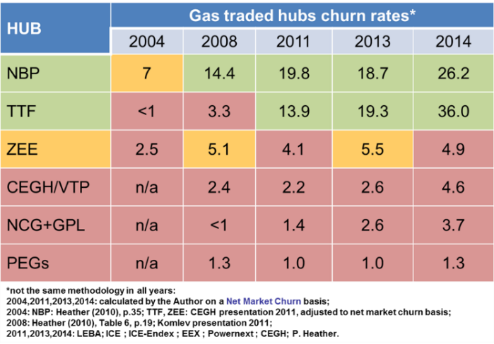

Source: Heather (2015)

From all the results, whichever methodology is used, it is clear that there are only two ‘mature’ hubs in Europe in 2014, the British NBP and the Dutch TTF and this dominance has continued and strengthened in Q1-2015. These are likely to remain leading benchmark hubs in Europe, the NBP a Sterling contract used to price all the gas for the British Isles and some LNG supplies; the TTF a Euro contract used to price gas for delivery to north-west Europe and for LNG supplies. Further down the line another European hub is feasible to price gas delivered to southern and/or eastern Europe, although this could still be done using either the NBP or the TTF, with price adjustments to allow for transportation and other factors. European gas hubs already do and will continue to provide a reliable reference price for contract gas deliveries and risk management purposes.

## 4.4. The prospects for a gas hub in the Mediterranean region

There is no doubt that the European Commission does wish there to be a Mediterranean Gas Hub[79] and this was clearly expressed in a statement by Maroš Šefčovič who said[80] that “the establishment of a Mediterranean gas hub is necessary”. In this section we will explore the need for such a hub as well as the true prospects of it developing.

When considering the possibility of a Mediterranean gas hub (MGH), it is necessary to review the physical gas infrastructure in both the Mediterranean countries and their connectivity with the remainder of the Union, as well as the current and future supply/demand situation for gas across all of Europe.

Geographically, there are only a few areas in the European Union that come to mind when considering a MGH: Spain, France, Italy and Greece. Of course, there could also be a more regional hub, especially in South-East Europe, which might include Greece, Bulgaria and Romania. Finally, one should also bear in mind that Turkey, although not in the EU, does border with Greece, does export gas to Europe through Greece, has a large and rising gas demand and could be a transit route for Russian, Caspian and in due course East Mediterranean gas flows.

The Iberian Peninsula receives a high proportion of its supplies from LNG deliveries to one of seven import terminals spread all around the coastline and has a well-developed internal gas grid. The recent increase in capacity at the Larrau as well as the Biriatou cross-border IPs together with the expected merger of the balancing zones within France will allow higher onward transportation of gas north or east within the Union.

France has a serious north/south capacity constraint in its national gas grid which can cause both physical tightness and financial anomalies, but it is expected to be improved. Furthermore, the French cultural attitude to trading is not very good and the southern hub, TRS in rated as ‘inactive’ and even the PEG Nord, which does register about 90% of all French gas trades, is only rated as ‘poor’.

Italy has a very well developed gas grid and is well connected externally through pipelines and LNG terminals, although there is a need for better south->north capacity, which is being addressed. Italy has Europe’s 3rd largest demand for gas and there have been noticeable improvements in recent years to their attitude to trading. Indeed, Italy’s total traded volumes in 2014 narrowly exceeded those of France for the first time and the OTC volumes were 40% greater compared to 2013 when they were 26% less. With the possibility in the future of new pipeline (TAP) gas arriving in the heel of Italy, adding to the existing supplies from Algeria through Tunisia and from Libya, coupled with a strong desire by the regulator and the government to make Italy a southern trading hub in Europe, it augers well for this country to take on that mantle.

Greece has also expressed publicly its desire to become a south-east European gas hub, either on its own or as part of a regional hub. This has been supported further this year by mostly geopolitical factors that could give credence to Greece becoming a vital gas physical import location for the European Union.

The biggest factor is that of the tensions that have risen between the EU and Russia over the Ukraine crisis and the Russian desire to bypass that country for its gas exports to Europe. With the Russian announcement to suspend construction of South Stream in favour of a new project dubbed ‘Turkish Stream’, the geographic position of Greece transforms the country into a unique entry point to EU energy markets for all pipeline gas coming through Turkey from different zones of production, mainly from Russia, partly from Azerbaijan and potentially, in a later timeframe, from the East-Mediterranean basin and from the Middle East.

There are many issues with this project, not least the commercial and legal implications for both Russia and its European buyers in relation to the delivery points in long term contracts; at best, EU buyers would prefer to take delivery on the Russian/Ukraine border rather than on the Greek border and, as a result of any change of delivery point to Greece, could opt to reduce their Take or Pay obligations and buy spot gas on the European hubs instead. The real issue though in practical terms, is how the flows of gas will reach markets in Central and Western Europe?

The infrastructure to carry large volumes of gas does not exist yet in Greece or the Balkans; indeed, from an infrastructure point of view, there are still many limitations which will need to be overcome: the Greek gas grid is very limited in its coverage of the country and capacity: it is essentially a one-pipe network carrying imported gas from the northern borders to the Athens in the south. Furthermore, the gas interconnections in south-east Europe will need reinforcing both in the capacities and the directionality of the flows. Current connectivity between Turkey, Greece, Bulgaria, Serbia and Romania is limited. There will need to be further reinforcements made in central Europe between Romania, Hungary, Serbia, Croatia and Slovenia. All of these improvements will in the long run improve the EU’s energy security but will be costly and take time.

Finally, could Turkey be a gas hub or part of a regional gas hub? Its demand has been rising fast and it is already a transit route for gas arriving at the Greek border; it has expressed a desire to become a hub and many commentators have written about this. However, a recent in-depth analysis[81] has concluded that “Turkey will hardly have the potential to become a regional gas hub in the medium term (up to 2020-2025). However, Turkey could have the potential to play an important role in the regional gas markets in the longer term (after 2025-2030) if a number of structural, commercial and political barriers described in the paper are overcome and – last but not least – if the EU gas demand recovers and the EU market actually needs more natural gas supplies”.

The following brief summary shows contract structure of gas supplies to Europe:

* Russian supply – imported under long term supply contracts of a relatively consistent structure, incorporating indexation to oil products with some volume flexibility but subject to a take or pay constraint. Price levels have been the subject of re-negotiation and the rebate system introduced from 2012 has brought prices closer to hub price levels.
* Norwegian supply can be split into two components: (a) Long term supply contracts formerly indexed to oil product prices but now mainly hub indexed. (b) Supply that flows based on spot price signals, mainly in response to seasonal variations.
* South Mediterranean supply – primarily import contracts into Italy and Spain with prices indexed to crude oil and oil products.
* LNG supply can be split into two components: (a) Long term oil-indexed supply contracts (primarily into Southern Europe). (b) Supply that is imported either on medium term contracts indexed to hubs or on a spot basis sold at hub prices (very important in area such as North West Europe).
* Domestic production – dominated by declining field production in the Netherlands and the UK, sold at hub prices.

The other key supply dynamic that is not captured in these five categories is gas storage capacity. Storage capacity enables the movement of gas between time periods, rather than representing an outright source of supply. Seasonal storage acts to move gas from lower priced summer periods to higher priced winter periods. Fast cycle storage acts in a similar fashion but over a shorter time horizon.

It is interesting to note that an increasing volume of LNG tankage is leading to an increase in the number of reloads, suggesting that some LNG terminals, particularly in Europe, are being used as LNG ‘hubs’; indeed, this is now prevalent in Spain, Belgium, France and now also the Netherlands, since the GATE terminal built its reloading facilities. In Britain, the Isle of Grain terminal is currently in the process of building a reloading facility.

In the Mediterranean region, there are four countries (Spain, France, Italy and Greece) importing both pipeline and LNG gas from a number of different sources. The question is their respective ‘competitiveness’ for attracting gas in future and therefore the feasibility of there being a regional gas hub in their country.

Another question is how a MGH might integrate with other developing hubs/gas markets in Europe:

* Central Europe: This region is ‘sandwiched’ between the ‘old’ and ‘new’ worlds in gas trading terms, as well as being a vital importation point into western Europe for Russian gas. If the VTP/CEGH does achieve its goal in truly becoming a *central European gas hub* then it is certainly possible that it could become a benchmark for gas supplies to Austria, Slovakia, Czech Republic, Hungary, Slovenia and, possibly, Italy (but see below).
* Southern Europe: In the context of gas markets, it is very unlikely that Spain and Italy would ever be linked:
  + The Iberian Peninsula gas markets will become further integrated with northern and central Europe with the merger of the balancing zones in France. The Iberian Peninsula has significant LNG facilities with regulated access and is connected with pipeline gas with North Africa. MIDCAT cross-border project will allow not only higher market integration and price convergence with the rest of Europe, but also fully leverage the LNG potential of the Iberian Peninsula as well as the pipe gas from Algeria towards the rest of the EU.
  + Italy on the other hand is better connected to the rest of Europe by pipelines as well as having a variety of imported pipeline gas from the south and LNG import facilities. It currently receives most of its gas needs through the two major pipelines from the north, the TAG from Baumgarten, today bringing Russian LTC gas (but this could change), and the Transitgas pipeline from Switzerland, bringing North Sea and Dutch gas via the TENP line and the French connection. An important development is the under construction reverse flow capacity that will allow, by 2018, up to 40 mcm/d of natural gas to flow into the Transitgas pipeline[82] which could see in future years gas imported to Italy from Algeria, Libya, LNG, and by 2020, Southern Corridor gas flowing to northern Europe. Italy already has a diverse gas supply portfolio and this could become even more flexible in future, putting it in a good position to be a regional hub.
* Eastern Europe: There is still very little trading of gas in Eastern Europe, with the majority of supplies being met from LTCs, mainly from Russia. There is still a very long way to go before there is a vibrant traded gas market in Eastern Europe but there is certainly scope, in time, for a regional hub.
* South East Europe: Both Greece and Turkey have expressed interest in developing their gas markets and in providing a gas hub for the region. Until now however, there have been many political, commercial and logistical reasons why this was not really practical. The opportunities currently are not diverse enough to create trading potential and to attract market participants; this is primarily because of a lack of infrastructure and of supply optionality which would help create a market. There are several pipeline connections planned in future which could alter the situation, as well as the prospect of large quantities of Russian gas post 2020 but the formation of a market is still unlikely to happen this decade. In the meantime, it seems more feasible that south eastern Europe will have gas priced at a differential to one of the other regional hubs.

What is clear is that all countries will have at least one hub and all the hubs will be so-called ‘balancing’ hubs in order to allow the TSO to balance the gas grid. Whether some of these hubs can transition to become ‘risk management’ hubs is dependent on many factors, as explored above.

There seems room in Europe for just two, three, or maybe four such hubs, which in turn may be able to provide regional benchmark pricing for the underlying physical contracts. However, it is already clearly apparent that all of the existing North-West European hubs are very closely correlated in price which suggests that the industry has already accepted two benchmark hubs (the NBP and TTF), from which contracts can be priced either directly or through basis differentials[83].

The real prospects today of a gas hub in the Mediterranean region, underpinned by the appropriate gas infrastructure, are still rather uncertain but, as there is clear willingness[84] to ‘make it happen’, and there could be substantial new volumes of physical gas entering the EU through the Mediterranean region, the possibility of a Mediterranean Gas Hub emerging is still very much alive.

1. Euro-Mediterranean region in this report covers the 28 EU Member States and countries in the Mediterranean.
2. Gas demand refers to the calculated one (excluding statistical differences and stock changes) unless specified otherwise.
3. Gas hubs are found across Europe at varying levels of maturity, being the most liquid located in North-West Europe. Already now, a significant convergence of the wholesale gas prices along a spine of Europe has been observed – covering a large share of the European gas markets. With the further implementation of network codes and new infrastructure projects, liquidity and price convergence is expected to further expand to other parts of the EU, facilitating the realisation of the EU internal energy market.
4. For the EU statement, see EU Commission (2014), EU Press release of 23 July 2014, <http://europa.eu/rapid/press-release_IP-14-856_en.htm>.
5. The delay of the Leviathan field development in Israel could be given as an example.
6. As the Mediterranean sea is becoming, more and more, an autonomous area of trade flows of intra-Mediterranean traffics due to the development of the countries in southern shore, LNG, with its high energy density, offers a cost-effective alternative to diesel for waterborne (transport, offshore services, and fisheries) and also to ground transportation activities, with lower pollutant and CO2 emissions and higher energy efficiency. LNG development into a global commodity can improve energy supply security by boosting the use of natural gas as fuel for transportation.
7. Eurogas, Long-term Outlook for Gas to 2035.
8. See Eurogas Long-term Outlook for Gas to 2035 (2013), under the Environmental Case, by 2035 gas consumption increases as a result of more fuel switching, with the result that CO2 emissions decline further.
9. Eurogas, Gas: the right choice for heating in Europe, 2014.
10. Most of the time, varying definition of “Europe” used in forecasts does not permit a direct comparison. In some studies, Europe refers to the EU only, while in some others a wider coverage is considered. It would also be accurate to compare forecasts if they were not done in the same period because of varying market dynamics when the forecasts were made.
11. According to the data from the Oil and Gas Journal.
12. Excluding Norway.
13. Increasing domestic production will likely support the development of hubs in Europe.
14. Production caps being implemented in the Dutch Groningen field might partially be offset by the volumes from Corrib gas field in Ireland which is due to come on stream in mid 2015.
15. Production numbers in this report refer to marketed production, i.e., they do not include gas re-injected in oil fields, gas flare or vented at producing sites.
16. Stranded gas includes, but is not limited to, gas lying in areas too deep to drill, gas that cannot be produced because of government opposition to drilling, and gas lying in the fields that are not economically viable to develop, mostly because they are beyond the reach of pipeline networks.
17. Wood Mackenzie, Europe's upstream sector in 2014 and activity to watch in 2015, January 27, 2015.
18. E.g., Romania.
19. Decommissioning of some critical infrastructure in the North Sea may leave existing discovered resources at risk of never being developed.
20. Particularly beneath the waters surrounding Europe - the Barents Sea, the North Sea, the Mediterranean and the Black Sea. The under/unexplored waters of the Adriatic area, in the Ionian Sea off Greece, and western Black Sea may see increased activity in the near future. A significant amount of acreage opened up to exploration following the recent and ongoing licensing rounds in Europe, with key hotspots in the Mediterranean.
21. International Association of Oil & Gas Producers, Exploration in Europe: Trends and Challenges, 2014.
22. No region-wide comprehensive assessment is available for other unconventional gas resources such as coal-bed-methane, tight gas and methane hydrates.
23. US Energy Information Administration, Technically Recoverable Shale Oil and Shale Gas Resources: An Assessment of 137 Shale Formations in 41 Countries Outside the United States, June 2013.
24. Note that the economic potential will depend on the actual local cost of production.
25. Shale gas resource potentials in this section are from the June 2013 EIA report.
26. In January 2013 the Algerian National Assembly amended the country’s hydrocarbons law to allow for the exploitation of unconventional resources.
27. These include challenging geology, delays in establishing fiscal and regulatory reforms, as well as significant downgrade in estimates of shale gas reserves. Although over 60 shale wells have been drilled in the country, only a few have been fracked and tested giving a general minerary picture of potential.
28. In many areas opposition to shale gas is riddled with wrong assumptions, technical misconceptions, some poor practices and inadequate regulation which have cast shadow on shale gas industry in the region.
29. Qatar (24.7 t cm), Saudi Arabia (8.2 tcm), UAE (6.1 tcm), Iraq (3.6 tcm), Kuwait (1.8 tcm), Oman (0.9 tcm), and others (1.0 tcm). The source of all such data in this section is the 2014 edition of the BP Statistical Review of World Energy.
30. GIIGNL LNG Industry Report 2014.
31. According to data registered by ALSI (<http://lngdataplatform.gie.eu/>).
32. Spain was followed by Belgium (18%), France (7%), Netherlands (6%), Portugal (4%), S. Korea (35), and Brazil and USA (1% each).
33. In the Declaration made by European Commission and Turkey after Turkey-EU High Level Energy Dialogue on 16 March 2015, it is stated that “TANAP is of vital importance for the EU’s and Turkey's security of supply and for the realization of the Southern Gas Corridor.
34. PECI is a label attached to those projects which have the highest positive impact in the largest possible number of Contracting Parties
35. Insufficient pipeline physical capacity is only one reason. Absence of a physical connection (e.g. Greece-Italy) or insufficient third party access to the network (which would in turn lead to efficient utilisation of existing capacity and remove instances of capacity hoarding) are other reasons very notable in the region that in turn result to bottlenecks.
36. The 100% figure takes into account that (a) According to ENTSOG Winter and Summer Supply Outlooks, the ratio “Winter demand”/ “Summer demand” would have a maximum value around 4/1 ; (b) the lowest summer demand at one point during the year is estimated to be not lower than 50% of average annual demand. This would mean that, even assuming a scenario of winter demand at (i.e. max. 100% higher than annual average value), a given country would still behave as a bottleneck country if the Entry Capacity – Exit Capacity – National Demand > 100% National Demand.
37. Meaning that the volumes traded are delivered at a constant ‘flow rate’ during the whole of the delivery period, without any re-nomination rights.
38. Meaning that the volumes delivered are guaranteed to equal the volumes traded: there is no interruption or volume tolerance permitted.
39. There is no relief of the obligation to deliver/take gas at the NTS; even an upstream Field failure, or a downstream exit point shutdown, does not constitute FM.
40. WD = Within Day; DA = Day Ahead; MA = Month Ahead.
41. For a full account of the process, see Heather (2010).
42. A full account of the issues relating to the Third Energy Package is described in K. Yafimava, “The EU Third Energy Package for Gas and the Gas Target Model: major contentious issues inside and outside the EU,” April 2013.
43. Klaus Schäfer, CEO of Eon-Ruhrgas, at ONS 2010: “We have to re-engineer the Long Term Contacts to anticipate the future needs of the market: price levels, indexation and review mechanism”.
44. South Hook LNG, South Wales, capacity 21.5 bcm/yr; Adriatic LNG, off the Veneto coastline, capacity 8 bcm/y.
45. German Energy Blog, 24th March 2010: “[BGH Declares Oil Price Linkage Clause in Gas Contracts Void](http://www.germanenergyblog.de/?p=2278)”: see article at: <http://www.germanenergyblog.de/?p=2278>BGH ruling 61/2010, can be accessed at: <http://juris.bundesgerichtshof.de/cgi-bin/rechtsprechung/document.py?Gericht=bgh&Art=pm&Datum=2010&Sort=3&nr=51371&pos=2&anz=63>
46. European Gas Hub Market conference, Frankfurt, 5th December 2011.
47. Market Maker: where a market participant agrees to make bid/offer spreads, within certain agreed parameters, in order to increase liquidity for all other participants.
48. All gas sold to Britain is market priced and a percentage of European contracts is also indexed to hub prices.
49. See Stern et al 2014: Reducing European Dependence on Russian Gas, Oxford Institute for Energy Studies, October 2014., Fig.12, p.62.
50. SG Cross Asset Research and IGU Wholesale Gas Price Survey - 2014 Edition.
51. Financial Times, Wednesday 20th November 2013: “Hub-linked prices will not necessarily mean lower gas prices”.
52. Executive vice-president for marketing.
53. It has been estimated in a survey conducted for ENTSO-G that it could cost €200bn to create a single European gas market.
54. The 12 German TSOs submitted to BNetzA in November 2012 a cost-benefit analysis of a merger of the two German gas market areas as part of their obligations under the Gas Grid Access Ordinance. According to their calculations, the initial cost could be €3bn for additional capacity to be built with a further €300 M additional cost in the first year. PWC was then asked to calculate the benefits to the consumer and arrived at a figure of just €57M/a.
55. For more detailed information, see: Ministry of Economic Affairs: The Netherlands as a Northwest European Gas Hub; November 2009; Ministry of Economic Affairs: Economic Impact of the Dutch Gas Hub Strategy on the Netherlands; December 2010; Various references and information at the GTS website at <http://www.gastransportservices.nl/en/zoekpagina?q=gas+roundabout&x=7&y=8>; Oil and Gas Financial Journal, The Netherlands: the energy hub of Europe, April 2010:
56. The “GasWirtschaftsGesetz 2011” (GWG-2011) was adopted by parliament on 19 October 2011.
57. Data from Gas Transport Services.
58. Bundesnetzagentur.
59. BNetzA presentation at the European Gas Hub Market conference, Frankfurt, 5th December 2011.
60. Trading Region South formed on 1st April 2015 from the merger of the former PEG Sud and PEG TIGF.
61. The project is now planned to be completed by 2019 and will probably include the merger of the Nord and Sud hubs.
62. Baumgarten Terminal has a total import capacity of 89 bcm/y.
63. Known as OMV Gas GmbH prior to 14th December 2011, the name change was part of the unbundling of the Austrian gas sector following the passing of the National Gas Act in October 2011.
64. “Road Map towards the regional gas market among Visegrad 4 countries”, June 2013: <http://www.visegradgroup.eu/documents/official-statements>.
65. GME organises and manages the natural-gas balancing platform (PB-GAS), offers a trading platform for spot and forward bilateral trades (P-Gas), as well as being an exchange market for futures contracts (MT-Gas). For more information, see: <http://www.mercatoelettrico.org/En/Mercati/Gas/MGas.aspx>.
66. Platts European Gas daily, April 4, 2012, p.4: “Italy mulls changes to balancing system”.
67. Source: Alba Soluzione: <http://www.albasoluzioni.com/>.
68. [www.taggmbh.at](http://www.taggmbh.at).
69. Virtuální obchodní bod (‘virtual trading point’ in Czech).
70. Gas Transfer Facility, strictly speaking a physical bilateral trading point.
71. Traded Curve refers to the maturity of products available to trade from today to several years forward.
72. Scores as of 1Q2015.
73. EU Energy Sector Enquiry 2007, p.34, para.70, note 52: “‘Churn’ here means the ratio between total volume of trades and the physical volume of gas consumed in the area served by the hub”.
74. Consumption = Production + Imports - Δ Storage – Exports.
75. Demand = Total Physical Throughput = Consumption + Exports.
76. For a description of different methods of trading, see “Routes to Market” section p.24, in Heather (2010).
77. These are the volumes that are traded at each hub as recorded by brokers (OTC) or exchanges (Exchange) and do not include ‘contracted’ (LTC or other bilateral deals) volumes which are conducted ‘off market’ (unless they are ‘given up’ for exchange clearing) and are usually private.
78. In the sole case of the Italian market, the PB-Gas trades are not included in these calculations as they are not affected at the PSV hub but are traded ‘in storage’; however, it is possible to note those balancing volumes in the “Italian spot total” column of the table in Appendix D.
79. Communication from the Commission to the European Parliament and the Council, European Energy Security Strategy, SWD(2014) 330 final, p.16: “the EU should engage in intensified political and trade dialogue with Northern African and Eastern Mediterranean partners, in particular with a view to creating a Mediterranean gas hub in the South of Europe”.

    <http://eur-lex.europa.eu/legal-content/EN/TXT/PDF/?uri=CELEX:52014DC0330&from=EN>.
80. “The establishment of a Mediterranean gas hub is necessary”.

    <https://www.theparliamentmagazine.eu/articles/eu-monitoring/%C5%A1ef%C4%8Dovi%C4%8D-meets-itreenvi-approval>
81. Fondazione Eni Enrico Mattei (FEEM), Nota di Lavoro 2.2014: “Turkey as a Regional Natural Gas Hub: Myth or Reality? 2014, p.2, (part of) Summary.
82. Petro Industry News, February 29th 2012: “Transitgas pipeline could flow south to north”: <http://www.petro-online.com/news/flow-level-pressure/12/breaking_news/transitgas_pipeline_could_flow_south_to_north/18916/>
83. Basis trading is very common in the oil world where different grades of crude are priced at a differential to one or other of the benchmark crudes, usually Brent or WTI.
84. “The EU wants to create a Mediterranean gas hub in the South of Europe to help diversify its energy suppliers and routes”: <https://ec.europa.eu/energy/en/topics/imports-and-secure-supplies/gas-and-oil-supply-routes>