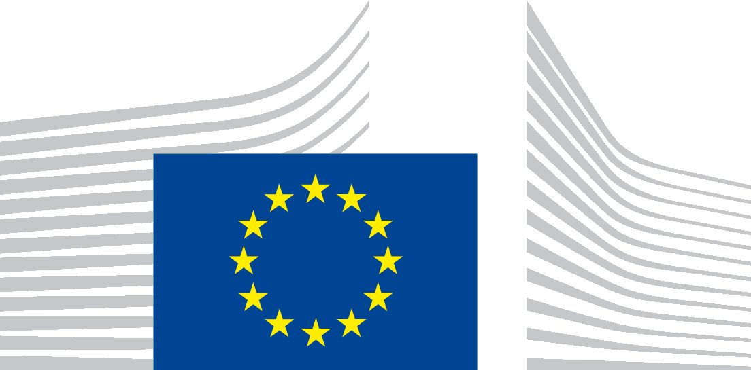 | EUROPEAN COMMISSION  Directorate-General for Internal Market, Industry, Entrepreneurship and SMEs  Competitiveness and European Semester  International Affairs
Brussels,
A4/ DL/grow.a.4(2017)4817439
Lora Verheecke
Access Info Europe
Cava San Miguel 8 4C
28005 Madrid
Spain

e-mail address: ask+request-4497-005db2e6@asktheeu.org

Subject: Ref Gestdem n°2017/4248
Dear Mrs Verheecke,
We refer to your e-mail dated 17/07/2017 in which you made a request for access to documents, registered on 19/07/2017 under the above-mentioned reference number.
You requested access to:
1. Any documents since 1st January 2010, including briefings, reports, correspondence (email or other), where the EU-Japan Business Round Table is concerned or mentioned.
2. A list of meetings, as well as agendas and minutes any other reports of such meetings, since 1st January 2010, between officials/representatives/experts of DG Trade and officials/representatives of the EU-Japan Business Round Table.

As we informed you in our mail to you of 2nd August, the part of the request under point 2 was dealt with by DG Trade under Gestdem 2017/4216.
Further to our request for a fair solution sent to you on 2nd August and your agreement given on 7th August, we have now prepared the documents covering the period from 2014 until today.
You will find them in attachment to this letter.
Some of the documents to which you have requested access contain personal data.
Pursuant to Article 4(1) (b) of Regulation (EC) No 1049/2001, access to a document has to be refused if its disclosure would undermine the protection of privacy and the integrity of the individual, in particular in accordance with Community legislation regarding the protection of personal data. The applicable legislation in this field is Regulation (EC) No 45/2001 of the European Parliament and of the Council of 18 December 2000 on the protection of individuals with regard to the processing of personal data by the Community institutions and bodies and on the free movement of such data.

When access is requested to documents containing personal data, Regulation (EC) No 45/2001 becomes fully applicable.
According to Article 9(1) of this Regulation and unless the conditions of Article 9(6) of the Regulation are met, personal data shall only be transferred to recipients, other than Community institutions and bodies, which are not subject to national law adopted pursuant to Directive 95/46/EC, if an adequate level of protection is ensured in the country of the recipient or within the recipient international organization and the data are transferred solely to allow tasks covered by the competence of the controller to be carried out.
We consider that, with the information available, the fulfilment of these conditions has not been established. Therefore, we are disclosing the documents requested expunged from this personal data.
In case you would disagree with the assessment that the expunged data are personal data which can only be disclosed if such disclosure is legitimate under the rules of personal data protection, you are entitled, in accordance with Article 7(2) of Regulation 1049/2001, to make a confirmatory application requesting the Commission to review this position.
Such a confirmatory application should be addressed within 15 working days upon receipt of this letter to the Secretary-General of the Commission at the following address:
European Commission
Secretary-General
Transparency unit SG-B-4
BERL 5/282
B-1049 Bruxelles

or by email to: sg-acc-doc@ec.europa.eu

Yours sincerely, signed electronically
Iwona PIÓRKO BERMIG
Annexes:
- Document register
-14 documents

Official Journal L 8 of 12.1.2001, p. 1
Judgment of the Court of Justice of the EU of 29 June 2010 in case 28/08 P, Commission/The Bavarian Lager Co. Ltd, ECR 2010 I-06055.

