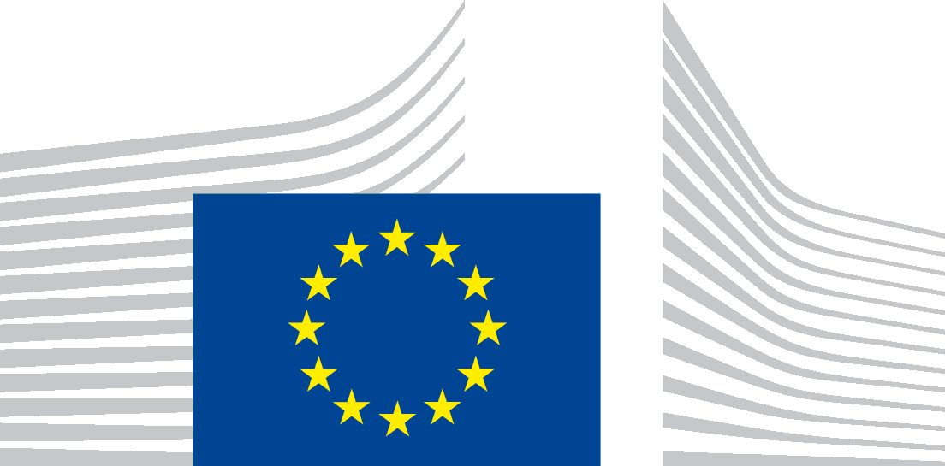 | EUROPEAN COMMISSION  Directorate-General for Financial Stability, Financial Services and Capital Markets Union  Inter-institutional relations, planning and stakeholders' relations
Brussels,
FISMA02/(2018) 7424233
Mr Peter Teffer
EUobserver
Rue Montoyer 188
1000 Brussels
Registered letter with acknowledgment of receipt
Subject: Your request for access to documents GESTDEM 2018/5412
Dear Mr Teffer,
Thank you for your e-mail dated 12 October 2018 in which you made a request for access to documents. Your request is as follows:
"Under the right of access to documents in the EU treaties, as developed in Regulation 1049/2001, I am requesting documents which contain the following information:
– all documents - including but not limited to minutes, (hand-written) notes, audio recordings, verbatim reports, operational conclusions, lines to take, e-mails, and presentations - related to the 4/10/2018 meeting between Paulina Dejmek Hack and YDRENAS COMMUNICATIONS AB (YCAB)
– all documents - including but not limited to minutes, (hand-written) notes, audio recordings, verbatim reports, operational conclusions, lines to take, e-mails, and presentations - related to the 4/10/2018 meeting(s) between Paulina Dejmek Hack, Vice-President Valdis Dombrovskis and Morgan Stanley (MS)
– all documents - including but not limited to minutes, (hand-written) notes, audio recordings, verbatim reports, operational conclusions, lines to take, e-mails, and presentations - related to the 28/6/2018 meeting between Vice-President Valdis Dombrovskis and Fédération bancaire française (FBF)
– all documents - including but not limited to minutes, (hand-written) notes, audio recordings, verbatim reports, operational conclusions, lines to take, e-mails, and presentations - related to the 24/5/2018 meeting between Vice-President Valdis Dombrovskis and UniCredit
– all documents - including but not limited to minutes, (hand-written) notes, audio recordings, verbatim reports, operational conclusions, lines to take, e-mails, and presentations - related to the 26/4/2018 meeting between Vice-President Valdis Dombrovskis and Bank of America Merrill Lynch
– all documents - including but not limited to minutes, (hand-written) notes, audio recordings, verbatim reports, operational conclusions, lines to take, e-mails, and presentations - related to the 12/9/2018 meeting between Andrea Beltramello and the Association for Financial Markets in Europe (AFME)
– all documents - including but not limited to minutes, (hand-written) notes, audio recordings, verbatim reports, operational conclusions, lines to take, e-mails, and presentations - related to the 16/3/2018 meeting between Andrea Beltramello and the Association for Financial Markets in Europe (AFME)
– all documents - including but not limited to minutes, (hand-written) notes, audio recordings, verbatim reports, operational conclusions, lines to take, e-mails, and presentations - related to the 16/3/2018 meeting(s) between Jan Ceyssens, Paulina Dejmek Hack and The Goldman Sachs Group, Inc. (GS) ".
We identified the following meeting documents:
Meeting on 4/10/2018 with Morgan Stanley: exchange of correspondence, briefing and minutes of the meeting (Ares 6553463)

Meeting on 28/6/2018 with Fedération française bancaire, exchange of correspondence, briefing and minutes of meeting (Ares 6553618)

Meeting on 24/5/2018 with Unicredit, exchange of correspondence, minutes of meeting (Ares 6553739)

Meeting of 26/4/2018 with Bank of America, Correspondence, briefing (Ares 6553841)

Meeting of 12/9/2018 with AFME, correspondence (Ares 6567998)

Meeting of 16/3/2018 with AFME, correspondence (Ares 6568072)

Meeting of 12/9/2018 with Goldman Sachs, correspondence (Ares 6567998).

You will receive a separate answer concerning the meeting on 4/10/2018 with Ydrenas communications AB (YCAB).

Please note that the documents which were received by the Commission from the above mentioned organisations are disclosed for information only and cannot be re-used without the agreement of the originator, who holds a copyright on it. They do not reflect the position of the Commission and cannot be quoted as such.

Minutes of meetings were drawn up for internal use under the responsibility of the relevant members of the Cabinet of Vice-President Dombrovskis. They solely reflects the author's interpretation of the interventions made and do not set out any official position of the third parties to which the document refers, which were not consulted on them.

After having examined all documents, I have decided to give you partial access to all documents for the reasons mentioned below:

Pursuant to Article 4(1)(b) of Regulation (EC) No 1049/2001, access to a document has to be refused if its disclosure would undermine the protection of privacy and the integrity of the individual, in particular in accordance with European Union legislation regarding the protection of personal data.

The applicable legislation in this field is Regulation (EC) No 2018/1725 of the European Parliament and of the Council of 23 October 2018 on the protection of natural persons with regard to the processing of personal data by the Union institutions, bodies, offices and agencies and on the free movement of such data, and repealing Regulation (EC) No 45/2001 and Decision No 1247/2002/EC (‘Regulation 2018/1725’).

All documents to which you request access contain personal data, in particular names, e-mail addresses, phone numbers.
Article 3(1) of Regulation 2018/1725 provides that personal data ‘means any information relating to an identified or identifiable natural person […]’. The Court of Justice has specified that any information, which by reason of its content, purpose or effect, is linked to a particular person is to be considered as personal data.

As regards personal data of Commission staff, please note in this respect that the names, signatures, functions, telephone numbers and/or initials pertaining to staff members of an institution are to be considered personal data.

In its judgment in Case C-28/08 P (Bavarian Lager), the Court of Justice ruled that when a request is made for access to documents containing personal data, the Data Protection Regulation becomes fully applicable
Pursuant to Article 9(1)(b) of Regulation 2018/1725, ‘personal data shall only be transmitted to recipients established in the Union other than Union institutions and bodies if ‘[t]he recipient establishes that it is necessary to have the data transmitted for a specific purpose in the public interest and the controller, where there is any reason to assume that the data subject’s legitimate interests might be prejudiced, establishes that it is proportionate to transmit the personal data for that specific purpose after having demonstrably weighed the various competing interests’.

Only if these conditions are fulfilled and the processing constitutes lawful processing in accordance with the requirements of Article 5 of Regulation 2018/1725, can the transmission of personal data occur.

According to Article 9(1)(b) of Regulation 2018/1725, the European Commission has to examine the further conditions for a lawful processing of personal data only if the first condition is fulfilled, namely if the recipient has established that it is necessary to have the data transmitted for a specific purpose in the public interest. It is only in this case that the European Commission has to examine whether there is a reason to assume that the data subject’s legitimate interests might be prejudiced and, in the affirmative, establish the proportionality of the transmission of the personal data for that specific purpose after having demonstrably weighed the various competing interests.

In your request, you do not put forward any arguments to establish the necessity to have the data transmitted for a specific purpose in the public interest. Therefore, the European Commission does not have to examine whether there is a reason to assume that the data subject’s legitimate interests might be prejudiced.

Consequently, I conclude that, pursuant to Article 4(1)(b) of Regulation 1049/2001, access cannot be granted to the personal data, as the need to obtain access thereto for a purpose in the public interest has not been substantiated and there is no reason to think that the legitimate interests of the individuals concerned would not be prejudiced by disclosure of the personal data concerned.

In case you would disagree with the assessment that the redacted data are personal data which can only be disclosed if such disclosure is legitimate under the applicable rules on the protection of personal data, you are entitled, in accordance with Article 7(2) of Regulation 1049/2001, to submit a confirmatory application requesting the Commission to review this position.
Such a confirmatory application should be addressed within 15 working days upon receipt of this letter to the Secretariat-General of the Commission at the following address:
European Commission
Secretariat-General
Unit C.1. ‘Transparency, Document Management and Access to Documents’
BERL 5/282
B-1049 Bruxelles, or by email to: sg-acc-doc@ec.europa.eu
Yours sincerely,

Eric DUCOULOMBIER
Enclosure: documents concerning meetings mentioned in your request (see above).

Official Journal L 205 of 21.11.2018, p. 39.
Judgment of the Court of Justice of the European Union of 20 December 2017 in Case C-434/16, Peter Nowak v Data Protection Commissioner, request for a preliminary ruling, paragraphs 33-35, ECLI:EU:C:2017:994.
Judgment of the General Court of 19 September 2018 in case T-39/17, Port de Brest v Commission, paragraphs 43-44, ECLI:EU:T:2018:560.
Judgment of 29 June 2010 in Case C-28/08 P, European Commission v The Bavarian Lager Co. Ltd, EU:C:2010:378, paragraph 59.
Whereas this judgment specifically related to Regulation (EC) No 45/2001 of the European Parliament and of the Council of 18 December 2000 on the protection of individuals with regard to the processing of personal data by the Community institutions and bodies and on the free movement of such data, the principles set out therein are also applicable under the new data protection regime established by Regulation 2018/1725.

