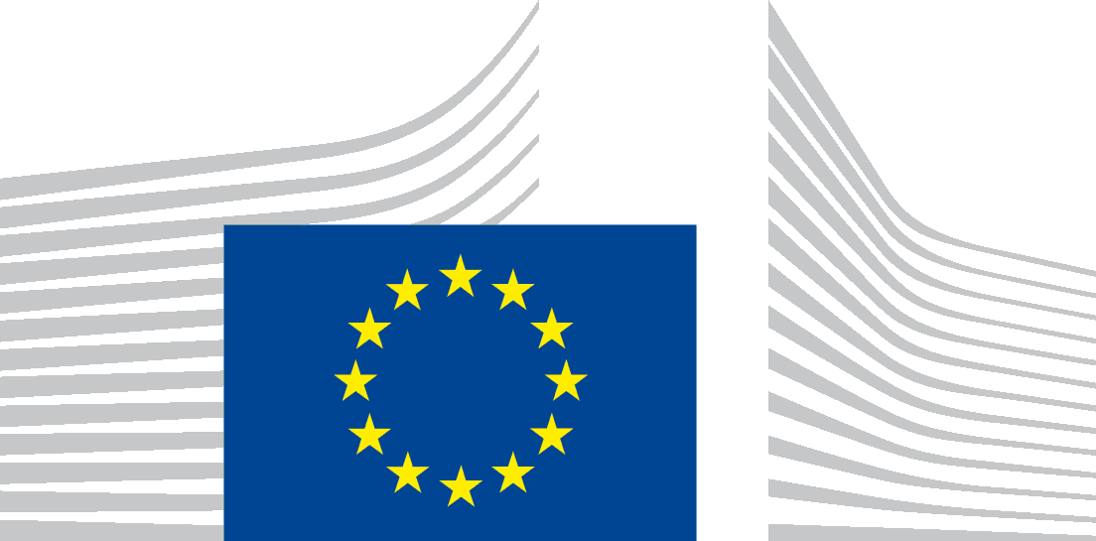 | EUROPEAN COMMISSION  DIRECTORATE-GENERAL FOR HEALTH AND FOOD SAFETY  Health systems, medical products and innovation  The Director  Acting Head of Unit B1: Performance of national health systems
Brussels
SANTE.DDG1.B.1/WB
Dear Sir,
Subject: Your application for access to documents – GESTDEM 2020/3667
We refer to your email of 16 June 2020 in which you make a request for access to documents, registered on 16 June 2020 under the above mentioned reference numbers.
The description given in your application does not enable us to identify concrete documents, which would correspond to your request.
We therefore invite you, in accordance with Article 6(2) of Regulation (EC) No 1049/2001 regarding public access to documents, to provide us with more detailed information on the documents you request, such as references, dates or periods during which the documents would have been drawn up, persons or bodies who drafted the documents etc.
The request to provide minutes, reports and correspondence of the Commission with lobby groups and think tanks where medical care and health issues are discussed (see below in italics) is not fully clear to us.
GESTDEM 2020/3667 (Ares(2020)3123266) - Medical care and healthcare issues
- minutes and other reports of meetings between the European Commission and private healthcare companies (including Fresenius, Helios /Quironsalud, Asklepios, Ramsay Health, Sana Kliniken, Elsan, Gruppo San Donato and Capio), professional services firms (including PWC, Deloitte, KPMG, EY and McKinsey) as well as with lobby groups and thinktanks (including the European alliance for cost efficiency in healthcare (COSTEFF), Health Consumer Powerhouse, etc.), where medical care and healthcare issues (including health sector reform, patients choice, cross-border healthcare, or healthcare service markets) were discussed (from June 1st 2017 till today).
- all correspondence (including emails) between the European Commission and private healthcare companies (including Fresenius Helios /Quironsalud, Asklepios, Ramsay Health, Sana Kliniken, Elsan, Gruppo San Donato and Capio), professional services firms (including PWC, Deloitte, KPMG, EY and McKinsey) as well as with lobby groups and thinktanks (including the European alliance for cost efficiency in healthcare (COSTEFF), Health Consumer Powerhouse, etc.), where medical care and healthcare issues (including health sector reform, patients choice, cross-border healthcare, or healthcare service markets) were discussed (from June 1st 2017 till today).
Could you please specify more which lobby groups and which think tanks you have in mind (beyond COSTEFF and Health Consumer Powerhouse)?
Could you also please specify what kind of meetings and correspondence you are interested in (we assume that you mean lobbying meetings, such as conferences, bilateral meetings, and related correspondence)?
If you need assistance in clarifying or specifying your application, you can contact us by email to: SANTE-CONSULT-B1@ec.europa.eu.
In accordance with the third paragraph of Article 2 of the Detailed rules for the application of Regulation (EC) No 1049/2001 , the deadline of 15 working days for handling your application will start running when we receive the requested clarifications.
Thank you in advance for your understanding.
Yours sincerely,
(e-signed)
Andrzej Jan RYS

Official Journal L 345, 29.12.2001, p. 94.

