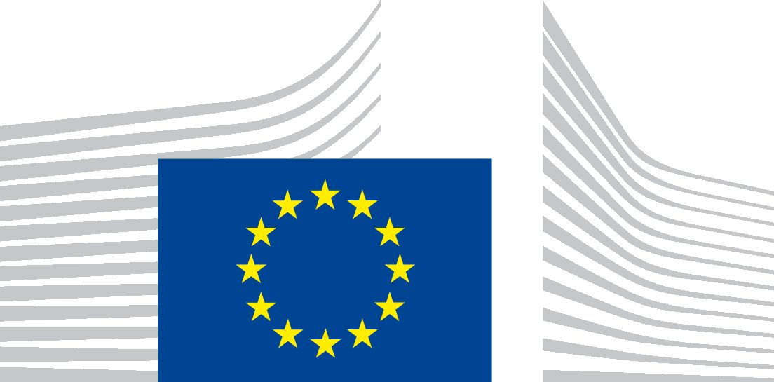 | EUROPEAN COMMISSION  DIRECTORATE-GENERAL  ENVIRONMENT  Directorate C - Quality of Life  ENV.C.4 - Industrial Emissions & Safety
Brussels,
ENV.C.4/AK env.c.4(2018)
EUobserver
Peter Teffer
Rue Montoyer 18B
1000 Brussels
Belgium

Subject: Your application for access to documents – Ref GestDem No 2018/262

Dear Mr Teffer,
Thank you for your request of 9 January which was registered under the above mentioned reference number and in which you requested:
- A list of which member states have notified the European Commission on the implementation of the provisions on penalties referred to in article 28 of Directive 2012/18/EU of 4 July 2012, and whether they did so before or after 1 June 2015
- The content of all member states' notifications of the provisions on penalties referred to in article 28 of Directive 2012/18/EU of 4 July 2012
- The content of any communication from the European Commission to member states about the provisions on penalties referred to in article 28 of Directive 2012/18/EU of 4 July 2012
National transposition measures and their content communicated to the Commission are publically available online at http://eur-lex.europa.eu/legal-content/EN/NIM/?uri=CELEX:32012L0018&qid=1519202821301.
There is no communication about the provisions on penalties referred to in Article 28 of Directive 2012/18/EU from the European Commission to Member States.
Aneta WILLEMS
Head of Unit

