D(12) MK/CM/XC/am – 000143
FROM: | Ms Ilze Brands Kehris, Chairperson of the Management Board
TO: | The attention of the Members of the Management Board
DATE: | 09 February 2012
SUBJECT: | Written procedure: 2013-01 Amendment of Part II - Establishment Plan (i.e. Annex A and B) of the 2013 Estimate of revenue and expenditure

Dear Members of the Management Board,
On 5 December 2011, the Management Board adopted the 2013 Estimate of Revenue and Expenditure (i.e. the 2013 Draft Budget).
However, through constructive discussions with the Commission’s services on the 2013 Draft Budget during the last two weeks, it emerged that DG Budget considered the Agency still to be in the start-up period. This means that the Agency could exploit the opportunity to request the three posts foreseen in the Financial Perspectives that it could not obtain in 2012.
The Executive Board therefore proposes to launch a written procedure in order to adopt an amending establishment plan including three new Temporary Agent posts and a Contract Agent post.
By the present note, the Management Board is informed of these facts. You are requested to agree to a written procedure, in accordance with Article 10 of the Rules of Procedure of the European Union Agency for Fundamental Rights. Should you have any objections to a written procedure, you are kindly requested to send them by e-mail or fax to Ms Barbara Jäschke (barbara.jaeschke@fra.europa.eu; +43 1 580 30 699) by 13:00 hrs on 16 February 2012. Provided there are no objections to the written procedure by this date, you will receive for your attention the proposal for an amending establishment plan including three new Temporary Agent posts and a Contract Agent post to be adopted.

Kind regards,
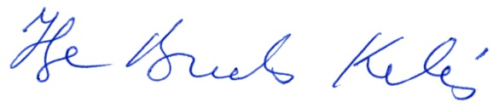
Ilze Brands Kehris
Chairperson of the FRA Management Board

