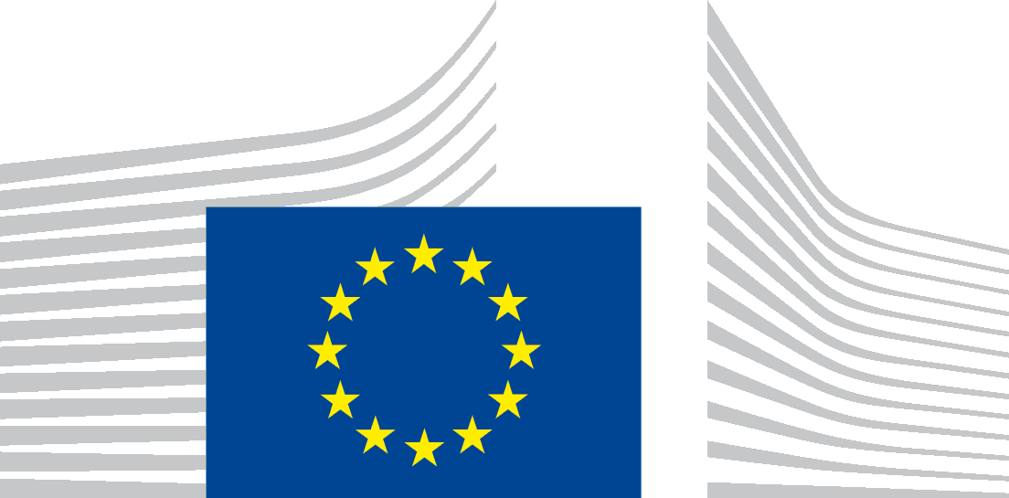 | EUROPEAN COMMISSION  DIRECTORATE-GENERAL FOR TRADE  Directorate A - Resources, Information and Policy Coordination  Transparency and Evaluation

Brussels,
TRADE.A.5/DL
By registered letter with acknowledgment of receipt

Ms Lora Verheecke
9 rue du Bronze
1070 Anderlecht

Advance copy by email:
ask+request-7734-93890c31@asktheeu.org

Subject: Your application for access to documents – Ref. GestDem N° 2020/1303

Dear Ms Verheecke,
We refer to your e-mail dated 3 March 2020 in which you make a request for access to documents in accordance with Regulation (EC) No 1049/2001 (“Regulation 1049/2001”), registered on 4 March 2020 under reference number GestDem 2020/1303.
1. SCOPE OF YOUR REQUEST
In your application you request access to:
“all communication, including emails, and documents (agenda, minutes, list of participants, etc) related to the meeting between Dermot Ryan and Agnieszka Drzewoska and Eurogas on 28th January 2020”.

Based on the scope of your request as outlined above, we have identified one meeting report.
2. ASSESSMENT AND CONCLUSION UNDER REGULATION 1049/2001
In accordance with settled case law, when an institution is asked to disclose a document, it must assess, in each individual case, whether that document falls within the exceptions to the right of public access to documents set out in Article 4 of Regulation 1049/2001. Such assessment is carried out in a multi-step approach. First, the institution must satisfy itself that the document relates to one of the exceptions, and if so, decide which parts of it are covered by that exception. Second, it must examine whether disclosure of the parts of the document in question pose a “reasonably foreseeable and not purely hypothetical” risk of undermining the protection of the interest covered by the exception. Third, if it takes the view that disclosure would undermine the protection of any of the interests defined under Articles 4.2 and 4.3 of Regulation 1049/2001, the institution is required "to ascertain whether there is any overriding public interest justifying disclosure".
In view of the objectives pursued by Regulation 1049/2001, notably to give the public the widest possible right of access to documents, "the exceptions to that right [...] must be interpreted and applied strictly".
I am glad to inform you that access can be granted to its content. However some personal data have been withheld in accordance with Article 4(1)(b) of Regulation 1049/2001.
The legal reasoning underlying the protection of these personal data is provided below.
2.1. Protection of privacy and integrity of the individual
Pursuant to Article 4(1)(b) of Regulation (EC) No 1049/2001, access to a document has to be refused if its disclosure would undermine the protection of privacy and the integrity of the individual, in particular in accordance with European Union legislation regarding the protection of personal data.
The applicable legislation in this field is Regulation (EC) No 2018/1725 of the European Parliament and of the Council of 23 October 2018 on the protection of natural persons with regard to the processing of personal data by the Union institutions, bodies, offices and agencies and on the free movement of such data, and repealing Regulation (EC) No 45/2001 and Decision No 1247/2002/EC (‘Regulation 2018/1725’).
Indeed, Article 3(1) of Regulation 2018/1725 provides that personal data "means any information relating to an identified or identifiable natural person […]". The Court of Justice has specified that any information, which by reason of its content, purpose or effect, is linked to a particular person is to be considered as personal data. Please note in this respect that the names, signatures, functions, telephone numbers and/or initials pertaining to staff members of an institution are to be considered personal data.
In its judgment in Case C-28/08 P (Bavarian Lager), the Court of Justice ruled that when a request is made for access to documents containing personal data, the Data Protection Regulation is fully applicable
Pursuant to Article 9(1)(b) of Regulation 2018/1725, personal data shall only be transmitted to recipients established in the Union other than Union institutions and bodies if "[t]he recipient establishes that it is necessary to have the data transmitted for a specific purpose in the public interest and the controller, where there is any reason to assume that the data subject’s legitimate interests might be prejudiced, establishes that it is proportionate to transmit the personal data for that specific purpose after having demonstrably weighed the various competing interests".
Only if these conditions are fulfilled and the processing constitutes lawful processing in accordance with the requirements of Article 5 of Regulation 2018/1725, can the transmission of personal data occur.
According to Article 9(1)(b) of Regulation 2018/1725, the European Commission has to examine the further conditions for a lawful processing of personal data only if the first condition is fulfilled, namely if the recipient has established that it is necessary to have the data transmitted for a specific purpose in the public interest. It is only in this case that the European Commission has to examine whether there is a reason to assume that the data subject’s legitimate interests might be prejudiced and, in the affirmative, establish the proportionality of the transmission of the personal data for that specific purpose after having demonstrably weighed the various competing interests.
In your application, you do not put forward any arguments to establish the necessity to have the data transmitted for a specific purpose in the public interest. Therefore, the European Commission does not have to examine whether there is a reason to assume that the data subject’s legitimate interests might be prejudiced.
Notwithstanding the above, please note that there are reasons to assume that the legitimate interests of the data subjects concerned would be prejudiced by disclosure of the personal data reflected in the documents, as there is a real and non-hypothetical risk that such public disclosure would harm their privacy and subject them to unsolicited external contacts.
Consequently, I conclude that, pursuant to Article 4(1)(b) of Regulation 1049/2001, access cannot be granted to the personal data, as the need to obtain access thereto for a purpose in the public interest has not been substantiated and there is no reason to think that the legitimate interests of the individuals concerned would not be prejudiced by disclosure of the personal data concerned.
This meeting report contains names and other personal information that allows the identification of natural persons, which have been redacted.
***
In accordance with Article 7(2) of Regulation 1049/2001, you are entitled to make a confirmatory application requesting the Commission to review this position.
Such a confirmatory application should be addressed within 15 working days upon receipt of this letter to the Secretary-General of the Commission at the following address:
European Commission
Secretary-General
Transparency, Document Management & Access to Documents unit SG-C-1
BERL 7/076
1049 Bruxelles
or by email to: sg-acc-doc@ec.europa.eu
Yours sincerely,

Damien LEVIE
Head of Unit
(e-signed)

Annex: - Disclosed meeting report

Regulation (EC) No 1049/2001 of the European Parliament and of the Council of 20 May 2001 regarding public access to European Parliament, Council and Commission documents, OJ L 145, 31.5.2001, p. 43.
Judgment in Sweden and Maurizio Turco v Council, Joined cases C-39/05 P and C-52/05 P, EU:C:2008:374, paragraph 35.
Id., paragraphs 37-43. See also judgment in Council v Sophie in ‘t Veld, C-350/12 P, EU:C:2014:2039, paragraphs 52 and 64.
See Regulation (EC) No 1049/2001, recital (4).
Judgment in Sweden v Commission, C-64/05 P, EU:C:2007:802, paragraph 66.
Official Journal L 205 of 21.11.2018, p. 39.
Judgment of the Court of Justice of 20 December 2017 in Case C-434/16, Peter Novak v Data Protection Commissioner, request for a preliminary ruling, paragraphs 33-35, ECLI:EU:T:2018:560.
Judgment of the General Court of 19 September 2018 in case T-39/17, Port de Brest v Commission, paragraphs 43-44, ECLI:EU:T:2018:560.
Judgment of 29 June 2010 in Case C-28/08 P, European Commission v The Bavarian Lager Co. Ltd, EU:C:2010:378, paragraph 59.
Whereas this judgment specifically related to Regulation (EC) No 45/2001 of the European Parliament and of the Council of 18 December 2000 on the protection of individuals with regard to the processing of personal data by the Community institutions and bodies and on the free movement of such data, the principles set out therein are also applicable under the new data protection regime established by Regulation 2018/1725.

