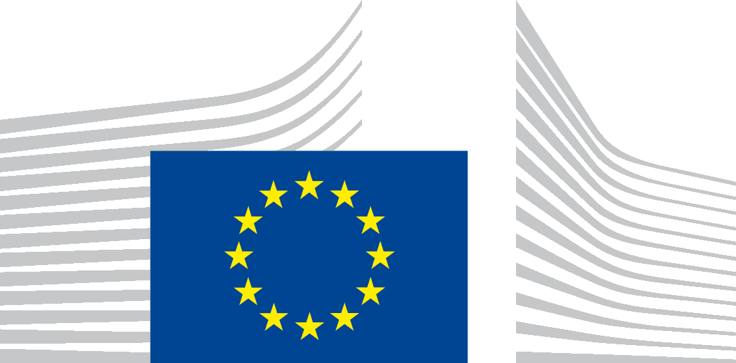 | EUROPEAN COMMISSION  DIRECTORATE-GENERAL FOR HEALTH AND FOOD SAFETY  Health systems, medical products and innovation  Medical Devices
Brussels
SANTE.DDG1.B.6/
Mr Peter Teffe
Bemuurde Weerd WZ 3
3513 BH Utrecht
The Netherlands
by email only to: ask+request-8008-13922127@asktheeu.org

Dear Mr Teffer,
Subject: Your application for access to documents – GESTDEM 2020/3409
We refer to your e-mail of 4 June 2020 in which you make a request for access to documents, registered on 5 June 2020 under the above-mentioned reference number.
The handling of your request involves the assessment of a very large number of documents originating from different services within the Commission. Such a detailed analysis cannot be carried out within the normal time limits set out in Article 7 of Regulation (EC) No 1049/2001.
However, Article 6(3) of Regulation (EC) No 1049/2001 also provides for a possibility to confer with an applicant informally with a view to finding a fair solution when an application relates to a very long document or concerns a very large number of documents.
In accordance with the case law of the EU Courts, such a solution can only concern the content or the number of documents requested, not the deadline for replying. This means that the scope of the request must be reduced in a way that would enable its processing within the extended deadline of 15 + 15 working days.
Based on the above-mentioned provision, we would kindly ask you to specify the objective of your application and your specific interest in the documents requested, and whether you could narrow down the scope of your application (i.e. the subject matter(s) and/or timeframe covered), so as to reduce it to a more manageable amount of documents.

In order to help you to narrow down your application, please note that the following categories of documents have been identified as you have indicated under the scope of your request:

- All progress reports about the development of EUDAMED;
- All e-mails (including any attachments) between DG SANTE and other DG's about the development of EUDAMED;
- All documents related to the Commission’s decision to delay the deployment of EUDAMED until 2022.
For point 1 of your request, we propose to narrow down the scope of your request to all progress reports on the development of EUDAMED, which the Commission has communicated to the Member States.
For point 2 of your request, please note that the development of EUDAMED was initially a competence of the Director General for Internal Market, Industry, Entrepreneurship and SMEs (DG GROW) and on 1 January 2020 this competence was transferred to DG SANTE. Therefore, we propose to limit the temporal scope of this point of your request to documents from 1 January 2020 to the date of your application i.e. 4 June 2020.

Otherwise, according to our estimates, the handling of your request would take 46 working days, broken down as follows:
- identification of the documents falling under your request, including consultation between different units and DGs: 15 working days;
- retrieval and establishment of a complete list of the documents identified: 6 working days;
- assessment of the content of the documents in light of the exceptions of Article 4 of Regulation 1049/2001: 5 working days:
- third-party consultations under Article 4(4) and/or 4(5) of Regulation 1049/2001: 7 working days;
- final assessment of the documents in light of the comments received: 2 working days;
- drafting of the reply: 1 working day;
- redaction of those parts of the documents to which one or several exceptions apply(ies): 2 working days;
- internal approval from all the involved services of the draft decision on your request: 8 working days.
Therefore, according to our first estimates, the documents falling under point 3 (decision to delay) and, a limited scope of documents falling under point 1 and 2 above could possibly be dealt with within the extended deadline of 30 working days counting from the date of registration of your application on 5 June 2020 until 17 July 2021.

Based on the above-mentioned provisions and timely evaluation, we would kindly ask you to narrow down the scope of your request as proposed above to reduce it to a more manageable amount of documents.

In order to enable us to respect the time-limits of Regulation (EC) No 1049/2001, we would ask you for a swift reply to our invitation to propose a fair solution, within five working days at the latest by e-mail to: SANTE-ACCESS-TO-DOCUMENTS@ec.europa.eu.
If you have any questions concerning the invitation, you can contact us: by e-mail at: SANTE-ACCESS-TO-DOCUMENTS@ec.europa.eu.
In the absence of a reply within five working days, we will unilaterally restrict the scope of your application to those parts that can be dealt with within the extended deadline of 30 working days, counting from the registration of your application on 5 June 2020.
Thank you in advance for your understanding.

Yours faithfully,

Anna-Eva AMPELAS
Head of Unit

Judgment of the Court of Justice of 2 October 2014, Strack v European Commission, C-127/13,(hereinafter referred to as the ‘Strack v Commission judgment’), EU:C:2014:2250, paragraphs 26-28.
Strack v Commission judgment , paragraph 28; Judgment of the General Court (then 'Court of First Instance') of 22 May 2012, EnBW Energie Baden-Württemberg v European Commission, T-344/08, EU:T:2012:242, paragraph 105.
Taking into account other applications for access to documents and other tasks that the staff concerned are likely to have to deal with during the same period.

