POMPIDOU GROUP

SharePoint Collaborative Workspace

User guide

Contributor/User

**Contents**

1. Presentation of SharePoint 3

1.1. Introduction 3

1.2. Logging on 3

1.3. Home Page 4

2. Modules 4

2.1. Displaying a list 4

2.2. Navigating in a list 6

2.3. Using the forum 7

2.3.1. Creating a new discussion 7

2.3.2. Replying to, viewing, editing or deleting a post 8

2.4. Using a document library 8

2.4.1. Adding or deleting a document 8

2.5. Using a calendar 11

3. Document Libraries: Check-out / Check-in 13

3.1. Check-out 13

**3.2.** Cancelling the check-out 14

**3.3.** Check-in 15

3.4. Version History 16

4. Alerts 18

4.1. Creating an alert 18

4.2. Modifying an alert 19

4.3. Removing an alert 21

1. ACCESS TO RESTRICTED WEBSITES OF THE COUNCIL OF EUROPE 22

➢ Presentation of the menu 22

➢ Resetting a password 23

➢ Changing a Password 24

➢ Automatic Notifications 27

# Presentation of SharePoint

## Introduction

SharePoint is a collaborative tool. It provides an easy way to share documents and data between a large number of users who have access to the Internet and a web browser.

In a collaborative workspace, the data (contacts, links, documents etc) are stored in lists or libraries generally known as ***"modules"***. Each item belonging to a given module has one or more properties, known as ***"metadata"***. The list of metadata can be customised.

The data can be displayed in various ways through "views" based on one or more metadata-related criteria.

As you navigate within the collaborative workspace, the Office ribbon is displayed and shows the various actions possible on the page, module, item etc, depending on the user’s permissions.

## Logging on

Collaborative workspaces are accessible via a web browser at the following URL:

<https://cs.coe.int/team10/Cost_of_drug_control_policies/SitePages/Home.aspx>

The Login credentials are your e-mail address and its associated password:

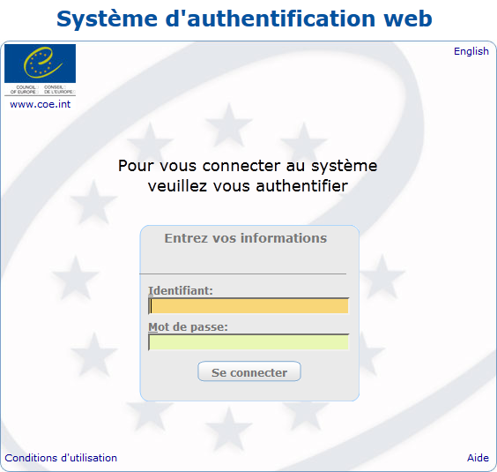

## Home Page

When the connection is established, the home page is displayed. It corresponds to the dashboard of the collaborative workspace and features:

* a quick-launch menu;
* a search field;
* an administration component;
* one or several Web Parts.

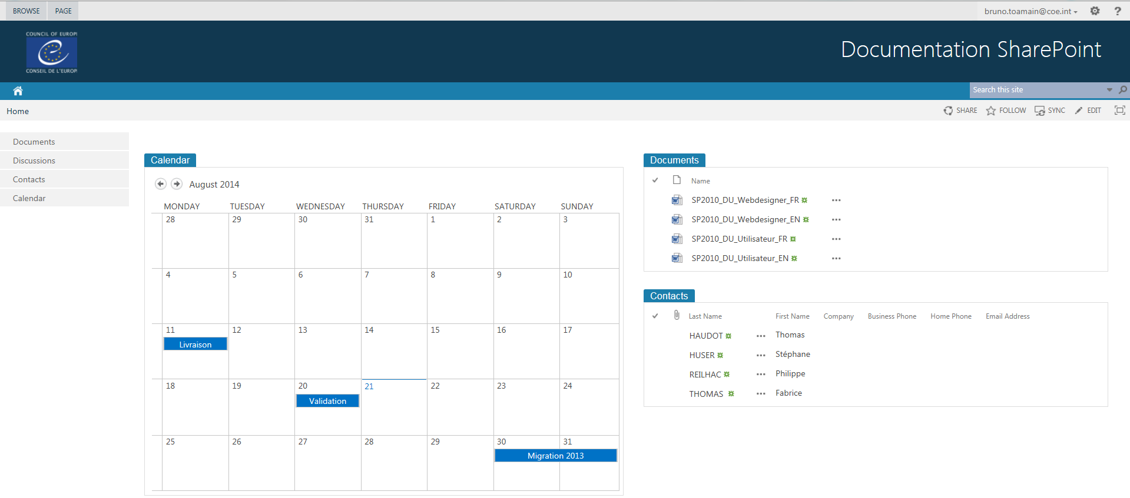

Quick launch/navigation menu

Web Parts

Search

Administration

Web Parts are customisable components (or blocks) of SharePoint. They are visible on the home page. Web Parts make it possible to directly display certain module views or a block of customisable text (with pictures, logos, links etc).

# Modules

SharePoint stores all its information in the form of modules (lists or libraries). They all work on the same principle but may take different forms.

Here are some of the most frequently used modules:

* Contact lists (names, addresses, phone numbers etc);
* Task lists (task type, description, percentage of completion, expiry date etc);
* Announcement lists (message with expiry date);
* Event lists (event type, location, start date, end date etc);
* Document Libraries (type of document, title, name etc);
* Customisable lists where the user (as long as they have adequate permissions) determines what information will be shown.

## Displaying a list

There are two ways of displaying the contents of a list and the different items making it up:

* + If the list is shown on the home page in the web parts section, you will see a specific view of the list. To see the list in its standard display, or change the view, click on the name of the list.

Example: the following screenshot shows how to access the ***"Calendar"*** content by clicking on the name of the list:



* + If the list is present in the Quick launch section on the left, simply click on it.

Example: the following screenshot shows how to access the ***"Calendar"*** content from the Quick launch section:



When you click on a list, a new page is displayed, showing all the list items.

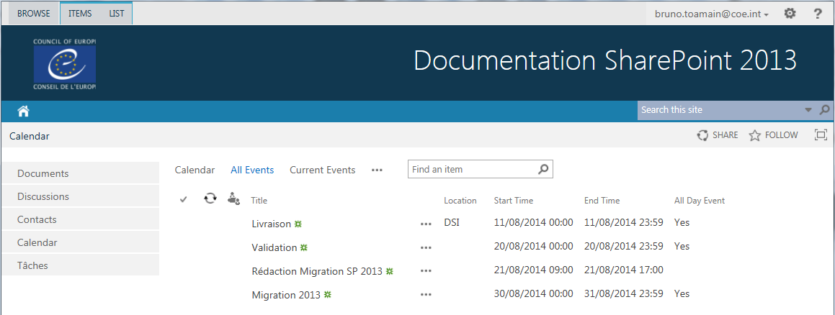

Here you can see that all the columns are shown (depends on the view chosen).

## Navigating in a list

"Views" is a key operating principle of SharePoint. Views can help you classify and manage information and documents far more effectively, while keeping things flexible. The same document, or the same information, may be displayed in several different ways (several different views available) without any redundancy.

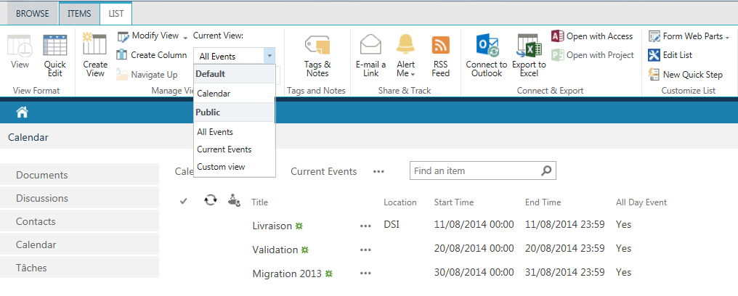

Views

The different displays are available for each list. When you click on a list, the ***"All Documents"*** display is activated by default, and all the list items are displayed, in no particular order.

## Using the forum

### Creating a new discussion

To create a new discussion, click on ***"new discussion"*** in the main page of the team discussion.

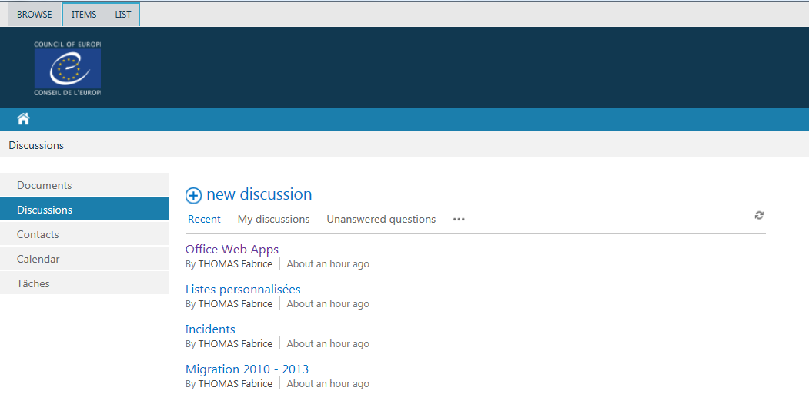

Creating a new discussion

Then type the subject of the discussion and a text describing the content of the discussion, and save using the ***"Save"*** button.

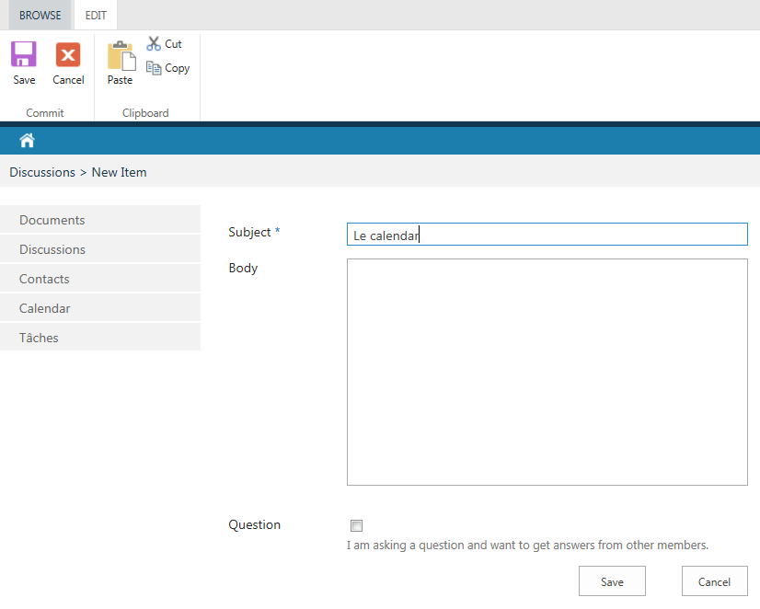

### Replying to, viewing, editing or deleting a post

You can access these functionalities by clicking on the discussion subject, which will open this discussion. You can reply immediately by clicking on ***"Reply"*** (bottom right).

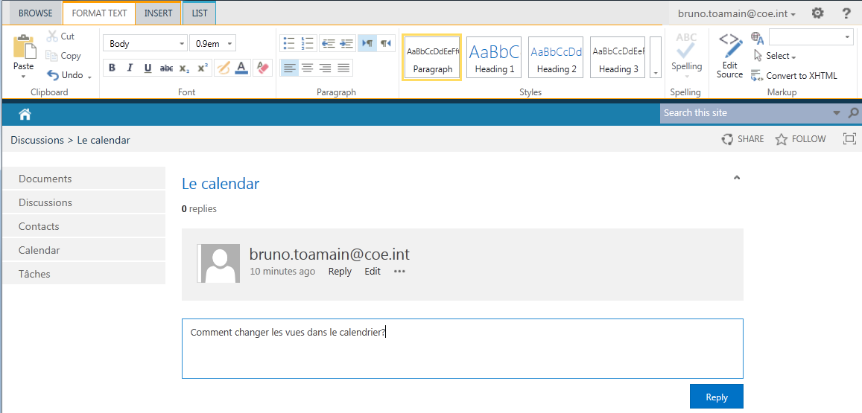

You can access the other functions available below the post (Reply, Edit) and clicking on "…" provides access to additional options (choosing the best reply or deleting a post).

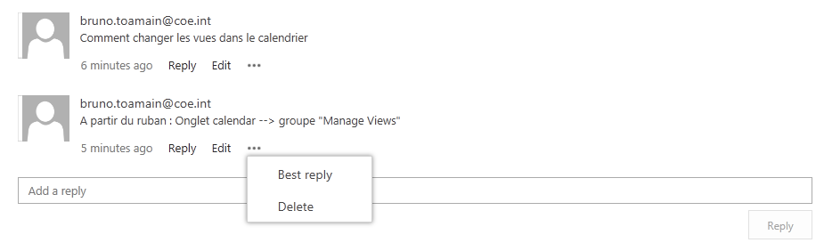

## Using a document library

### Adding or deleting a document

To publish a document, you must first choose which *Document Library* the document is to be deposited in. Once you have opened the list concerned, there are two possible scenarios:

* You want to create a new document 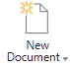
* Your document already exists 

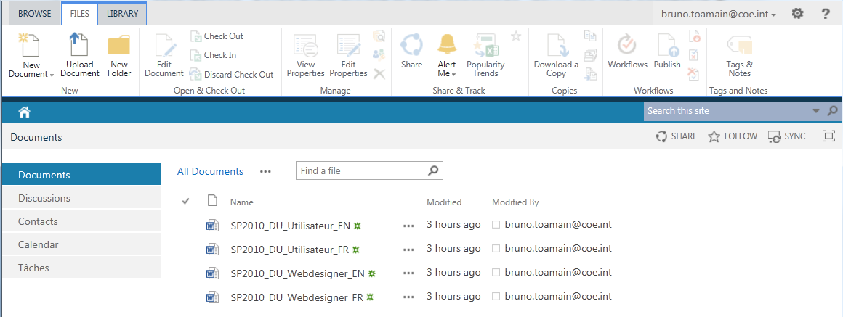

New document

Existing document

|  |  |
| --- | --- |
|  |  |
| **Document saved directly in the SharePoint library** |  |

* If you **create a document** (by clicking on ***"New Document"***), the document template corresponding to the list type will be opened, allowing you to edit your document in the usual way. When you click on the save button (for example in Word), you will be asked to type in the document name of your choice. You can see here that the ***"Save As"*** window is slightly unusual: it is not a local volume that is indicated as the location to save the document but the SharePoint library. Validate by clicking on the ***"Save"*** button.
* If you wish to add an **existing document** (by clicking on ***"Upload document"***), a page will open, prompting you to type in the access path to your document. You can click on ***"Browse"*** to access your PC's explorer window, where you can choose the file and then validate in the two windows (click on ***"Open"***, then on ***"OK"***).

The document now appears in the collaborative workspace and in the list:

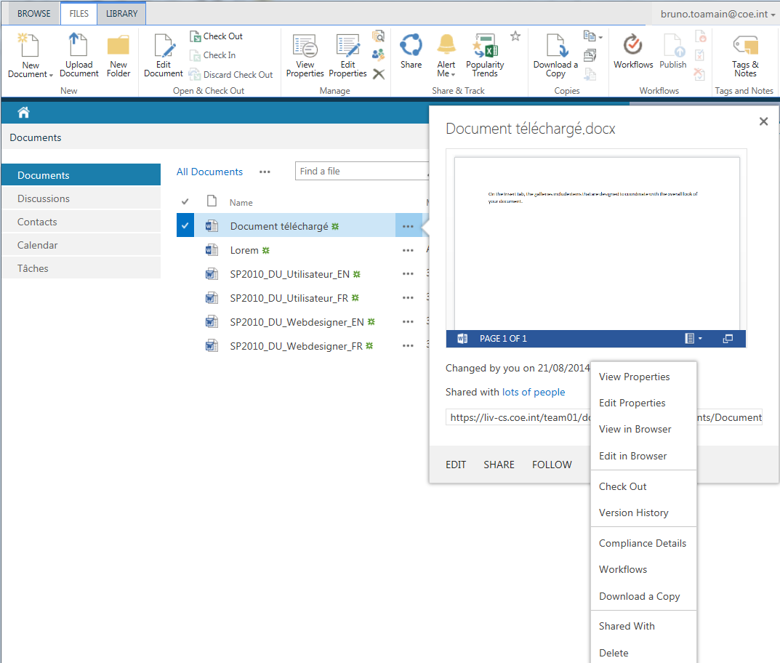

To delete the document

To edit the document

Suppression du document

* To consult the document (without modifying it), simply click on its name.  
  This opens a new window where you should select ***"Read Only"***.

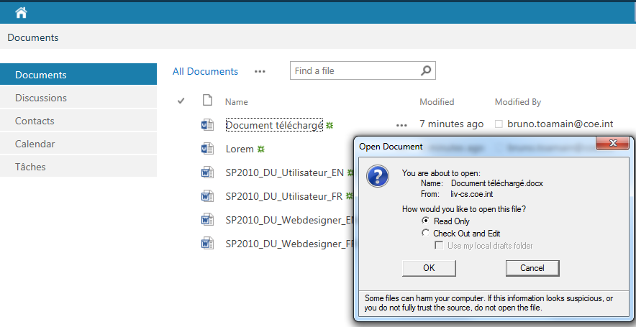

* To modify a document, you must click on "…" and then on ***"Edit"***, or on its name, but in the window which then opens you must select ***"Check Out and Edit"***.
* To delete a document, simply click on ***"Delete"*** after first clicking on " …" to the right of the document name and then on "…" at the bottom of the menu 

## Using a calendar

When a list is displayed, click on  in the ***"Events"*** ribbon to add a new event.

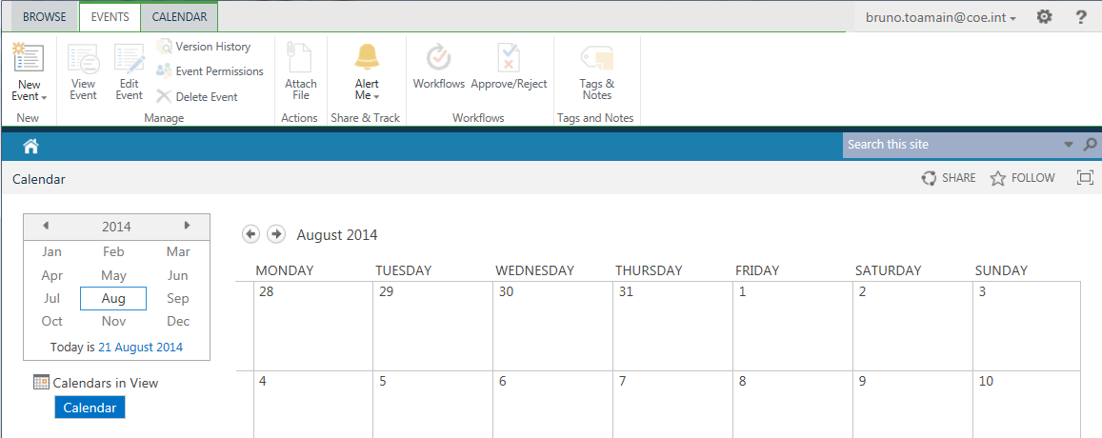

Alternatively, you can click on a day to reveal the  option so that you can add a new event.

http://www.lomag-man.org/clipart/cliquezici_jaune_vignette.gif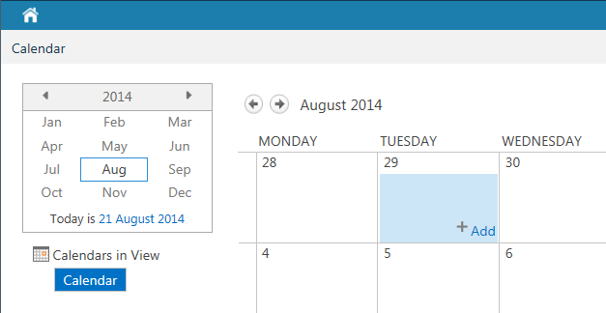

The list used in the following example is a calendar list. The screen for adding a new item will be as follows:

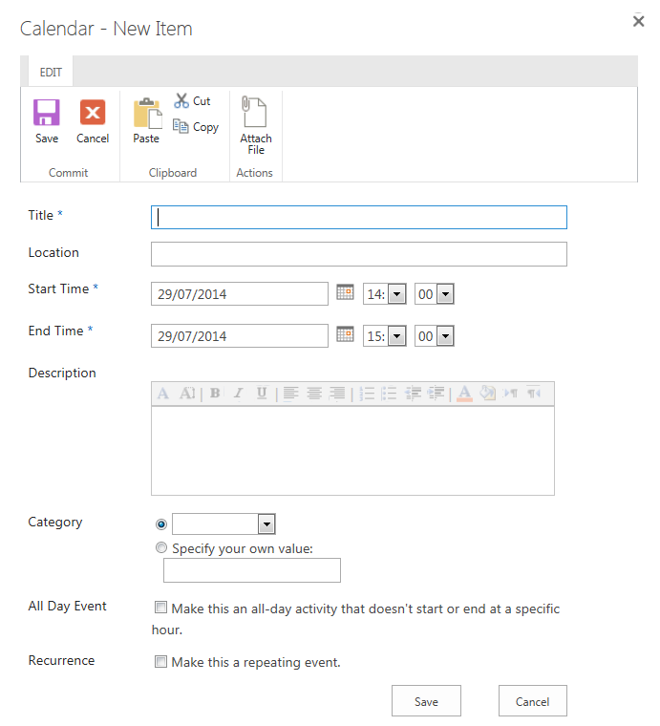

You will then be asked to provide all the information relating to an event (title, start date, end date, description, place and frequency).

You can make it a repeating event (daily, weekly, monthly, yearly) by ticking the ***"Recurrence"*** box.

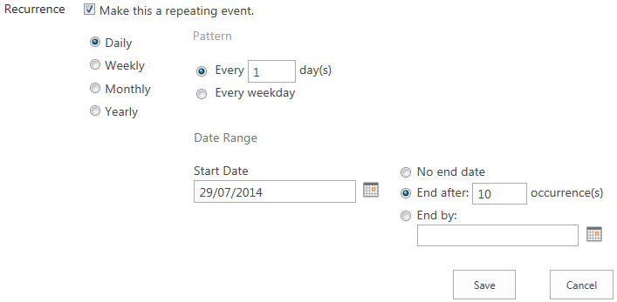

Note: The fields marked with * are mandatory.

Once you have filled in the fields, click on the ***"Save"*** button to save your input.

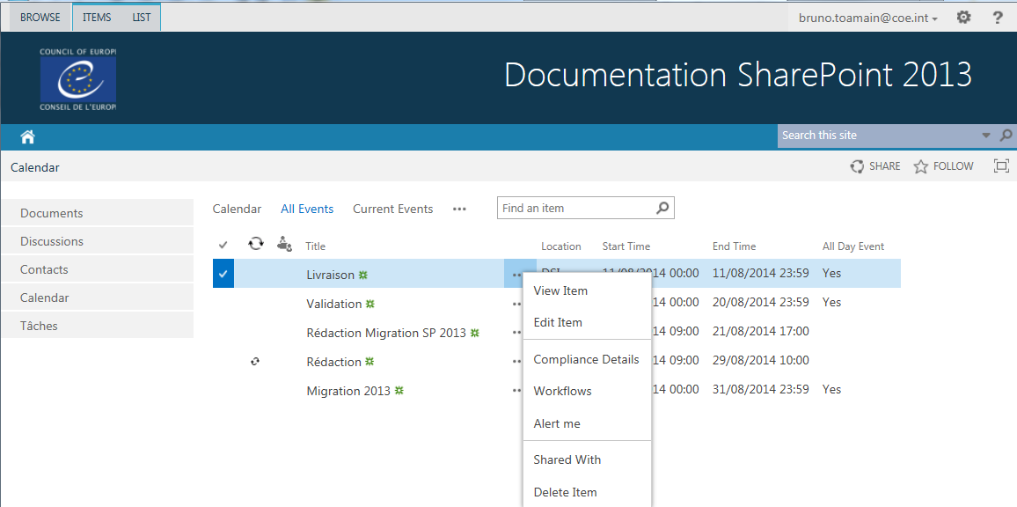

Further options

Event now added

The new event has now been added to the list. Clicking on the event title will give you access to all the data for the event, but clicking on "…" (to the right of the title) opens a context menu, enabling you to view the event, edit it, delete it and also be alerted by e-mail whenever this item is changed.

# Document Libraries: Check-out / Check-in

## Check-out

If someone is editing a document, it is imperative that no one else changes it at the same time, which could result in data being lost as the last person to save their document overwrites the other person's work.

The ***"Check Out"*** function gets around this problem. When you wish to edit a document, click on the ***"Check Out"*** option in that document's context menu:

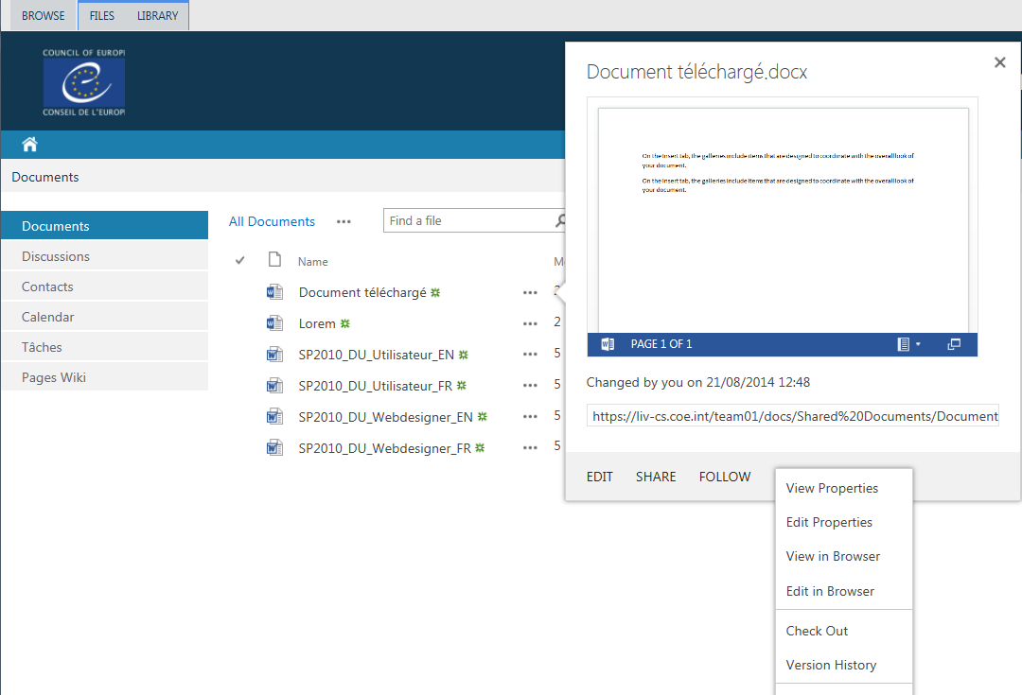

This option is also available via the ***"Files"*** ribbon tab, after you have selected the document:

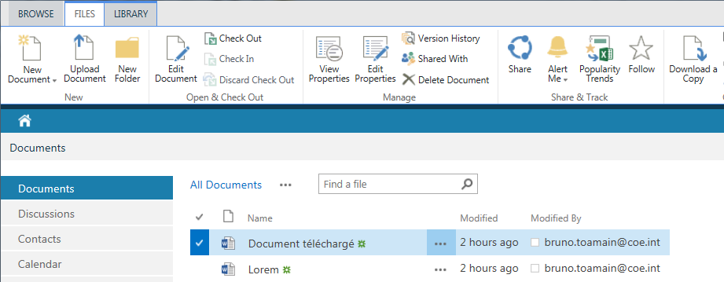

This will make you the only person with writing permission for that file. If someone else opens it in the meantime, they will only be able to consult it and not edit or save it. The checked-out status is indicated by the small arrow at the bottom right of the icon: 

## Cancelling the check-out

To cancel the ***"Check-out"*** on a document, click on ***"Discard Check-out"*** among the additional options of the document concerned.

Note: this option cancels the "Check-out" on a document, and also any changes made to the document.

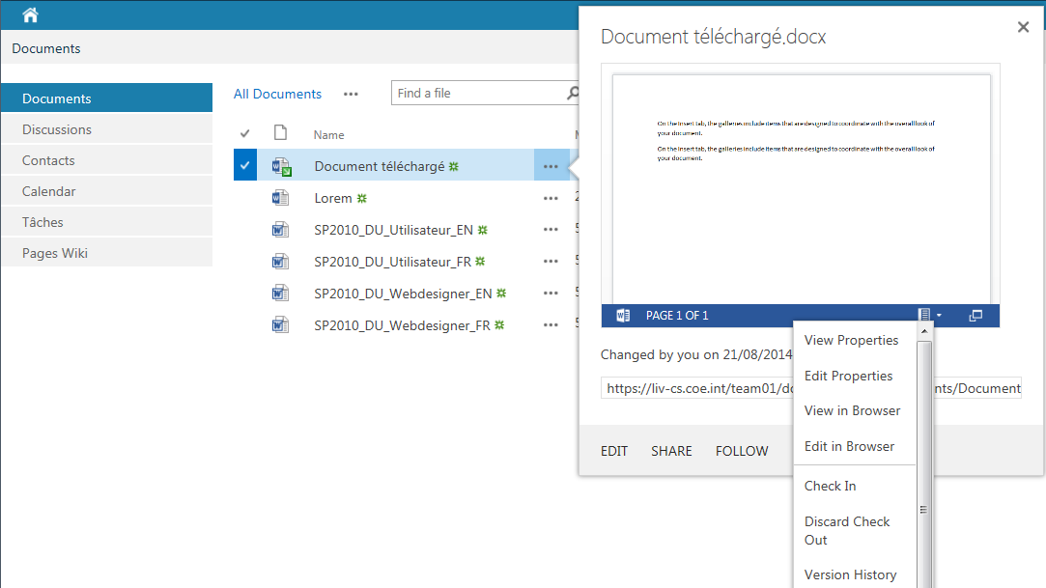

This option is also available via the ***"Files"*** ribbon tab, after you have selected the document:

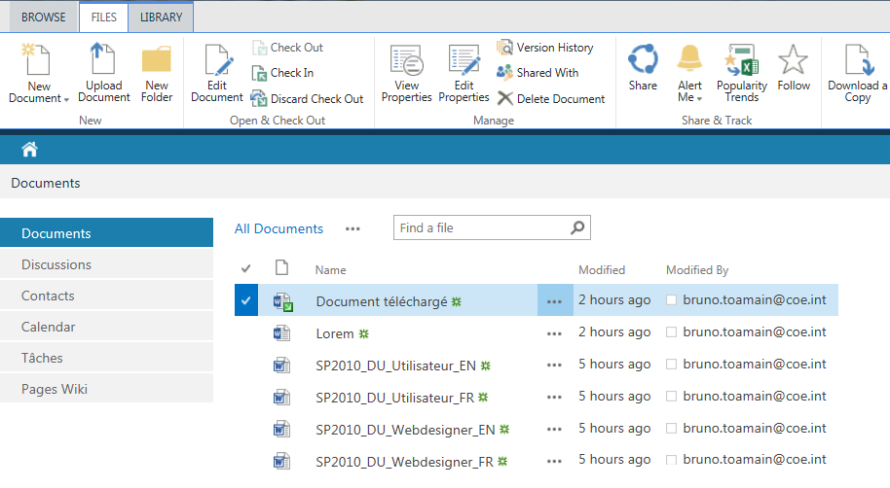

## Check-in

To publish the changes you have made to the document in the collaborative workspace, click on the ***"Check-in"*** option in the context menu of the document concerned:

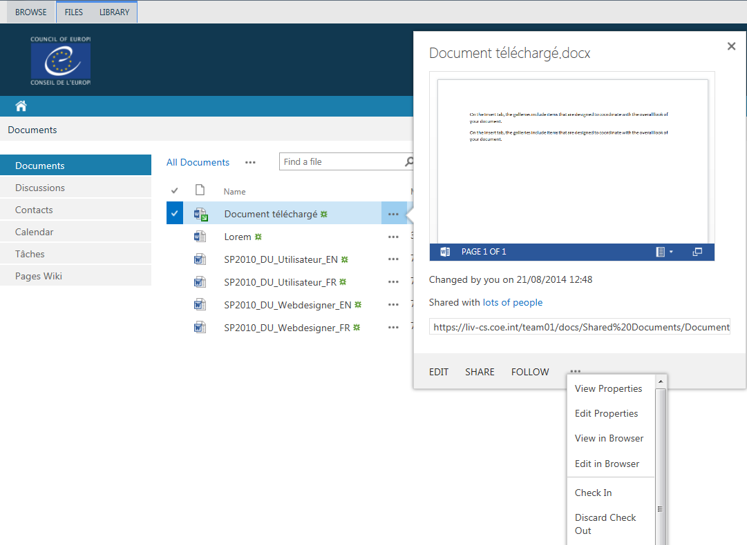

This option is also available via the ***"Files"*** ribbon tab, after you have selected the document:

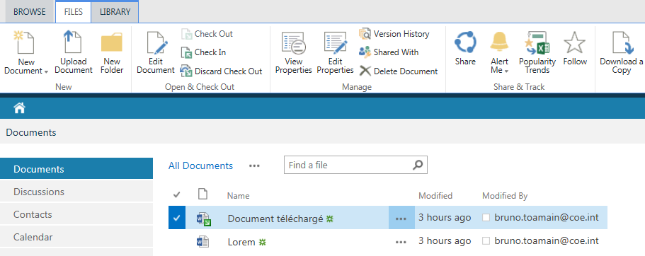

The following dialogue box then opens:

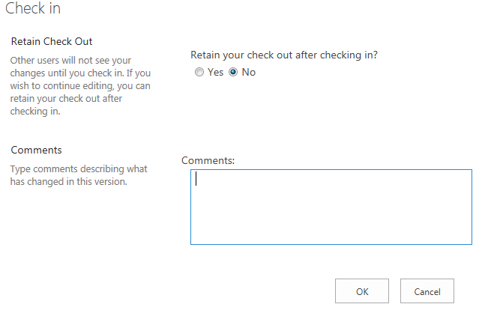

* "***Retain Check Out"***: confirm whether the document should continue to be checked out after your changes have been published;
* ***"Comments"*** enables you to indicate what has changed in this version.

Note: The administrator of the collaborative workspace can carry out actions on a document locked by a user.

## Version History

This option enables you to save each state of a module's data, making it possible to restore the document as it was at an earlier date.

To restore a document to a previous state, click on ***"Version History"*** in the context menu of the data:



A list of the different versions is displayed. To view the contents of each version, simply click on its date: the version of the document opens in read-only mode.

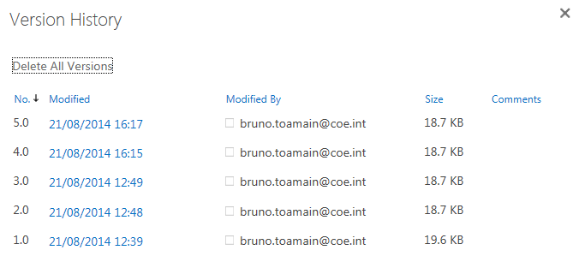

To restore a previous version, click on ***"Restore"*** in the context menu of the required version.

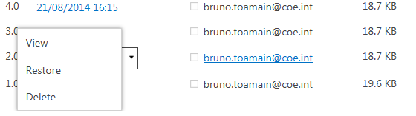

You can also access the version history via the ribbon by clicking on the "***Files***" tab and then on "***Version History***"

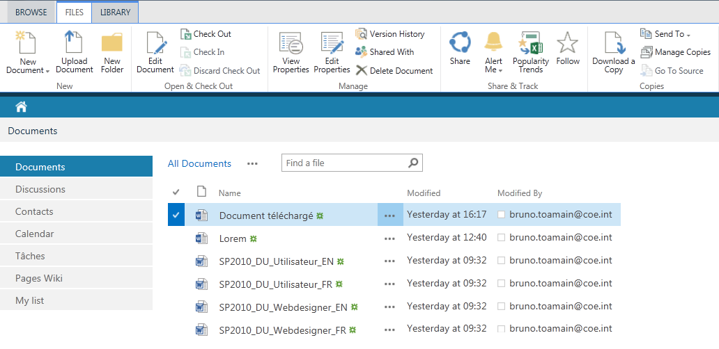

# Alerts

You can set up e-mail alerts in order to be informed of changes relating to a module.

## Creating an alert

To add an alert on a module, with the module displayed, click on the "Library" tab in the Office ribbon and then on ***"Alert Me"*** and ***"Set alert on this library"***:

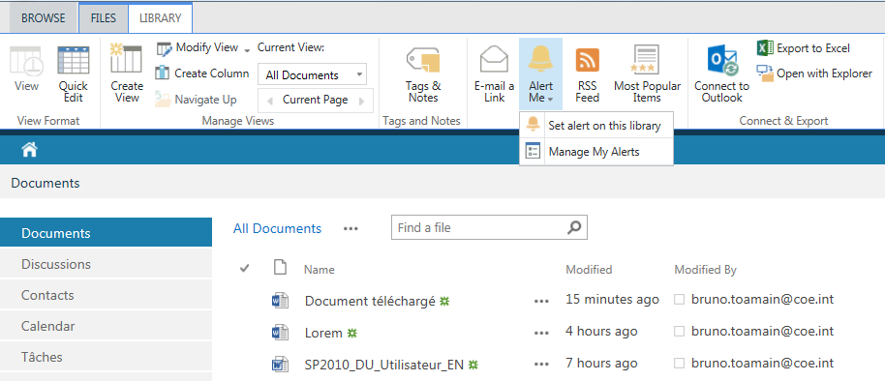

Note: Depending on the type of module, the word ***"Library"*** might be replaced by another word such as ***"Calendar"*** or ***"List"***

The following dialogue box opens:

* 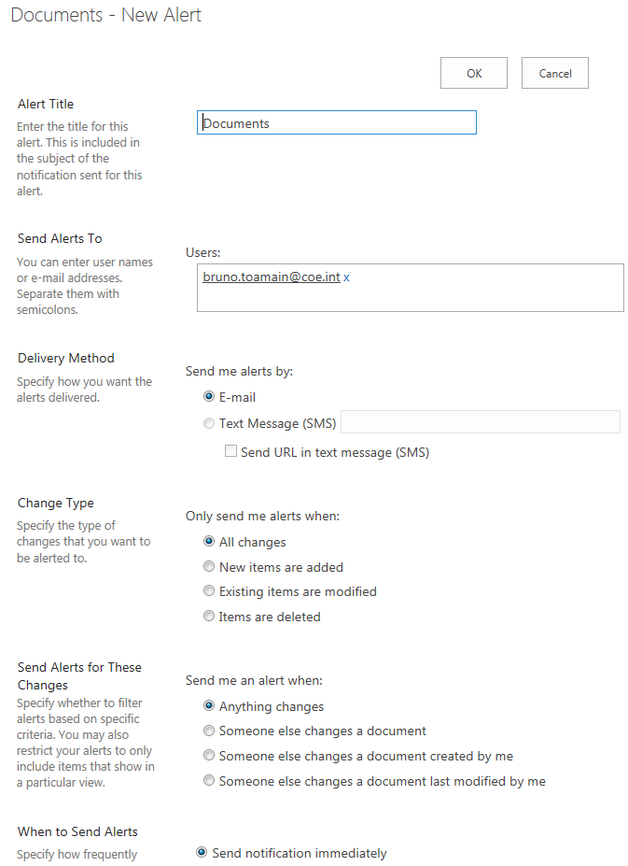***"Alert Title"***: name of the alert, by default the name of the list;
* ***"Send Alerts To"***: recipient(s) of the alert, by default the logged-in user;
* ***"Delivery Method"***: notification method, e-mail by default;
* ***"Change Type"***: event type (any change, new data, alteration of data, deletion of data);
* ***"Send Alerts for These Changes"***:type of change (any change, modification by a third party, third party modifications of data created by the user, modification by a third party of the data last amended by the user, modification of data present in a specific view);
* ***"When to Send Alerts"***: notification frequency (immediate, daily, with specification of the time, weekly with specification of the day and time).

Fill in the different criteria for the alert and click on the ***"OK"*** button to validate its setting up. A confirmation e-mail is sent.

## Modifying an alert

To modify an alert, with the module displayed, click on ***"Library"***, and then on ***"Alert Me"*** and ***"Manage My Alerts"***:

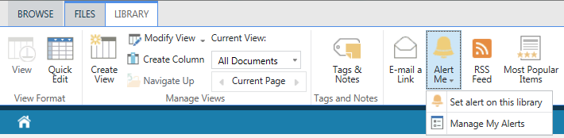

Note: Depending on the type of module, the word ***"Library"*** might be replaced by another word such as ***"Calendar"*** or ***"List"***

The list of alerts created for all modules of the collaborative workspace is displayed:

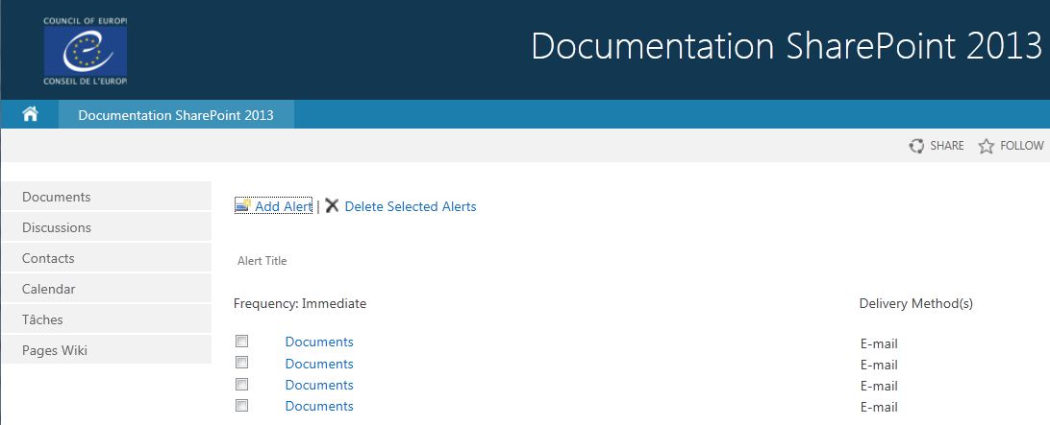

Note: The administrators of the collaborative workspace can view and carry out actions on all the alerts of the site's users.

Click on the title of the alert to be changed.

The alert settings screen is displayed:

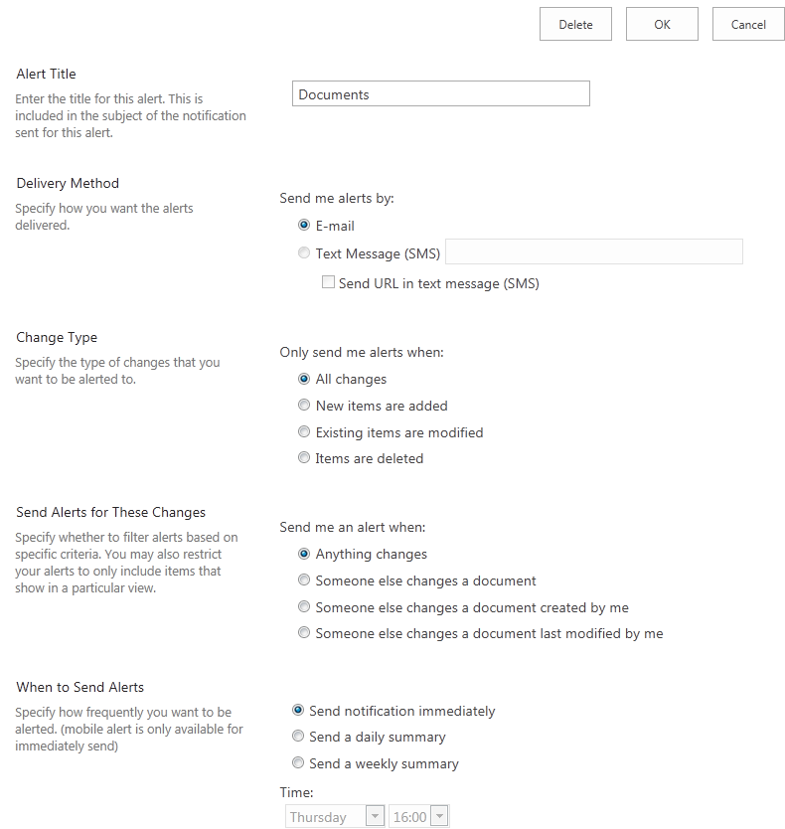

* ***"Alert Title"***: name of the alert, by default the name of the list;
* ***"Send Alerts To"***: recipient of the alert, by default the person logged in;
* ***"Delivery Method"***: method of notification, e-mail by default;
* ***"Change Type"***: type of trigger event (any change, new data, change of data, deletion of data;
* ***"Send Alerts for These Changes"***: type of modification (any change, modification by a third party, third party modifications of data created by the user, modification by a third party of the data last amended by the user, modification of data shown in a specific view);
* ***"When to Send Alerts"***: notification frequency (immediate, daily, with specification of the time, weekly with specification of the day and time).

Fill in the different criteria for the alert and click on the ***"OK"*** button to validate its setting up.

## Removing an alert

To delete an alert, with the module is displayed, click on ***"Library"*** and then on ***"Alert Me"*** and ***"Manage My Alerts"***:



Note: Depending on the type of module, the word ***"Library"*** might be replaced by another word such as ***"Calendar"*** or ***"List"***

The list of alerts created for all modules of the collaborative workspace is displayed:



Note: The administrators of the collaborative workspace can view and carry out actions on all the alerts of the site's users.

Select the alert to be deleted by ticking the box provided and then clicking on ***"Delete Selected Alerts"***.

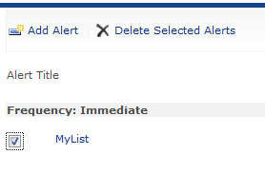

Confirm the deletion by clicking on the ***"OK"*** button in the dialogue box that opens:

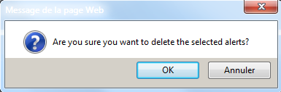

1. **ACCESS TO RESTRICTED WEBSITES OF THE COUNCIL OF EUROPE**

* LOGGING ON

The application can be accessed at the following address:

<http://seagma.coe.int>

Users with external or "extraweb" accounts enabling them to access Council of Europe resources (Intranet, collaborative workspaces and various in-house applications) have anonymous user access to Seagma enabling them to change or reset their password.

Presentation of the menu

When the application's URL is accessed in a browser, the following page is displayed:

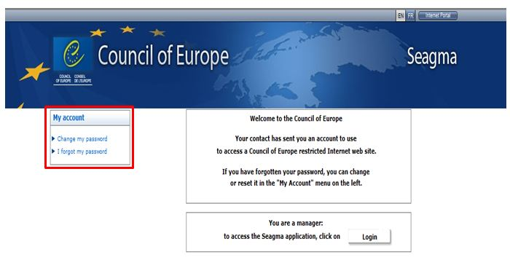

The "My account" menu on the left of the welcome screen gives access to the following functionalities:

* "Change my password"
* "I forgot my password"

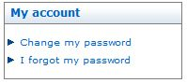

Resetting a password

|  |  |
| --- | --- |
|  | If a user forgets their password, they can automatically randomly regenerate a new password (it is not necessary to change the password when they next log on). |

To reset their password, the user must:

* type in their user ID
* type in the character string appearing in the randomly generated image
* then click on the "Reset" button.

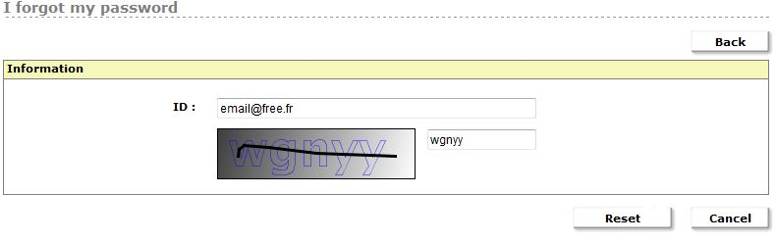

If the ID typed in does not exist or is incorrect, the following error message is displayed:

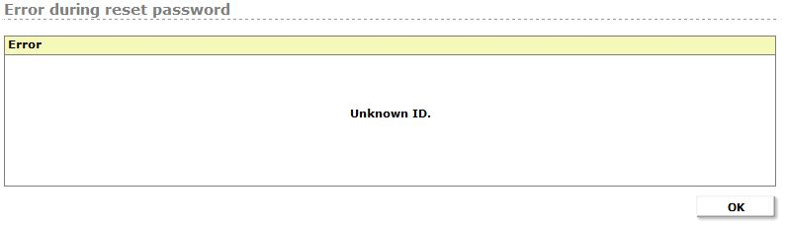

Another error message may be displayed when the user account has been disabled:

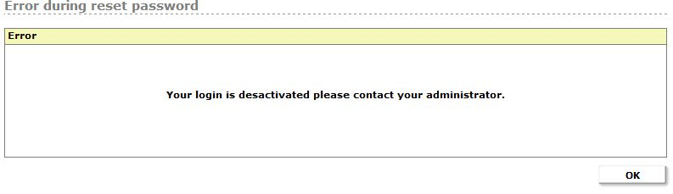

Otherwise, the following message is displayed:

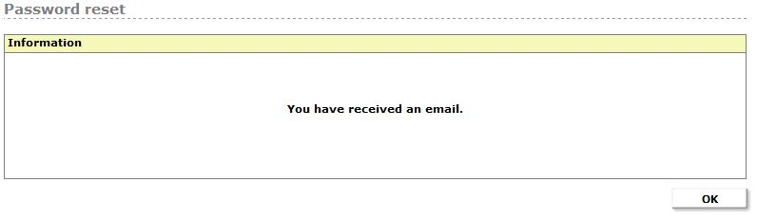

The user then receives an e-mail intended to check that they are the person requesting the password reset. When they click on the "Reset" link in the body of the e-mail, another e-mail, containing the password, is sent.

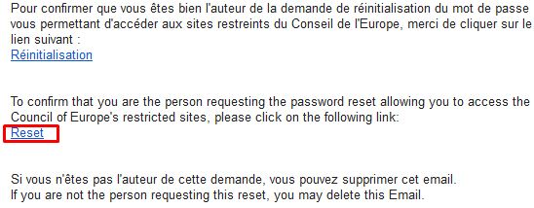

This second e-mail encourages the user to change the randomly generated password using the link in blue.

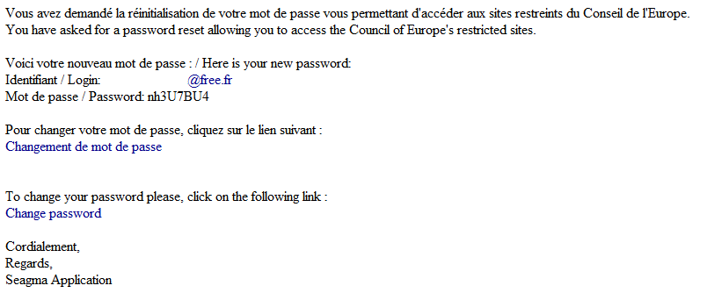

Changing a Password

To change their password, the user:

* clicks on the "Change my password" in the left-hand menu
* types their ID (e-mail address) in the "ID" field
* types their current password in the "Password" field,
* types their new password in the "New password" field and in the "Password confirmation" field

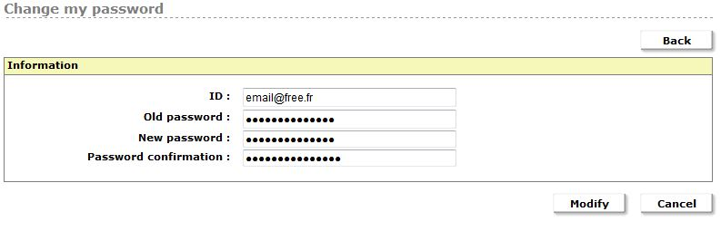

The Council of Europe's **security** **policy** regarding passwords is as follows:

|  |  |
| --- | --- |
|  | * The duration of a password is 63 days. It is recommended to reset it every 2 months. It must not contain any special or accented characters; * The password must be at least 8 characters long; * Whenever a password is reset, the new password must be different from the last ten passwords previously used. |

After the user clicks on the "Modify" button and checks that all the fields are filled in, the following message is displayed:

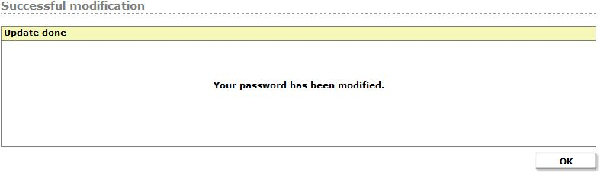

Various types of error message may be displayed if a password change fails:

1. If the user ID does not exist or an incorrect current password is typed, the following message is displayed:

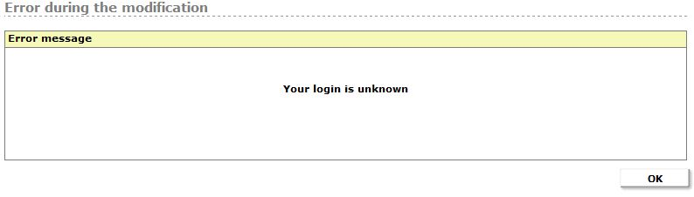

1. If the confirmation password does not match the new password typed in, the following message is displayed:

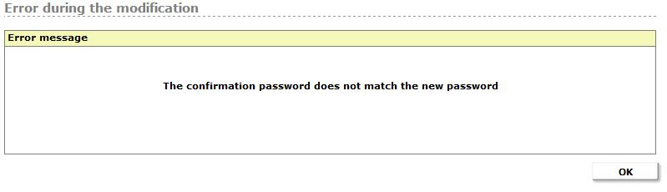

1. If the new password does not comply with security policy, the following message is displayed:

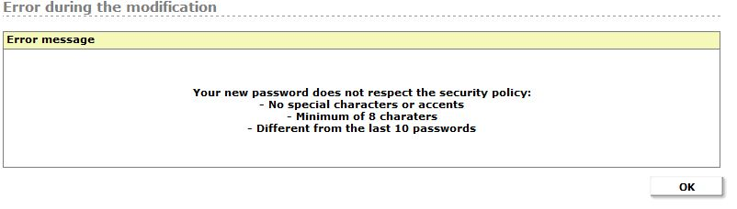

1. If the account has been deactivated, the following message is displayed:

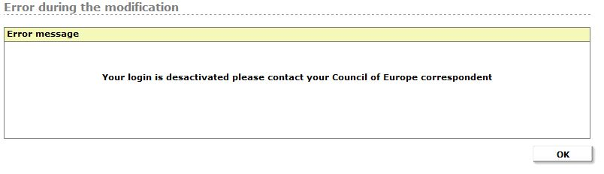

Automatic Notifications

External users (anonymous access) receive a notification e-mail 7 days before their password expires. This e-mail contains a link to the password reset page so that they change it. Once a password has been reset, it is once again valid for a period of 63 days.

|  |  |
| --- | --- |
| Light Bulb On 32 h g | These notifications do not apply to Permanent Representation accounts.  Only the holders of "External" and "Retired" accounts receive a notification one week before their password expires. |