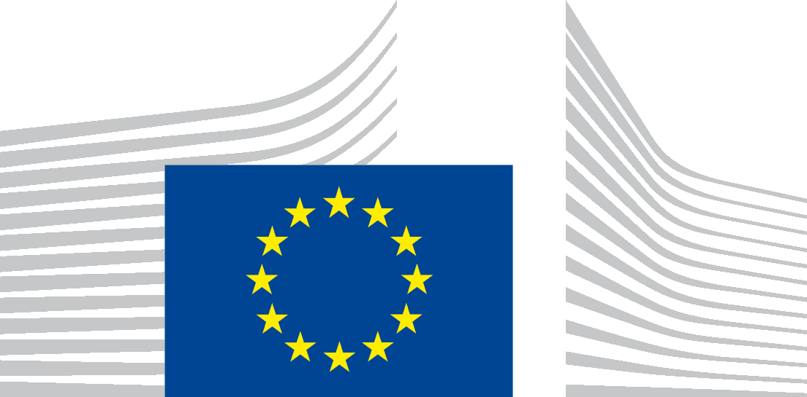 | EUROPEAN COMMISSION  CONSUMERS, HEALTH, AGRICULTURE AND FOOD EXECUTIVE AGENCY  The Director
Luxembourg,8/12/2019
CHAFEA/VW
By registered letter with acknowledgment of receipt:
Aisha DOWN
Emerika Bluma 8
Sarajevo
Bosnia and Herzegovina
Advance copy by email:
ask+request-7377-125c6824@asktheeu.org
Subject: Your confirmatory application concerning your access to documents request Submissions for Track and Trace Everis tender
Ref.: your email of 20 November 2019-Ares(2019)7250249
Dear Ms Down,
I refer to your email concerning a confirmatory application for access to documents request ‘Submissions for Track and Trace Everis tender’, in accordance with Article 7(2) of Regulation (EC) No 1049/2001 regarding public access to European Parliament, Council and Commission documents (hereafter “Regulation 1049/2001”).
Request for information
In the first part of your confirmatory application, you ask the Consumers, Health, Agriculture and Food Executive Agency (Chafea) “[…] to review the response in light of two questions:
First, were there other parties that submitted tenders for this contract? If not, why?
Secondly, the European Parliament flagged this contract as containing a conflict of interest: http://www.europarl.europa.eu/doceo/document/E-8-2016-009343_EN.html.
In this release, you have not provided data that could clarify, one way or another, if this concern was well-founded. However, this was a sizeable contract. (1.3 million Euros), and one that had significant impact on a European law.
[…] Please release any further due diligence that was done on the contractors, on PwC, or on Everis for this contract--including relationships between PwC and the tobacco industry, and any communication with third parties on the subject of this contract.”
These questions do not constitute a request for access to documents, but a request for information, which does not fall under the scope of Regulation 1049/2001, but is dealt with under the Code of Good Administrative Behaviour.
Therefore, your questions have been referred to the responsible Health and Food Safety Unit of Chafea, which will provide you a reply in a separate letter.
No disclosure
In the second part of your application, you request Chafea to “[…] consider releasing data about the employment history of the contractors themselves.”
I identified the Chapter 7, Appendix B: References in the field of the document Formal Offer under Framework Contract DI/07171 Lot 2, 10/06/2016, Ares(2016)2712355 that corresponds to the description included in your confirmatory application.
The document to which this chapter belongs was also identified as being in the scope of your initial request for access to documents (ref Ares(2019)6453044, 6453124, 7003834 and 7027118).
After conducting a fresh review of the reply given at the initial stage, I regret to inform you that I must confirm the initial decision of non-disclosure of Chapter 7, Appendix B of the document Formal Offer under Framework Contract DI/07171 Lot 2, 10/06/2016.
Indeed, disclosure of the requested document would undermine the protection of the commercial interests of Everis, as putting this information in the public domain would affect its competitive position on the market. Therefore, the exception laid down in Article 4(2) first indent of Regulation (EC) No 1049/2001 applies to this document.
The requested document contains commercially sensitive information relating to clients, previous projects, methodologies, know-how, specific pricing and other information carrying a commercial value. Disclosure to the public of such information would undermine the protection of Everis’ expertise, know-how, strategy and creativity and, thus, their commercial strength.
We have considered whether partial access could be granted to the requested document. No meaningful partial access can be granted to Chapter 7 without undermining the commercial interests described above.
The exceptions laid down in Art 4(2) of Regulation (EC) 1049/2001 apply unless there is an overriding public interest in the disclosure of the document. I have examined whether there could be an overriding public interest in disclosure, but such an interest could not be substantiated.
Full disclosure
In the third (and last) part of your confirmatory application, you mention that “[…] document 6 contains a clarification request sent from Everis to the Commission on the subject of the contract.” and request us to “[…] send the document they have attached with their questions.”
We enclose a copy of the requested document.
Please note that Chafea received this document from Everis and it is disclosed for information only. The document does not reflect the position of Chafea and cannot be quoted as such.
Means of redress
The means of redress available against our position concerning the public access to the requested document are judicial proceedings and complaints to the Ombudsman under the conditions specified, respectively, in Art 263 and 228 of the Treaty on the Functioning of the European Union.
Yours sincerely,
Véronique WASBAUER

OJ L 145 of 31.5.2001, p. 43.

