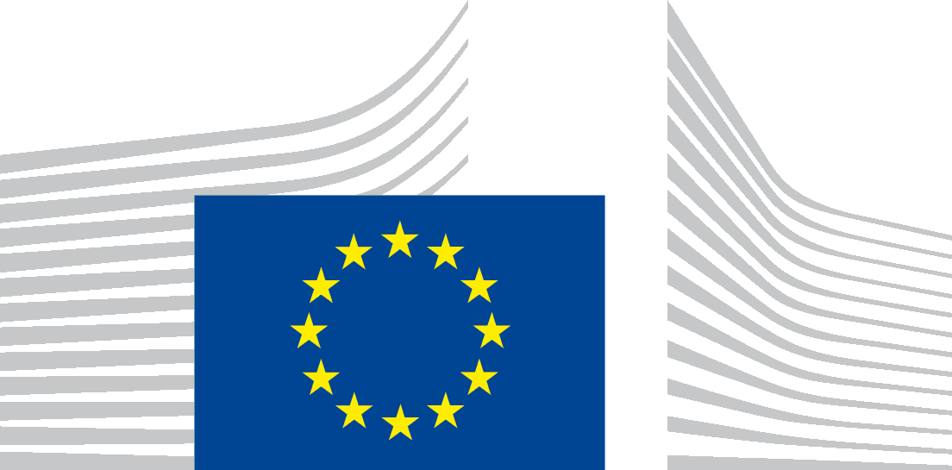 | EUROPEAN COMMISSION  DIRECTORATE-GENERAL FOR HEALTH AND FOOD SAFETY  Food and feed safety, innovation  Food information and composition, food waste
Brussels
SANTE.DDG2.E.1/HM/Mk (2020)3923763
Ms Molling Luise
Granitzstr. 2 13189 Berlin
Germany

by emai only:
ask+request-8209-bb088987@asktheeu.org

Dear Ms Molling,
Subject: Your application for access to documents – Ref GestDem No 2020/3663
We refer to your email dated 12 June 2020 in which you make a request for access to documents, registered on 16 June 2020 under the above-mentioned reference number.
We also refer to our letter of 07 July 2020 extending the time limit to respond to your request according to Article 7(3) of Regulation (EC) No 1049/2001.
- Scope of your request
In your request, you ask, on the basis of Regulation (EC) No 1049/2001 ‘any correspondence from companies and associations (letters, e-mails, etc.) from the food industry on the subject of FOP nutritional labelling, in particular Nutri-Score, in the period June 2019 - June 2020’
Following our request for clarification dated 17 June 2020, you replied on 17 June 2020 that ‘to speed up the process please limit my request to all correspondence from food industry on Nutri-Score’.
- Identification and assessment of the concerned documents
We have identified 13 documents that fall within the scope of your request.
You will find attached a table listing the identified documents and summarising the outcome of the assessment carried out on the basis of Regulation (EC) No 1049/2001.

Having examined all the documents under the provisions of Regulation (EC) No 1049/2001 and considered the opinion of the third party, we have come to following conclusion, which is further explained below:
- Full access can be granted to documents No 10 to 12, which are publicly available;
- Partial access can be grated to documents No 1 to 9 and 13 as their full disclosure is prevented by one exception to the right of access laid down in Article 4 of the Regulation); document No 6 also contains withheld parts considered outside of the scope of this request.
We enclose a copy of the documents No 1 to 9 and 13 redacted of the parts which cannot be disclosed as further explained below. Documents No 10 to 12 are accessible through a hyperlink.

- Reasons for partial disclosure
Protection of personal data - Article 4(1)(b) of Regulation (EC) No 1049/2001
With regard to the identified above, a complete disclosure of the identified documents is prevented by the exception concerning the protection of privacy and the integrity of the individual outlined in Article 4(1)(b) of Regulation (EC) No 1049/2001, because they contain the following personal data:
- the names/initials and contact information of Commission staff members not pertaining to the senior management;
- the names/initials and contact details of other natural persons;
- handwritten signatures/abbreviated signatures of natural persons;
- other information relating to an identified or identifiable natural person such as pictures.
Article 9(1)(b) of the Data Protection Regulation does not allow the transmission of these personal data, except if you prove that it is necessary to have the data transmitted to you for a specific purpose in the public interest and where there is no reason to assume that the legitimate interests of the data subject might be prejudiced. In your request, you do not express any particular interest to have access to these personal data nor do you put forward [any] arguments to establish the necessity to have the data transmitted for a specific purpose in the public interest.
Consequently, we conclude that, pursuant to Article 4(1)(b) of Regulation (EC) No 1049/2001, access cannot be granted to the personal data contained in the requested documents, as the need to obtain access thereto for a purpose in the public interest has not been substantiated and there is no reason to think that the legitimate interests of the individuals concerned would not be prejudiced by disclosure of the personal data concerned.
You may reuse public documents, which have been produced by the European Commission or by public and private entities on its behalf based on the Commission Decision on the reuse of Commission documents. You may reuse the documents disclosed free of charge and for non-commercial and commercial purposes provided that the source is acknowledged and that you do not distort the original meaning or message of the documents. Please note that the Commission does not assume liability stemming from the reuse.
Please note that documents originating from third parties are disclosed to you based on Regulation (EC) No 1049/2001. However, this disclosure is without prejudice to the rules on intellectual property, which may limit your right to reproduce or exploit the released documents without the agreement of the originator, who may hold an intellectual property right on them. The European Commission does not assume any responsibility from their reuse.
- Means of redress
In case you would disagree with this position, you are entitled, in accordance with Article 7(2) of Regulation (EC) No 1049/2001, to submit a confirmatory application requesting the Commission to review this position.
Such a confirmatory application should be addressed within 15 working days upon receipt of this letter to the Secretariat-General of the Commission at the following address:
European Commission
Secretariat-General
Unit C.1. ‘Transparency, Document Management and Access to Documents’
BERL 7/076
B-1049 Brussels, or by email to: sg-acc-doc@ec.europa.eu

Yours faithfully,

Yours sincerely,

Alexandra Nikolakopoulou

- Annex 1: Table of disclosed documents
- Annex 2: Disclosed documents

Regulation (EC) No 1049/2001 regarding public access to European Parliament, Council and Commission documents (OJ L 145, 31.5.2001, p. 43).

