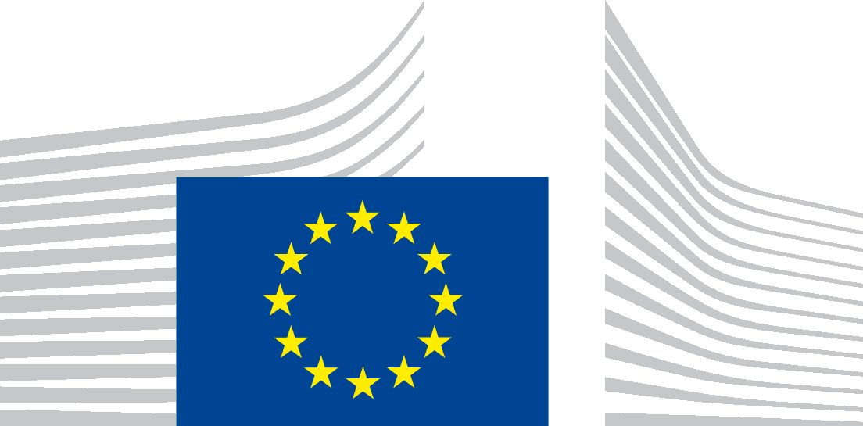 | EUROPEAN COMMISSION  DIRECTORATE-GENERAL FOR MOBILITY AND TRANSPORT  Directorate A - Policy coordination  A.4 - Legal issues & Enforcement
Brussels, 22/05/2018
MOVE.A/A4/BJ(2018)
By registered letter with acknowledgment of receipt

Margarida da Silva
CEO
Corporate Europe Observatory
Rue d'Edimbourg, 26
B- 1050 Bruxelles

By e-mail: ask+request-5499-a78e41d5@asktheeu.org

Subject: Your application for access to documents – DG MOVE - Ref GestDem No 2018/2374
Dear Ms da Silva,
I refer to your application dated 25 April 2018 in which you make a request for access to documents, registered on 27 April 2018 under the above mentioned reference number.
You request access to documents which contain the following information:

- a list of lobby meetings held by DG Mobility and Transport with Facebook or its intermediaries. The list should include: date, individuals attending + organisational affiliation, the issues discussed;
- minutes and other reports of these meetings;
all correspondence (i.e. any emails, correspondence or telephone call notes) between DG Mobility and Transport (including the Commissioner and the Cabinet) and Facebook or any intermediaries representing its interests.
I consider your request to cover documents held up to the date of your initial application, [25 April 2018].
Please note that due to the wide scope of your request, covering also areas falling under the responsibility of other Directorates-General, parts of your request have been attributed to other Directorates-General. This reply relates only to the documents held by DG MOVE.
You received (will receive) the replies from the other respective Directorates-General in due course.
[DG ENER : Gestdem 2018/2320, DG COMM : Gestdem 2018/2291, DG ECHO : Gestdem 2018/2329, DG SG : Gestdem 2018/2330, TF50 : Gestdem 2018/2325 and EPSC : Gestdem 2018/2326].
On the basis of your request the following document has been identified:
- Report meeting DG MOVE with Facebook and Airbus (high altitude drones) – 24.04.2018

Having examined the document requested under the provisions of Regulation (EC) No 1049/2001 regarding public access to European Parliament, Council and Commission documents, I have come to the conclusion that it may be partially disclosed. Some parts of the document have been blanked out as their disclosure is prevented by exception to the right of access laid down in Article 4 of this Regulation.
The document to which you have requested access contains personal data, in particular names of the participants.
Pursuant to Article 4(1) (b) of Regulation (EC) No 1049/2001, access to a document has to be refused if its disclosure would undermine the protection of privacy and the integrity of the individual, in particular in accordance with Community legislation regarding the protection of personal data. The applicable legislation in this field is Regulation (EC) No 45/2001 of the European Parliament and of the Council of 18 December 2000 on the protection of individuals with regard to the processing of personal data by the Community institutions and bodies and on the free movement of such data.

When access is requested to documents containing personal data, Regulation (EC) No 45/2001 becomes fully applicable.
According to Article 8(b) of this Regulation, personal data shall only be transferred to recipients if they establish the necessity of having the data transferred to them and if there is no reason to assume that the legitimate rights of the persons concerned might be prejudiced.
I consider that, with the information available, the necessity of disclosing the aforementioned personal data to you has not been established and/or that it cannot be assumed that such disclosure would not prejudice the legitimate rights of the persons concerned. Therefore, the document is being disclosed in a version, in which these personal data have been redacted.
In accordance with Article 7(2) of Regulation 1049/2001, you are entitled to make a confirmatory application requesting the Commission to review this position.

Such a confirmatory application should be addressed within 15 working days upon receipt of this letter to the Secretary-General of the Commission at the following address:
European Commission
Secretary-General
Transparency unit SG-B-4
BERL 5/282
B-1049 Bruxelles
or by email to: sg-acc-doc@ec.europa.eu

Yours sincerely,

(e-signed)
Barbara Jankovec
Head of Unit

Other Gestdem references and DGs : 2320/ENER – 2291/COMM – 2329/ECHO – 2330/SG – 2325/TF50 Contact – 2326/EPSC.
OJ L 145, 31.05.2001, p. 43.
Official Journal L 8 of 12.1.2001, p. 1
Judgment of the Court of Justice of the EU of 29 June 2010 in case 28/08 P, Commission/The Bavarian Lager Co. Ltd, ECR 2010 I-06055.

