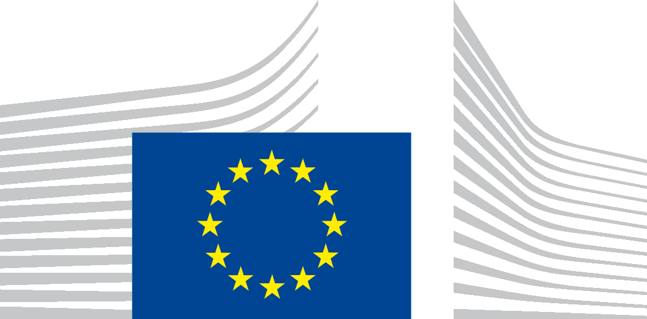 | EUROPEAN COMMISSION  DIRECTORATE-GENERAL FOR INTERNATIONAL COOPERATION AND DEVELOPMENT  The Director-General
Brussels
DEVCO/KD
Dear Madam,
We refer to your e-mail of 15 January 2020 in which you make a request for access to documents, registered on the same day under the above-mentioned reference number. We also refer to our email dated 5 February 2020 via which the time limit for handling your application has been extended by 15 working days pursuant to Article 7(3) of Regulation (EC) No 1049/2001, as well as to our email dated 16 April 2020, informing you that the handling of your request is facing delays and is taking more time than anticipated.
You request access to all correspondence (including emails, letters, phone conversations), minutes and other reports of meetings between DG DEVCO officials and/or representatives (including the Commissioner and the Cabinet) and the Secretary General as well as other representatives of the Energy Charter Secretariat (since January 2018).
We consider your request to cover documents held up to the date of your initial application, i.e. 15 January 2020.
You can find the documents falling within the scope of your application in the Annex attached.
Documents 9, 10, 14.4, 15.8 and 15.10 are publicly available. You can find the links to these documents in the annex.
Since the documents in the Annex originate from third parties, the originator of the documents has been consulted.
Following an examination of the documents listed in the Annex under the provisions of Regulation (EC) No 1049/2001 regarding public access to documents, and taking into account the opinion of the third party, we regret to inform you that your application cannot be granted, as disclosure is prevented by exceptions to the right of access laid down in Article 4 of this Regulation. We have considered whether partial access could be granted to the documents requested under Article 4(6) of this Regulation; however, no meaningful partial access could be granted without undermining the interests protected under Article 4 therein.
Article 4(1)(a), third indent of Regulation (EC) No 1049/2001 provides that the institutions shall refuse access to a document where disclosure would undermine the protection of the public interest as regards (...) international relations.
As far as the protection of international relations is concerned, the EU Court has acknowledged that the institutions enjoy a wide discretion when considering whether access to a document may undermine the public interest.
Documents 1, 2, 3, 4, 5, 6, 7, 8, 11, 12, 13, 14 (except for 14.4) and 15 ( except for 15.8 and 15.10) which you seek to obtain contain internal information received by the ECS, internal draft documents which were not intended for publication or any further dissemination and contain sensitive positions of countries. Their disclosure would reveal internal information sent in confidence and could undermine relations between the Energy Charter Secretariat and Contracting Parties/Observers, including the European Union and its Member States.
Consequently, we conclude that disclosure of the abovementioned documents would seriously undermine the protection of the public interest as regards international relations, in a reasonably foreseeable and non-hypothetical manner, pursuant to article 4(1)(a), third indent of Regulation (EC) No 1049/2001.
The author of the documents has objected to disclosure of the documents that they sent to the Commission and has motivated their position as follows: the disclosure of the requested document could undermine international relations between ECS and Contracting Parties/Observers within the meaning of Art 4(1)(a) third indent of Regulation (EC) 1049/2001.
With regard to the documents 4, 5, 6, 7, 11, 12, 13, 15 (except 15.8 and 15.10) listed in annex to the present letter, disclosure of the identified documents is prevented by the exception concerning the protection of privacy and the integrity of the individual outlined in Article 4(1)(b) of Regulation (EC) No 1049/2001, because they contain the following personal data:
- the names/initials and contact information of Commission staff members not pertaining to the senior management;
- the names/initials and contact details of other natural persons;
- handwritten signatures/abbreviated signatures of natural persons.

Article 9(1)(b) of the Data Protection Regulation does not allow the transmission of these personal data, except if you prove that it is necessary to have the data transmitted to you for a specific purpose in the public interest and where there is no reason to assume that the legitimate interests of the data subject might be prejudiced. In your request, you do not express any particular interest to have access to these personal data nor do you put forward any arguments to establish the necessity to have the data transmitted for a specific purpose in the public interest.
Consequently, we conclude that, pursuant to Article 4(1)(b) of Regulation (EC) No 1049/2001, access cannot be granted to the personal data contained in the requested documents, as the need to obtain access thereto for a purpose in the public interest has not been substantiated and there is no reason to think that the legitimate interests of the individuals concerned would not be prejudiced by disclosure of the personal data concerned.
In accordance with Article 7(2) of Regulation (EC) No 1049/2001, you are entitled to make a confirmatory application requesting the Commission to review this position.
Such a confirmatory application should be addressed within 15 working days upon receipt of this letter to the Secretary-General of the Commission at the following address:
European Commission
Secretariat-General
Transparency, Document Management & Access to Documents (SG.C.1)
BERL 7/076
B-1049 Brussels
or by email to: sg-acc-doc@ec.europa.eu
Yours faithfully,
Koen DOENS
(e-signed)

Enclosure: Annex
c.c.: ve_devco.cad (DEVCO.R)

Ref. Ares(2020)730686 - 05/02/2020.
Ref. Ares(2020)2080292 - 16/04/2020.
Judgment of the Court of First Instance of 25 April 2007, in case T-264/04, WWF European Policy Programme v Council, EU:T:2007:114, paragraph 40.
Regulation (EU) 2018/1725 of the European Parliament and of the Council of 23 October 2018 on the protection of natural persons with regard to the processing of personal data by the Union institutions, bodies, offices and agencies and on the free movement of such data, and repealing Regulation (EC) No 45/2001 and Decision No 1247/2002/EC, OJ L 295, 21.11.2018, p. 39.

