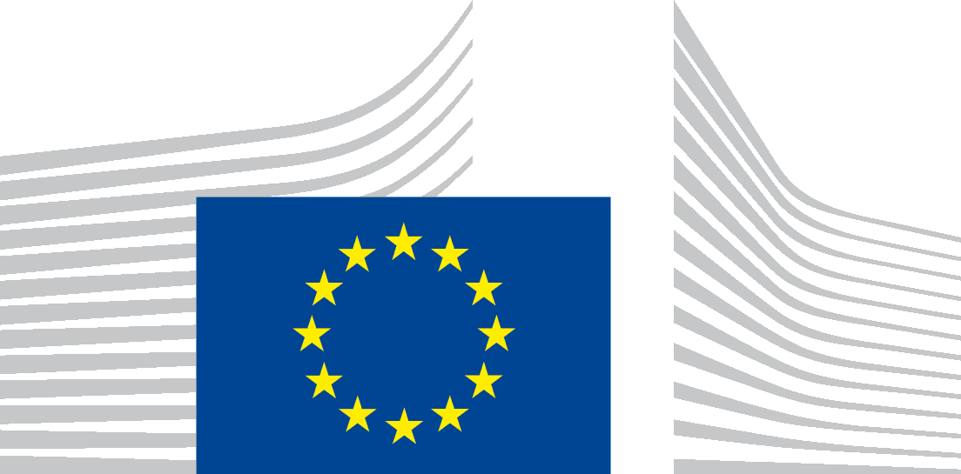 | EUROPEAN COMMISSION  DIRECTORATE-GENERAL FOR HEALTH AND FOOD SAFETY  The Director-General
Brussels
SANTE.DDG2.D.3/PD/es (2020) 7331686
By registered mail with acknowledgment of receipt
Mr SOLANKY Kunal

42 Wykeham Crescent
OX4 3SB Oxford
United Kingdom

Advance copy by email:
ask+request-8596-3b01f158@asktheeu.org
Dear Sir,
Subject: Your application for access to documents – GESTDEM 2020/5858
We refer to your e-mail of 30 September 2020 in which you make a request for access to documents, registered on 5 October 2020 under the above-mentioned reference number.
We further refer to our e-mail of 26 October 2020 extending the time limit to respond to your request according to Article 7(3) of Regulation (EC) No 1049/2001 (or ‘the Regulation’).
- Scope of your request
In your request, you ask, on the basis of Regulation (EC)No 1049/2001, access to:
‘documents which contain the following information: Article 124 of Regulation 2017/625 stipulates: "Member States shall inform the Commission of planned controls in the areas governed by the rules referred to in Article 1(2) on their territory, by the competent authorities of third countries".
Could you kindly provide me with a list starting from 2010 to present of all such third country controls, which sought to evaluate either animal welfare or animal health in Member States? Furthermore, with regards to the above list, if a third country has shared the findings of their controls with the Commission, please could you also send me these findings?’
In your follow-up e-mail of 30 September 2020, you further requested to:
‘please ensure the list details at the minimum the auditing country, the audited country and the species audited.’
- No documents held
We regret to inform you that the Commission does not hold any documents that would correspond to the description given in your application.
Please note that the obligation of Member States to inform the Commission of third country controls in their territory has taken effect on 14 December 2019, date of entry into force of the Regulation (EU) 2017/625 that introduces it. Furthermore, during most of the period since that date third country controls in the territory of Member States remain suspended due to the ongoing COVID-19-related sanitary situation and the resulting travel restrictions.
- Means of redress
In case you would disagree with this assessment, you are entitled, in accordance with Article 7(2) of Regulation (EC) No 1049/2001, to submit a confirmatory application requesting the Commission to review this position.
Such a confirmatory application should be addressed within 15 working days upon receipt of this letter to the Secretary-General of the Commission at the following address:

European Commission
Secretary-General
Transparency, Document Management & Access to Documents (SG.C.1)
BERL 7/076
B-1049 Brussels
or by email to: sg-acc-doc@ec.europa.eu

Yours sincerely,
Sandra GALLINA
(e-signed)

According to standard operational procedure, the reply is usually also sent to you by registered post. Please note, however, that due to the extraordinary health and security measures currently in force during the COVID-19 epidemics, which include the requirement for all Commission non-critical staff to telework, we are unfortunately not in a position to follow this procedure until further notice. We would therefore appreciate if you could confirm receipt of the present e-mail.
Regulation (EC) No 1049/2001 regarding public access to European Parliament, Council and Commission documents (OJ L 145, 31.5.2001, p. 43).

