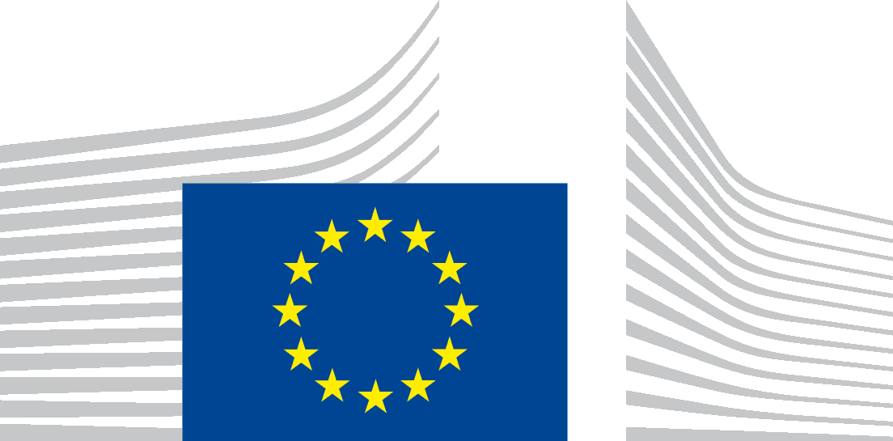 | EUROPEAN COMMISSION  DIRECTORATE-GENERAL FOR INTERNAL MARKET, INDUSTRY, ENTREPRENEURSHIP  AND SMES  Planning, finance, data  B1. Planning & Briefings
Brussels
GROW.B.1/AS

Lora VERHEECKE
9 rue du Bronze 1070
Bruxelles
Belgium

ask+request-9700-5c07e772@asktheeu.org

Subject: Your application for access to documents – GESTDEM 2021/4129
Dear Ms Verheecke,
We refer to your e-mail of 23 June 2021 in which you make a request for access to documents, registered on the same day under the above-mentioned reference number.
You request access to: “All documentation (including but not limited to all email correspondence, attendance lists, agendas, background papers, transcripts and recordings) and the meeting minutes/notes relating to the meeting between Thierry Breton and BusinessEurope on 28th April 2021”.
We have identified the enclosed 2 documents falling within the scope of your request.
With regard to the above mentioned documents, a complete disclosure of the identified documents is prevented by the exception concerning the protection of privacy and the integrity of the individual outlined in Article 4(1)(b) of Regulation (EC) No 1049/2001, because they contain the following personal data:
- the names/initials and contact information of Commission staff members not pertaining to the senior management;
- the names/initials and contact details of other natural persons;
Article 9(1)(b) of the Data Protection Regulation does not allow the transmission of these personal data, except if you prove that it is necessary to have the data transmitted to you for a specific purpose in the public interest and where there is no reason to assume that the legitimate interests of the data subject might be prejudiced. In your request, you do not express any particular interest to have access to these personal data nor do you put forward any arguments to establish the necessity to have the data transmitted for a specific purpose in the public interest.
Consequently, I conclude that, pursuant to Article 4(1)(b) of Regulation (EC) No 1049/2001, access cannot be granted to the personal data contained in the requested documents, as the need to obtain access thereto for a purpose in the public interest has not been substantiated and there is no reason to think that the legitimate interests of the individuals concerned would not be prejudiced by disclosure of the personal data concerned.
You may reuse public documents, which have been produced by the European Commission or by public and private entities on its behalf based on the Commission Decision on the reuse of Commission documents. You may reuse the document disclosed free of charge and for non-commercial and commercial purposes provided that the source is acknowledged and that you do not distort the original meaning or message of the document. Please note that the Commission does not assume liability stemming from the reuse.
In case you would disagree with this position, you are entitled, in accordance with Article 7(2) of Regulation (EC) No 1049/2001, to submit a confirmatory application requesting the Commission to review this position.
Such a confirmatory application should be addressed within 15 working days upon receipt of this letter to the Secretariat-General of the Commission at the following address:
European Commission
Secretariat-General
Unit C.1. ‘Transparency, Document Management and Access to Documents’
BERL 7/076
B-1049 Brussels, or by email to: sg-acc-doc@ec.europa.eu
Sincerely yours,
Laurence de Richemont
Head of Unit
Electronically signed

